KidsHubTV is a part of a global children’s disciple-making strategy called KidsHubs.

The idea started in Madagascar after the KidsGames leaders were given a spot on national TV every afternoon. They broadcast the show for 3 years. Now other countries are getting started.

What is KidsHubTV?
KidsHubTV began as a kid’s club-style TV show mirroring the local KidsHub groups featuring a Bible story and theme and skills demonstrated by a cast of children along with young adult leaders.
Since then KidsHubTV has become more interactive and created a platform for local KidsHubs groups & young people around the world to make their own videos and share them on www.kidshubtv.com and facebook. Bible story animations and animated titles & music have also been shared to help build local versions of the show.
The long-term goal of KidsHubTV is to encourage young people to make Christian videos sharing their opinions, skills & talents globally via mobile phones and www.kidshubtv.com.
It is hoped that as a result of seeing KidsHub videos children would be encouraged to participate in a local KidsHub or church group and/or visit the KidsHubTV website. And a church wanting to grow their children’s ministry in a region (like India) where the show is screening, could download Bible lessons written to complement each episode, and benefit from the momentum of the show.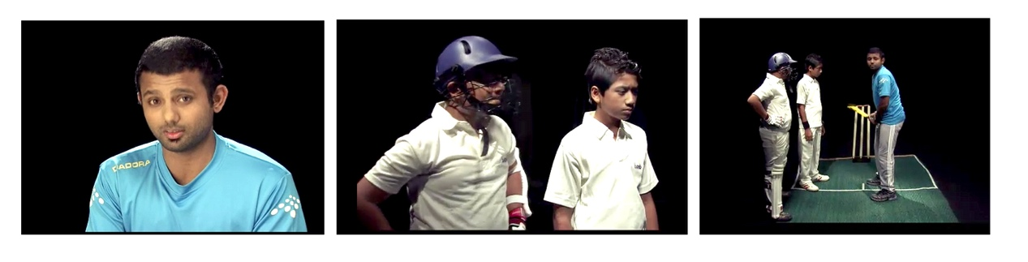
Cricket coaching on KidsHubTV India
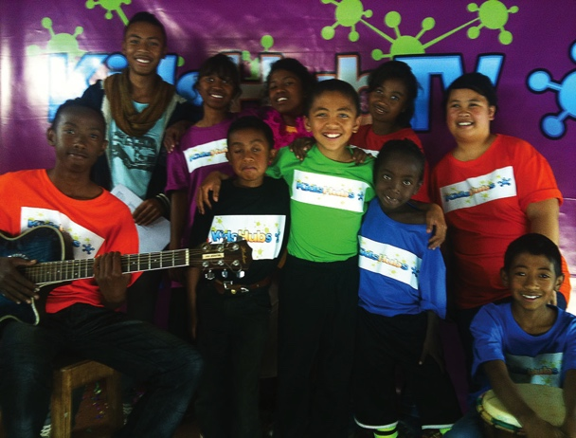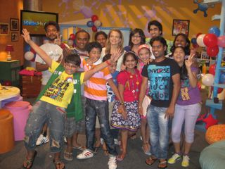
KidsHubTV Madagascar KidsHubTV India

Examples of KidsHubs
The types of KidsHubs that can be run are endless as it relies on the skills available of those running it. Here are examples of some different models:
- Video Making with teens in India & Togo
- Drama & Gardening in Australia & Liberia
- 3 day Holiday Camp (cooking, craft, drama etc) in Uganda
- Weekly kids club in Government housing estate in USA
- Weekly child-run Radio show in Tanzania
- Daily TV show with child hosts in Madagascar

How do KidsHubs and KidsHubTV connect?
It is hoped that as local KidsHubs form they can video their own segments and provide ‘talent’ for the locally produced KidsHubTV show. Kids and their ‘skills’ can be featured in the KidsHubTV show thus linking kids across a country/region. This is already happening in Madagascar. It is also hoped that the broadcasting of KidsHubTV would immediately create a demand for local KidsHubs to form locally as kids seek to join one in their area. Again this has been the experience in Madagascar where ‘fans’ have been asking where they can join a group. Current training being run globally by CYCAS (Children, Youth, Community and Sport) trainers can incorporate specific training in how to set up a local KidsHubs plus associated training modules including how to write skill lessons, relational discipling of children & mentoring etc.

KidsHubs Supporting Media

KidsHubsTV Website
The www.kidshubtv.com website has been developed. The website features Bible story animations (as seen on www.max7.org) plus separate segments of interest (cricket tips, craft & art, science, IT & Media for example) from the India KidsHubTV show. In addition corresponding discipleship ideas and Bible curriculum lessons are available for download to use in a local KidsHub group as a direct link to www.kidshubs.com. Information booklets on how to start a KidsHub in a local church plus a’ KidsHubTV Start up Manual’ are also available for download from the site. Users sign up as a Producer to access these free resources.
The website also features videos uploaded by local KidsHub groups around the world so children can share what they’re doing with other KidsHubs globally.

KidsHubRadio
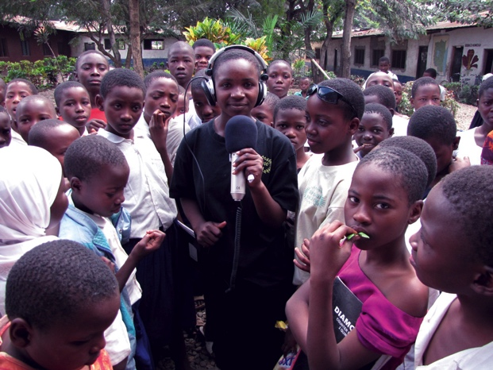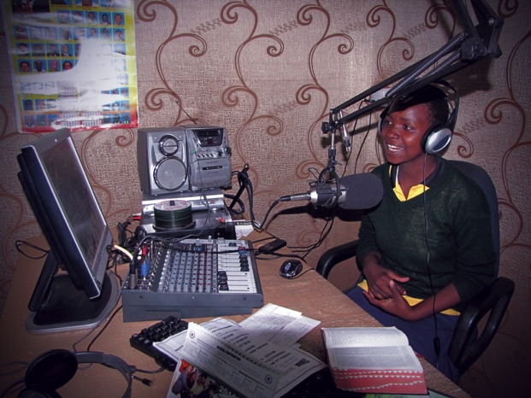
KidsHubRadio is a 30 - 60 minute upbeat call-in/sms/tweet/email/facebook children/youth program run by children for children. Currently in Tanzania a group of children under the supervision of adult leaders have been broadcasting a weekly program dealing with a different Bible topic and issue. Child listeners are encouraged to call in and join discussions, ask questions and pray with the young presenters. The presenters themselves interview guests, run Bible quizzes, give a talk on the Bible story, answer listener questions and pray on air. Songs are also featured, including live performances by artists and children’s choirs. It is proving to be a low-cost, yet highly interactive medium for reaching children and channelling them into local churches and children’s ministry activities. Likewise the children involved in running the radio show are being empowered & encouraged in their faith.

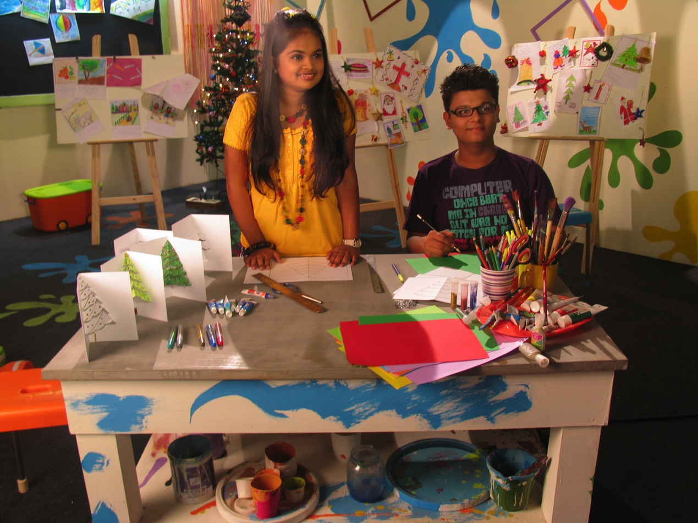
KidsHubTV India

Key Principles for KidsHubTV
- KidsHubTV is open source to encourage producers anywhere to create their own local version of the TV show.
- It is understood that in return producers would share content where applicable to be used in other versions of the TV show.
- The TV show and it’s producers would always honour Christ and encourage the value & worth of children in God’s eyes and therefore in the world’s eyes.
- A producer would be free to use all the resources available to create the TV show with the understanding that they agree with the show’s theological basis. (See the statement of belief in the Lausanne Covenant http://www.lausanne.org/en/documents/lausanne-covenant.html)

Current TV Show Format Variations

TV Format 1 (India)
The show is based around a “KidsHub” – a mixed group of boys and girls each with a particular passion. These would cover skills in sport, science, creative ideas, music, history and technology. Each Bible theme is explored from these various angles in an entertaining way that mimics what a local KidsHub would do. One Bible theme and one life skill could be tackled in each episode.
The Indian version of a KidsHubTV episode broadly covers the following in 30 minutes (23 broadcast mins):
TIME | CONTENT
5 mins | Opening segment that introduces a real-life problem the hub has to solve based on the Bible theme of the day.  Variation: Opening with an object lesson teaser with hosts (and kids); physical or creative challenge or game based around the Bible theme of the day.
2 - 3 mins | Animated Bible Story
5 mins | Let’s Do it – Hub kids & hosts help solve the ‘problem’ posed by doing something ‘hands on’ e.g. Creative skill; brain skill; craft; science experiment; sports and/or physical skill related to Bible theme.  Variation: feature local KidsHubs showing kids learning and doing things. E.g. Madagascar ‘Smart Clubs’ teaching a dance or song segment each week.
5 mins | Lifeskill segment – practical skills for living (health & hygiene, helping others, relationship skills etc.) related to Bible theme.
3 mins | Interviews with local KidsHub kids –  - KidSpeak: Children give their views or answers to a particular question (loosely related to the Bible theme).  - GodSpeak: Children give their summary of what they think God is saying through the Bible story covered in the episode.  Variation: segments filmed by disadvantaged children, and a “day in the life” of a child in their neighbourhood.
2 mins | 7 Day Challenge – something kids are going to do during the week as a result of what they’ve learnt from the Bible (with footage of TV hub kids and/or local KidsHubs doing it). E.g. Cleaning village, making Bible message posters to pin up, memorising a Bible verse, talking to God, helping a friend etc.
Currently the Indian version has a strong narrative flow, where the kids & hosts have a conflict or problem they have to solve (that is linked to the Bible theme). The Bible story helps the kids ‘solve’ their problem and/or teaches them how to deal with the situation. The segments all add to or are based on the Bible theme.

Ep2: The Man who forgot God
https://vimeo.com/143247306

Ep3: The Lost Sheep
https://vimeo.com/143247311

TV Format 2 [Madagascar & Togo]
The approach is a magazine format show hosted by 2 main child anchors/presenters and a couple of Segment anchors/presenters. The Segments remain the same as Format 1 but the treatment of it is more like a talk show/ live show. This format is flexible and will include interviews with various celebrities/experts from all walks of life addressing current issues relevant to the young adults and teens.

Current Video Resources Available
- KidsHubTV Segment & Opening titles with music
- Bible Story Animations (see www.kidshubtv.com)

Steps to starting your own KidsHubTV

Stage 1- Gather a team and practise making media
Gather a group of like-minded video professionals and/or keen video makers to help start a production team. These may well be older children and teens (as well as adults) who fast become adept at using mobile phones and basic editing computer programs to create videos.
Start a local KidsHub Media group (use the 10 Media/video making lessons available online www.kidshubs.com) and train a team of children/youth in how to create their own videos. Start by creating short Bible story videos (see www.kidshubtv.com for examples made by children) or interviews with ‘expert’ Christians, sports tips, a tour of a child’s neighbourhood or whatever topic interests them).
These videos can then be submitted for streaming on the KidsHubTV website and may be used in global versions of the show. Sign up as a Producer to create your own ‘channel’ and upload your videos.
Begin working with and encouraging those children gifted as presenters and interviewers; along with those showing abilities in scripting, camera work, sound recording and editing.

Stage 2- Produce simple TV program segments
Try scripting and creating a 23-minute program (or shorter depending on discussions with potential broadcasters) or parts of one. Pick a Biblical theme or Bible passage and start by producing one or two segments like a hands-on “Let’s Do It” or “Life Skill” or interview children for “Kids Speak” and “God Speak” or “7 Day Challenge” based around the chosen theme/message.
Keep uploading examples of your videos to www.kidshubtv.com (or use the ‘Contact us’ page on the website if you need help uploading).
Training for local Producers and then teams of children may also be possible – pending funding.

Stage 3- Broadcast simple version of KidsHub TV
Talk to local/regional TV broadcasters (satellite and networks) to see if they will broadcast the show for free or at a reduced rate. If there are broadcast charges, look around for businesses/government sectors/individuals to help fund it.
Meanwhile continue to encourage local KidsHubs group/s to keep working on scripts for episodes, Bible story videos, interviews etc. Regardless of whether they can be broadcast on a network – the videos can still be seen on the KidsHubTV website and shared with others.

Stage 4- Produce KidsHub series
Script and produce a KidsHubTV series (10 – 13 episodes as per the broadcaster’s requirements, usually 23 – 24 mins in length).

kidshubtv.com
kidshubs.com

