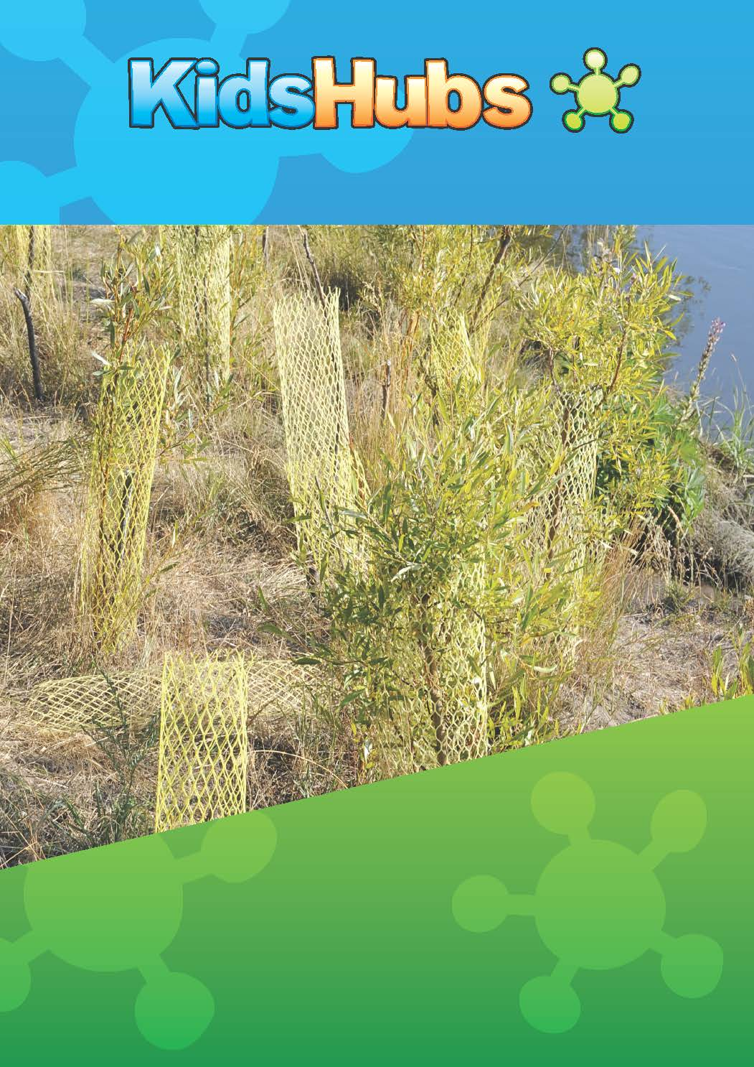
Bush Regeneration
Stages 1-5
Natural Area Restoration Guide

INTRODUCTION TO KIDSHUBS

KidsHubs is a free global program that helps reach out to and mentor children and young people. It can be used as part of an existing program or group, in a church, a school, a camp or to start a new group in your community. KidsHubs seek to help children learn how to follow Jesus from the Bible at the same time as learning a new skill for life. It is also a great way to encourage adults and teenagers to interact with and disciple children. KidsHubs can be based around just about anything—sport, media, photography, drama, cooking, farming, chess, music and so much more. KidsHubs is not an organisation, but a free idea and a movement.

KIDSHUBS SKILL SESSIONS AND HOW THEY CAN BE USED
KidsHubs Skill Sessions can be used as a plug-in to an existing Bible curriculum lesson such as 7Ways BibleMax (max7.org) with a two-hour-plus duration time. A KidsHubs Skill Session could also be used on alternate weeks if a club is limited to one hour Sessions. A group could therefore do a BibleMax lesson one week and a KidsHubs plug-in on the next week, and so on. KidsHubs Skill Sessions used at camps could be extended to three hours by introducing extra activities.

KIDSHUBTV
Alongside KidsHubs Sessions is KidsHubTV, an exciting new kids club-style TV program, which mirrors the local KidsHub groups featuring a Bible story and theme and skills demonstrated by a cast of children along with young adult leaders.
It is being produced in an open-source way so that producers across the world can have free access to core global content. Bible story animations and animated segment titles and music have been created and shared to build local versions of the show.
The long-term goal of this production is to see whole programs and short segments produced by local KidsHubs and shared via mobile phones and the KidsHubTV website with a view to broadcasting if possible.
It is hoped that as a result of seeing KidsHub videos children would be encouraged to participate in a local KidsHub or church group and/or visit the KidsHubTV website. And a church wanting to grow their children’s ministry in a region (like India) where the show is screening could download Bible lessons written to complement each episode, and benefit from the momentum of the show.

NATURAL AREA RESTORATION GUIDE

NATURAL AREA RESTORATION (BUSH REGENERATION)
The idea of this group is to help children learn about the natural environment by cleaning up and restoring a small wilderness or natural forest. The children will learn that the earth belongs to God and that he has given us responsibility to care for it.
They will also learn to research, do practical work and plan and work together as team.
You might decide to fix up a piece of natural forest or stream for a number of reasons. Including:
It may be dirty and unhealthy and full of garbage or refuse
You may like to encourage animals and bird life to return
It may be eroding soil and causing environmental problems elsewhere
The community might need a beautiful, natural place to enjoy

RESOURCES TO USE WITH THESE SESSIONS
Rubbish collection bags
Gardening tools
Native seedlings
Adult help for working bee

Preparation
Before you start, find somewhere close to where you meet. Then find out who owns the land and ask them if you can clean it up and help restore the natural environment. They may help you by providing advice, plants, assistance or money. It may take same time to find a suitable site. An area to regenerate that may be a wise choice could be part of a public school grounds, a ‘reflective garden’ in hospital grounds or a children’s native garden patch in a local government park. This may help to guarantee that the type of rubbish being picked up isn’t too dangerous, and will give a ready audience for use and appreciation of the effort.

Interesting facts about natural area restoration (example only)
- Leaves- the leaves on the ground are important part of the forest. So don’t burn them or rack them up and throw them away. The ‘leaf mulch’ is a place for insects and animals to live. The leaves also decompose and improve the soil.
- Ecosystem- the natural area is made up of many different living things; trees, scrubs, streams, leaf mulch and soil, animals and birds. Every living thing relies on the others for their food and shelter. If one important element is killed or removed then it can affect everything else. Try and see what ways the plants and animals are connected.
- Changing world- the affects of humans is seen everywhere on earth. The area where you live will have lots of evidence that humans live there. Most of the affects can look bad too; litter, overcrowding, and pollution. The whole world is changing. All of need to take responsibility and be good stewards of what God has given us. Remember God loves beauty.

Stage 1 | survey the site

BIBLE LINK
Passage:
Psalm 24. “The earth is the Lord’s and everything in it, the world and all who live in it.”
Main Questions:
Why does God belong to everything?
What do you think his attitude is to the state of the environment?

ACTIVITIES
- Photograph the site so you can have before and after photographs.
- Read the Bible and talk, then work on the site together, and end the session by recognizing what has been achieved in physical work and asking the kids for insights that they have had about the Bible topic while they were working.
- ?
- Using gloves, collect all the garbage on the site and put it into groups. Count or estimate how much of each type of rubbish.
- Depending on the number of children and strong youth/adult helpers in the group, you need to pick a small area to start with to get faster feedback/a quick win, and to make a highly visible result that’s easy to maintain. If the group is working with bare earth, they may be able to work up to 40m2 for 6-10 kids, but a densely weedy area may need to be ½ to 1/3 that size.
- Ask questions: What is worst? Why is this? Why does rubbish collect here? What is the problem with the site if left with all this rubbish? What can you do to change this? Does this rubbish please God? Why?

STAGE 2 | RESEARCH PAST ENVIRONMENT

BIBLE LINK
Passage:
Genesis 1: 28-31 ‘God saw all that He had made and it was very good’
Main Questions:
How do we know that everything God made is good? Find evidence around you.
Have people looked after the earth well? Why or why not?

ACTIVITIES
- Ask an older person to come and describe what the environment used to be like 40 years ago? Children can ask questions about why it has changed and what plants and animals used to be present.
- Go to a library to read and research about the natural ecosystem.
- Ask questions: What plants and animals on the site today? What could we do about it? How long might this take?

STAGE 3 | PLAN THE PROCESS

BIBLE LINK
Passage:
Genesis 2: 15 ‘”The Lord took man and put him in the garden to work it and take care of it.”
Main Questions:
What responsibility did God give people?
Why do we have these responsibilities and not monkeys or birds?

ACTIVITIES
- Brainstorm all the things you will need to think about to restore the site. Here are some headings that may be useful: equipment, plans, who can help, plants needed, fundraising, ongoing care and maintenance.
- Draw a map of the site and what you will plant in each area.
- Make a plan of how you will go about doing the work. Here are some websites, which may help you. http://www.greeningaustralia.org.au/uploads/Our%20Solutions%20-%20Toolkit%20pdfs/NT_2_Natural_Area_Web.pdf
- …
- What plants can you use that will bring back native birds and animals?
- How can you stop the site from getting full of rubbish and weeds again?

STAGE 4 | WORKING ON THE SITE

BIBLE LINK
Passage:
Psalm 90: 17 “May the favour of the Lord rest on us, establish the work of our hands for us.”
Main Questions:
Why are we confident that God will help us? At what time will God not help us?
What does God think of work? What do you think of work? Why?
Why is work important for us?

ACTIVITIES
Depending on the condition of your site you will spend a number of weeks working at the site to clean up rubbish, stop erosion, plant seedlings and water plants.

- Have a ‘working-bee’ on the site with some fathers to do some heavy work.
- Ask an expert to show child how to identify weeds from good plants.
- Plant seedlings, protect them and water them.
- Make a pathway through the site and put a seat there for people to enjoy the area.

STAGE 5 | CELEBRATE AND MAINTAIN

BIBLE LINK
Passage:
John 15: 1-8
Main Questions:
How does this Bible passage in John 15 reflect the natural forest you have restored?
How is your life like this forest?
What have you learned by doing this project together?

ACTIVITIES
- The kids could choose a Bible verse that reflects their thoughts about the regeneration, and make a sign for the site.
- Have a celebration to open the restored nature area.
- Invite guests from church and local government.

OTHER BIBLE LINKS

JESUS’ TEACHING USING TREES
Luke 13: 6-9
Matthew 12: 33-37
Matthew 13: 24-30
Mark 4:30-34

THE LORD’S CREATION
Psalm 65:9- 11
Psalm 96: 10-13
Psalm 104: 13 and 24
Psalm 147: 8

RESTORATION
Forgiveness and a new start-
Psalm 71: 20
Psalm 80: 3
Psalm 51: 10-12
How are we restored?

