Puppetry
Sessions 1-5

_{INTRODUCTION TO KIDSHUBS}
KidsHubs is a free global program that helps reach out to and mentor children and young people. It can be used as part of an existing program or group, in a church, a school, a camp or to start a new group in your community. KidsHubs seek to help children learn how to follow Jesus from the Bible at the same time as learning a new skill for life. It is also a great way to encourage adults and teenagers to interact with and disciple children. KidsHubs can be based around just about anything—sport, media, photography, drama, cooking, farming, chess, music and so much more. KidsHubs is not an organisation, but a free idea and a movement.

KIDSHUBS SKILL SESSIONS AND HOW THEY CAN BE USED
KidsHubs Skill Sessions can be used as a plug-in to an existing Bible curriculum lesson such as 7Ways BibleMAX (max7.org) with a two-hour-plus duration time. A KidsHubs Skill Session could also be used on alternate weeks if a club is limited to one hour Sessions. A group could therefore do a BibleMAX lesson one week and a KidsHubs plug-in on the next week, and so on. KidsHubs Skill Sessions used at camps could be extended to three hours by introducing extra activities.

KIDSHUBTV
Alongside KidsHubs Sessions is KidsHubTV, an exciting new kids club-style TV program, which mirrors the local KidsHub groups featuring a Bible story and theme and skills demonstrated by a cast of children along with young adult leaders.
It is being produced in an open-source way so that producers across the world can have free access to core global content. Bible story animations and animated segment titles and music have been created and shared to build local versions of the show.
The long-term goal of this production is to see whole programs and short segments produced by local KidsHubs and shared via mobile phones and the KidsHubTV website with a view to broadcasting if possible.
It is hoped that as a result of seeing KidsHub videos children would be encouraged to participate in a local KidsHub or church group and/or visit the KidsHubTV website. And a church wanting to grow their children’s ministry in a region (like India) where the show is screening, could download Bible lessons written to complement each episode, and benefit from the momentum of the show.

SESSION SCOPE
Session 1 Introduction - Different puppets and how they work | Session 2 Talking- Operating the mouth of the puppet for speech | Session 3  Eye contact – shows the heart of the puppet | Session 4  Giving a puppet life | Session 5  A personality for the puppet -helps to identify its character.
James 1:21-25 Gen 2: 16-17 | James 1:19,  3:6-8 | James 1:21-25  Matt 6:22-23 | Genesis 2:7 James 2:17 | Gal 5:22-23
We need to pay attention, learn and make wise choices | Become quick to listen and slow to speak. | Our eyes give us information about ourselves and our eyes tell others about us too. | Our life is from God. Our actions show whether our faith is alive or dead. | God has given us different personalities, and he gives us His Spirit so that we can become more like Him, in our own unique way.
God has given us freedom of choice. How will we use it? | We can say anything we want. How can we change our talking habits to speak more wisely? | It is up to us to observe the truth about ourselves and others and make wise choices. | Our behaviour tells others what our faith in God is like. | Will we allow God to work in and through us by his Holy Spirit?

RESOURCES TO USE WITH THESE SESSIONS
- Puppets – use Appendix A as a list of the many different types of puppets to look at and demonstrate with the children. If you have other types of puppets, include them as well.
- Bible.
- Session 3 – modelling clay or similar. 1 sheet of paper or scarf. Kim’s game equipment tray, fabric cover, up to 14 items (see description in session for details).
- Puppet theatre or staging area will be helpful for sessions 4 & 5. This could be a theatre or a simple fabric and rope structure. There are instructions for building a portable hinged puppet theatre from timber and fabric on the KidsHub site.
- Options: snacks, drinks, paper and pens.

PUPPETRY 1 - INTRODUCTION TO PUPPETRY

OVERVIEW OF THE SESSION
Skill: Different types of Puppets and how they work

Bible Passage: James 1:21-25 Genesis 2: 16-17

Main Idea: We can pay attention, learn and make wise choices

Discussion/Reflection: God has given me free choice. How will I choose to live?

THE SESSION PLAN
Introduce the Skill (10-15 min)

Different types of Puppetry
Explain to the children that there are many different styles or types of Puppetry that are used around the world. Some styles of puppetry are very old and have been taught for thousands of years, while other styles have only been around since the early 1990’s.
Explain you will concentrate on the style known as mouth puppets, this style has become famous around the world as the one used by the Muppets, most of the Sesame Street characters are mouth puppets.
These methods are not the only puppetry skills that can be used. In fact, there are at least seventeen different styles of puppets. Each one of these can be used to creatively present a message, each one requires specialised skills, each one is fun to perform and suitable for children to learn.
Practice the Skill (10-15 min)
If you are able to find real examples of some of these forms of puppets, you can show them to the children as well. Allow the children to take turns using the puppets for a few minutes before putting them away (to minimize distraction) so you can continue with the session.

Activity: Become a puppet and a puppeteer
Divide the children into pairs. One person is the puppet and the other is the puppeteer. The puppeteer stands behind or in front of the puppet and moves them around to do different actions. Once each pair has had a turn being puppeteer and puppet make it a game for the whole group to watch one pair and guess what the puppet is doing. Repeat with different pairs if there is time.
Actions to perform:
Waving to a friend to get their attention.
Bumping into another person and apologising for the collision.
Cheering a favourite team.
Singing the national anthem.
Picking and smelling flowers.
Playing ‘fetch’ with a dog.
Trying to hold a very wriggly baby.
Think up some other actions that your children will have fun doing.
Discussion (5-10 min)
Listening and Doing – we need to listen and act on what we are being taught,
How are we like puppets?
List the ways we are not like puppets at all.
God created us to have free will, but a puppet does what the puppeteer makes it do. It cannot make a choice, it must move where the puppeteer makes it move.
How are we limited (physically) and puppets are not?
Are we able to move and do anything we want?
Can we do anything we want to? Why?
Bible Time (10-15 min)
- Introduce
Read James 1: 21–25 together.
Suggestion: try using props like a mirror and a big Bible to hold up as you read. Two volunteer actors could simply manipulate puppets to be the person in the mirror, and the one who reads the Bible.
- Explore: How we should live.
Ask the children to write down (or discuss) as many different things they can think of that they have learnt from the Bible about how they should live.
- Discussion of the Biblical theme
What is the ‘the word’ or ‘perfect law’ referring to in these verses? (The Bible, God’s words written for us).
How do they give us freedom? (They tell us we are free of sin, free to follow and obey God and live as he wants us to for example).
Do you feel free?
Can you think of a time you were told or taught something which you disobeyed or forgot? What happened?
Now read what God said to Adam in Genesis 2: 16-17.
Could Adam do anything he wanted?
What did he have choices about?
Does God want us to be his ‘puppets? Why/Why not?
If God had not given Adam the choice, he would have essentially been a robot, simply doing what they were programmed to do. God created Adam (and later, Eve) to be “free” beings, able to make decisions, able to choose between good and evil. In order for Adam to truly be free, they had to have choice.
- Application (5 min)
God does not want us to be His puppets; He created us to have free choice, part of that free choice is to decide to follow Him, or to not follow Him.
How does knowing you have free will or free choice change how you live?
Puppet Application (10-25min)
Hand out some puppets for the children to use. Invite the children to perform the same actions with the puppets that you did earlier with your human partner puppets.
Actions to perform:
Waving to a friend to get their attention.
Bumping into another person and apologising for the collision.
Cheering a favourite team.
Singing the national anthem.
Picking and smelling flowers.
Playing ‘fetch’ with a dog.
Trying to hold a very wriggly baby.
Think up some other actions that your children will have fun doing.
Life Tip Assignment (3 min)
Take some time to talk to the children about making good choices and acting in a way that pleases God. Give them the assignment to write down at least one good choice or action each day in the next week that would please God.
Introduce Next Skill (5 min)
Tell the children next week they will learn how to make their puppet talk realistically. It’s all about ‘lip-synching’.
Pray (5 min)
Allow each child to pray if they want to. Thank God for his Word to us – that shows us how to live the best way. Ask for His help to make good choices that please him.
Use different prayer models (see 7Ways to Pray in the 7Ways Leader’s Guide on www.max7.org for some examples of prayer activities).

PUPPETRY 2 - TALKING

OVERVIEW OF THE SESSION

Skill: Operating the mouth of the puppet for speech

Bible Passage: James 1:19, 3:6-8

Main Idea: Become quick to listen and slow to speak

Discussion/Reflection: How can we change our talking habits to speak more wisely?

THE SESSION PLAN
Introduce the Skill
Just by saying we are a puppeteer doesn’t make us a puppeteer, we need to learn and practice the skill to become a puppeteer. We read the same in James 1 last Session, just because we hear the word doesn’t make us a Christian, we need to act on what we read and say and do. A puppet is an object that is manipulated to animate it, or make it look alive. Our puppets will also speak. To do this we need to learn lip sync.
Lip Sync is moving the mouth of the puppet in time with the words that we are saying. When we talk, our puppet’s mouth will open and close as though the words are coming out of its mouth. This is one of the hardest skills to learn as a puppeteer, and it is one that will require a lot of practice, but it is also one skill that once you have learnt it you will always remember it. It is like riding a bike! It seems almost impossible the first time you try it, but once you have learnt how you wonder what all the fuss was about.
Jaw /Mouth Manipulation
Think of your hand as a mouth, the back section (your palm) is the back of your throat; this is where the sound comes from. We need to open the mouth to allow the sound to come out. The wider we open it - the louder the sound.
When we talk, we open our mouth, but if you look closely you will see that it is only the bottom part of your mouth (the lower Jaw) that opens. You can test this:
place your finger on the front of your top teeth,
now talk.
You can feel as you talk that only the lower jaw moves.
We need to do this with the puppet. This helps keep the puppet looking realistic and also helps our puppet’s eye contact with the audience (which we will talk about in another session).
To make this work with our hand - we need to move the thumb and not the fingers of our hand, this is a little hard to learn but the more you practice the easier it will get.
To begin with you may find it easier to place your other hand on top of the puppet head to stop the movement.
Be careful that you are not pushing the head forward as well as this can happen when we try and just use the thumb to open and shut the mouth. This can make the puppet look like it is ‘pecking’. While that may become a movement of a particular character, it is better to learn to control a puppet without that type of ‘pecking’ movement.
Breaking down the skill
Practice by saying the alphabet. Each time you say a word open the mouth of the puppet.
The next step is a bit harder. Each time that we say a word we need to open the mouth, but as you will have noticed some words have more than one syllable. This means we need to open the mouth for each syllable of a word. If we had to say the word “banana” for example it has three syllables BA-NA-NA. For each syllable we need to open and close the mouth so that the puppet looks like they are saying the word.
Open the mouth on ‘BA’ then close, open on ‘NA’ then close, open on ‘NA’ then close. Try it slowly to begin with, then practice getting a little quicker. You will find that you do not always need to open the mouth fully to make the puppet look as if they are saying the word.
An example of opening the mouth a little way on a syllable is when we say “APPLE”. ‘AP’ is a big open and ‘PLE’ is a small movement.
Banana= ba-NAH-na
Apple= AP-ple
Actually you can swap them around to make AP the small movement and PLE the big movement. There are no rules as to which syllables need which movement. A helpful guide is, small on small syllables and big on big syllables.

Practice Time
The voice is a very important part of the puppet. The puppet - just like us - can say things that help or hurt. We need to be careful about what comes out of our mouth.
Game - Chinese Whispers
You will need at least 5 people. The more people involved, the better, because the message that is being passed around is likely to become distorted and even funnier.
Write 2-3 messages down on paper, each consists of at least ten words. The message can be serious or silly. Be sure the children can read it or simply tell them a message to pass on.
Sit the players down on the floor in a circle or in a line.
Give the first player the message to pass on. Have that person pass on that message to the next person by whispering it in their ear. (If you have given them the written message they cannot pass that on only whisper it).
Have them repeat the message very quickly in a whisper to the person sitting next to them. No one else must hear. The next child then passes on the message and so on. Continue on around the circle or down the line. The game goes on until the last person says whatever they heard, out loud and the first person reveals the real message. Compare them and have a laugh!
Words are not only spoken, they can be written, and in today’s world with the internet and mobile technology written words can spread faster than the spoken word. Hundreds/thousands can see a ‘tweet’ in seconds, a comment on Facebook cannot be taken back.
What does that mean for how we communicate online, on phones and personally?
How can we be wise with the words we use?

- Bible Time - We need to be careful about what we say.
Make a game of searching up the Bible verses. Give the Bible reference and see who is the first to find it. They can read it out loud (with their puppet on)!
- The Bible speaks about the tongue
The tongue also is a fire, a world of evil among the parts of the body. It corrupts the whole person, sets the whole course of his life on fire, and is itself set on fire by hell (James 3:6).
No man can tame the tongue. It is a restless evil, full of deadly poison (James 3:8).
What do you think when you read these passages?
They are very strong words. Why are they important?
What do these passages mean ?
Let’s look at James 1:19 - My dear brothers and sisters, take note of this: Everyone should be quick to listen, slow to speak and slow to become angry,
How will you obey the instructions indicated in James 1:19 in your own life?
How do you become a quick listener?
How do you become a slow speaker?
What do you need to do not to get angry?
When you look at all 3 passages together, what are they all talking about?
What does each one require? (self-control)
How about James 1:26? (Those who consider themselves religious and yet do not keep a tight rein on their tongues deceive themselves, and their religion is worthless.)
- Our words, our attitudes
Think about the attitudes expressed through your words in the past week. Ask yourself these questions, and answer them honestly.
What attitude do I need to confess and make right with God?
Who do I need to go and ask forgiveness because he or she has been affected by my words?
Practice lip-sync
Ask the children to say James 1:19 with their puppets. Have one puppet say it to another puppet. Have the second puppet listening to the other one, then repeat it back.
It will take time to do this, and the puppets will be SLOW at first, but this is helping to remind us that we also need to be slow to speak and quick to listen.
Speed things up a little at the end by singing a song together with the puppets.

PUPPETRY 3 – EYE CONTACT

OVERVIEW OF THE SESSION

Skill: Eye contact – shows the ‘heart’ of the puppet

Bible Passage: James 1:23-25, Matthew 6:22-23

Main Idea: Our eyes give us information about ourselves and our eyes tell others about us too.

Discussion/Reflection: We need to observe the truth about ourselves (and others) and make wise choices.

THE SESSION PLAN
Introduce the Skill (10-15 min)
The eyes of the puppet are one of the most important aspects of puppetry; they give us the contact with the audience.
Eye contact is so very important, in many cultures, when we look into someone's eyes we know we have connected with them and are communicating with them, in other cultures, we show great respect and attention by not looking in the eyes of a person who is speaking to us. The same goes for our puppets. How our puppets eyes look at the audience, will show we are connecting with them. How our puppets look at each other, and around the room will give them life, character and can show they are either distracted or focused as a puppet character.
There are different types of eyes that puppets have.
Flat eyes.
Rounded eyes
Googly eyes
The best for connecting with the audience are the rounded eyes. This is because these eyes allow ‘focus’ and make the puppet appear to be actually seeing.
Focus is when the eyes are slightly inward looking, almost becoming cross-eyed. If you are placing eyes onto your own puppet and they do look cross-eyed, just move them out slightly until you are comfortable with the ‘focus’.
Eyes also help us express emotion and that is the focus for this session. Using the images above, draw some sets of eyes, so that all the children can see.
Eyes and Emotion
If you are able to get some modelling clay, create a very simple ‘blob’ character. Make 2 round balls for eyes with marked pupils and place the eyes apart, then together, then in different places; to show how the eyes position can affect how the character looks.

Choose some Games - using our eyes to show emotion.
Guess the feeling - Cover the bottom half of a person’s face (use a sheet of paper) and then have them show a different emotion, no sound allowed. Have the others try and guess what that emotion is just by looking at the person’s eyes. This game will show the power of eye contact.
Staring competition. No blinking. How long can you last? Pair up with someone and have a staring competition, last person to look away, or blink is the winner.
Bible Time (10-15 min)
- Re-read James 1:22-25.
Kim's game. Set up a tray with 20 objects on it. Start with it covered to begin the game. Remove the cover and allow the kids 2 minutes to look at everything on the tray. Then take the tray away and give the children a pen and paper and have them try and remember the 20 objects that they have seen.
Were you surprised at how much we can remember?
What do you remember most? Things you see, hear or do?
Which combination of the 3 is most powerful?
We need to be careful what we allow are eyes to see. Our visual memory is powerful. What we watch, read and look at will affect our lives. Whatever we see, even if it is a lie (like photos that are modified in computer programs), we are more likely to believe is true than what we read or hear.
- Read Matthew 6:22-23
This is from Jesus’ teaching from the Sermon on the Mount- it is a brief word about our vision, our eyes and the use we put them to, and Jesus gives a strong picture of what will happen if we are not discerning about our eyes.
What do windows do? (view, air, see in)
How are windows different to the rest of a building? (not as secure as the rest of a building)
What do windows show? (view out and in – whatever is there)
What happens when it is dark inside and light outside? (you can see out, but you can’t see in)
Describe what happens when it is light inside and dark outside?
What do we do with windows at night when it is dark?
Why does Jesus say our eyes are like windows for our body?
What do our eyes let in that is good for us? (good deeds and thoughtfulness of others, the words of the Bible, seeing all the beauty God has made).
Leader Comment: Sometimes we see things that we cannot help seeing. Things that we witness innocently, but we would never want to see. This can affect us as well. It can help to talk about these things with someone who is a safe person. So that we are not living alone with the horrible things we have seen.
What do our eyes see and let in that is not good for us? Let the children suggest their own examples - this is just in case the children cannot think of examples. (People are treated without human dignity, cruel and violent behaviour, objects and items that we may long for and want- that we cannot have)
What do our eyes show?

- Reflection
Close your eyes and quietly think about your own eyes, and your own self.
What do you want to focus on when you open your eyes?
Think about what you want people to see when they look in your eyes.

Leader Comment: Our eyes are the window to our whole selves, when we let in evil – we fill ourselves with darkness, and we are truly in the dark. When we focus on the good, then we are open to God – we are filled with light, Jesus reveals himself – his Spirit teaches us. We are in the light and are able to walk in the light.
- Life Application
Pray, asking God for his help to be faithful about what we see and let into our lives and what we show, God’s light and love for the world. Pray for each other to keep our commitment.
Puppet Activities:
Mirror Expressions - One person makes the expressions with their face; happy, sad, excited, bored, sleepy or scared. The other person tries to copy the expression with the puppet. This is difficult because the puppet faces themselves don’t move, but the way a puppet holds its head, moves, the eye direction etc. will all tell the audience about the emotional state of the puppet. Remind the children to focus on what is happening with the puppets eyes. The eyes of the puppet are going to reflect the emotion that we are trying to show.
So when our puppet is sad, the eyes will be looking down. When the puppet is happy the eyes will be looking up and around. If the puppet is scared, the eyes will be moving quickly from side to side or up and down, or hidden as the puppet shields its face from whatever frightens it.
Skill Tip: Do your Puppet Practice using a mirror. When we see what we are doing, it gives us a true account of how we are using our puppet, and helps us to improve.

PUPPETRY 4 — Make it real

OVERVIEW OF THE SESSION

Skill: Giving a puppet life

Bible Passage: Genesis 2:7 and James 2:17

Main Idea: Our life is from God. Our actions show whether our faith is alive or dead.

Discussion/Reflection: Our behaviour tells others what our faith is like.

THE SESSION PLAN
Giving Puppets life – Introduction (2 min)
Leader Introduction: Our puppets can now speak and look at all that is around them. But that’s not all they need to do. Our puppets are only partly alive! We need to ANIMATE them.
Animate - to give life, make alive.
In Genesis 2:7 we read that the Lord God formed a man from the dust of the ground and breathed into his nostrils the breath of life, and the man became a living being.
We need to take our puppets and bring life into them! What better way than to look to the Creator of life for an example. Look at each other; look at the marvellous way that God created each one of us, we are all different all unique and all loved by our Creator.
Breathing (5-10 min)
Look at the way we breathe.
Using your puppets make them breathe. They do not need to speak to have life.
We can show many expressions without speaking.
What are some that you can think of?
Emotion (10 min)
Emotions and reactions like anticipation and surprise don’t last longer than a couple of seconds, so list these reasonably quickly but ask the children to act out each emotion/reaction as you say them out loud.
Try: confusion, surprise, expectation, happiness, unhappiness, amusement, weariness, anger, humour, nervousness, fear and wonder.
Awareness (10-15 min)
Our puppets won’t always be emotional, or have to react in a big or obvious way when we are performing them. Sometimes we just need to keep them in an animated state of ‘awareness’. This is when a puppet is still visible to their audience; still ‘breathing’ and still witnessing the story unfold but not necessarily active, moving around or talking.
When you have a puppet that is aware, but not performing, what could they be doing? (Allow children to answer, here are some ideas to get the discussion going - looking around, scratching, breathing, eating, snoozing etc.)
Get the children to try some of these attitudes of puppet animation with their puppets.

- Bible Time
Introduction: We can know everything about being a puppeteer, we can know how to do lip-sync, to use the eyes and body to show emotion but unless we put the puppet on and bring it to life we are not using the puppet for the purpose it was created.
What do you think shows how a person thinks most strongly? Their actions, or their words? (give time for the children to answer this and give reasons for their answers).
It is the same with our faith. We can know all about God, we can know all the Bible stories. We can say we have faith in Jesus, but unless we put all of that faith and knowledge into action, we are not being who God made us to be.
- Read
Look at James 2:14-18 with the children and ask:
What is your first reaction to hearing these words from the Bible?
Can you easily think of someone who fits the description of a person whose words and actions don’t tell the same story?
Raise your hand if you first thought of someone else whose words and actions don’t tell the same story?
Raise your hand if you thought of yourself first?

- Consider
Leader Comment: sometimes it is easier to see this problem first in someone else, but God wants us to take the time today to search ourselves and see if our words and actions tell the same story.
Guide the children through the following steps to think about their faith and their actions.
- Read James 2:14-18 again.
- Invite the children to ask God to show them their lives through His eyes. To show them how He is pleased with them, and how He wants them to change and grow as followers of Jesus.
- Give the children time to think and reflect (at least 5 minutes and in some groups, 10 minutes would be a minimum that would be helpful for this reflection). Perhaps you could play some instrumental music, or just give quiet space for reflection. A sheet of paper to draw or write upon. Whatever you think will help the children to be with God and listen to His Spirit.
- Pray
Leader: Pray for the children that they will be able to understand what God has shown them, and they can use God’s strength through His Spirit to live out their faith in all of their actions.
Puppet Activities: Walking and Moving (30 mins)
Part of a puppets life and animation, is the way they move, the way they walk. Even though your puppets feet don’t actually ‘strike’ the ground, they need to look like they do! Try these activities using the puppets.
Here are some tricks to try and make your puppets walk more realistically.
- Show the puppet moving side to side to demonstrate ‘shifting weight’ from one foot to the other as you walk.
- Give each footfall (as the foot is meant to strike the ground) a firm stop. So as the puppet moves from side to side, make it stop – firmly — at the same point on each side to give the illusion of foot strike on a hard surface.
Try some walking variations: fast, slow, exhilarated, exhausted and dying of thirst.
Try moving with or on an imaginary objects: Skateboard, ice-skates, over rocks, over hot coals, through mud or bouncing on a bed or jumping castle.
Practice entering and exiting the puppet stage. Use imaginary machinery like escalators and elevators; or stairs; even a motorcycle, trampoline, or canon and Tarzan rope/vine.
Have fun with other things that can happen while walking on the puppet stage like slipping on a banana peel, a stage collapse, a slippery slide or a rope.

PUPPETRY 5 – PERSONALITY

OVERVIEW OF THE SESSION

Skill: A personality for the puppet will help to identify its character

Bible Passage: Galatians 5: 22-23

Main Idea: God has given us different personalities. He gives us His Spirit so that we can become more like Him in our own unique way.

Discussion/Reflection: Will we allow God to work in and through us by His Holy Spirit?

THE SESSION PLAN
Leaders Introduction: [Share out puppets] Part of the fun in learning puppets is being able to develop a character and personality for your Puppet. Personality is made up of our temperament, energy and mood. Character is our moral strength and self-belief. It can be helpful to look over the descriptions of personality and temperament to think about a Puppet character you could create.
God has made us all different, we are all unique and there will only be ever one you. We can have some fun now making up some characters for our puppets!
Temperament
Hand out the Temperament Information Sheets [Appendix - C]
There are different ways to look at the type of people we are, how we react, make decisions, behave and respond to others - they are called personality tests.
Choleric - (ambitious and leader-like) - People with this temperament tend to be egocentric and extroverted. They may be excitable, impulsive, and restless, with reserves of aggression, energy, and/or passion, and try to instil that in others.
Bible Characters who may have been Choleric are Paul, James, Martha and Titus.
Sanguine (pleasure-seeking and sociable) - People with this temperament tend to be playful, lively, sociable, carefree, talkative, and pleasure-seeking. They may be warm-hearted and optimistic
Bible Characters who may have been Sanguine are King David and Peter
Phlegmatic (relaxed and thoughtful) - People with this temperament may be inward and private, thoughtful, reasonable, calm, patient, caring, and tolerant. They tend to have a rich inner life, seek a quiet, peaceful atmosphere, and be content with themselves. They tend to be steadfast, consistent in their habits, and thus steady and faithful friends
Bible Characters who may have been Phlegmatic are Job, Joseph, Timothy, Barnabas
Melancholy (analytical and literal) - People with this temperament may appear serious, introverted, cautious or even suspicious. They can become preoccupied with the tragedy and cruelty in the world and are susceptible to depression and moodiness. They may be focused and conscientious.
Bible Characters who may have been Melancholic are Moses, Abraham, Solomon and John.
Can you think of some other people from the Bible who fit into these personalities?
Which ones do you fit into?
What about your puppet character? Which one is most like your puppet?
Our personalities are considered a blend of 2 of these, with one being more dominant. Other ways of describing personalities have been to use animal types to describe levels of energy, how outgoing someone is, and what their mood seems to be like.
It mainly has to do with ENERGY, PEOPLE and MOOD. Describe the elements of the personalities and invite the children to practice acting out these elements (then put them together) for each personality.
Temperament Activity
Invite one child to perform a puppet ‘temperament’ to the other children in the group. The group has to guess what temperament the puppet has. Swap children to enable as many as possible to take a turn.
Leader Comment: We have been made new. Our personality will not change but our attitude will. We will want to serve God. Our attitude and what we do with it helps to define how others see and respect us. This is called our Character. Our character is defined by our attitudes and thinking being seen and understood by others in all that we do and say.
- Our character and the Bible
If you are able to have nine different types of fruit it could be a helpful way to illustrate the fruits of the Spirit. If you can’t get the fruit maybe have nine pictures of fruit.
What does the Bible say about what our character should be?
- Read
Let’s look at Galatians 5:22-23
The Bible teaches us that people produce fruit as well.
How can we get the fruit of the Spirit?
How many fruit of the Spirit are there? Name them.
Who helps us use the fruit of the Spirit properly?
- Encourage
This may be a time of encouragement for some of the children in your group. Be sensitive to those in your group who may not be displaying any of these fruits.
Can we have all of the fruit?
Which ones can you see in others?
Puppet Activities
Tell the children to spend some time thinking about what type of Temperament and Character they would like their puppet to have. Say:
Write your ideas down.
Think of the different ways in which your puppet will show these character traits.
What is your Puppet’s name?

Review Questions & thoughts
Ask the children:
How are puppets like people (good and bad)?
How is our relationship with a puppet like us and God?
How is our relationship with a puppet NOT like our relationship with God?
What is the strangest thing you’ve learned so far in our time together?
What is the best thing you’ve discovered in our time together?

APPENDIX A – Different Types of Puppets
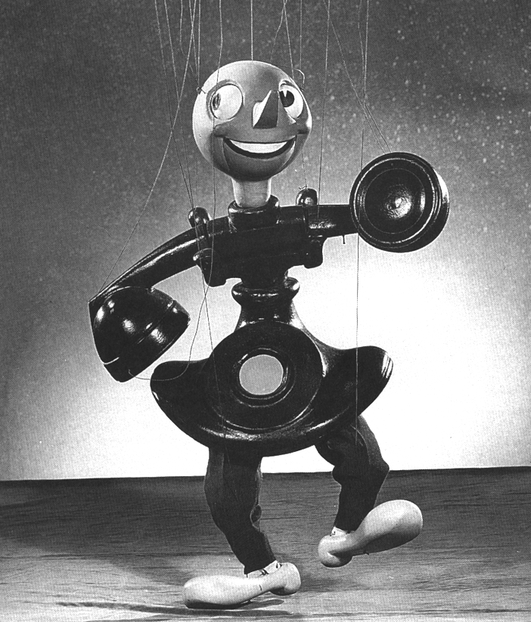
- Marionette
A puppet suspended and controlled by a number of strings held from above by a puppeteer.
- Ticklebug
A four-legged puppet, similar to a hand puppet but created by drawing features on the hand itself. The puppeteer uses the thumb and forefinger as two legs on one side, lifts the middle finger as a head, and uses the ring and little fingers as the opposing legs.
- Muppet
A term referring to some of the puppets constructed by the Jim Henson Company seen on ‘The Muppets’ and ‘Sesame Street’.
- Black light puppet
A kind of puppet that is operated on a stage lit only with "black" lighting which both hides the puppeteer and accentuates the colours of the puppet. This is achieved using ultra-violet (or "black light") and UV-affecting colours. For origin of black light look at Bunraku Puppetry.
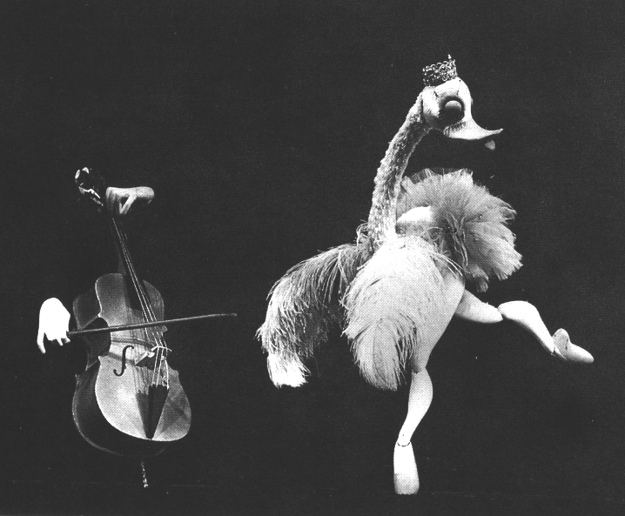
- Light Curtain puppet or "Black Theatre"
Puppetry is performed by puppeteers dressed all in black performing on a stage with a black background. (Most commonly the background and the clothes are made of black velvet). The lighting is specially done so that there is essentially a line on the stage, where on one side there is light and on the other is darkness. The puppeteers push the puppets over the line into the light, while they blend into the black unlit background. Puppets of all sizes and types may be categorized under this umbrella term since this form allows a wide range of puppets, controlled by one or many puppeteers. From a small bee controlled by one puppeteer to a majestic dragon controlled by ten. The original concept of this puppet form is traced to Bunraku Puppetry where the light technique was first used.
- Bunraku
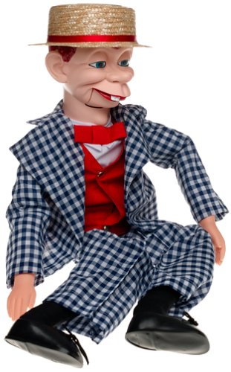
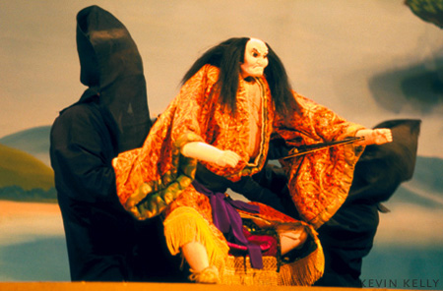
Originally developed in Japan over a thousand years ago, a form of puppetry where puppets are controlled by individuals dressed all in black. Originally, the puppeteers dressed all in clad would become invisible when standing against a black background while the torches illuminated only the wood carved puppets. While the traditional Bunraku theatre is found mostly in Japan, the modern use of the Bunraku would be in black light or light curtain puppet theatre.
- Ventriloquist dummy
A puppet operated by a ventriloquist performer to focus the audience's attention away from the performer's activities and heighten the illusion that the ‘dummy’ is real and speaking for itself.
- Rod puppet
A puppet with articulated joints, similar to a marionette, but operated from below by stiff rods, rather than from above by strings.
- Marotte
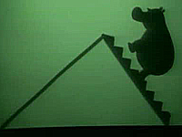
A simplified rod puppet that is just a head and/or body on a stick. In a marotte à main prenante, the puppeteer's other arm emerges from the body (which is just a cloth drape) to act as the puppet's arm.
- Shadow puppet
A 2-dimensional rod puppet that is operated behind a screen. A light source projected from the rear creates a shadow of the puppet on the screen that can be seen by the audience.
- Wayang
The Indonesian archipelago has many rich puppetry traditions.
- Water Puppetry
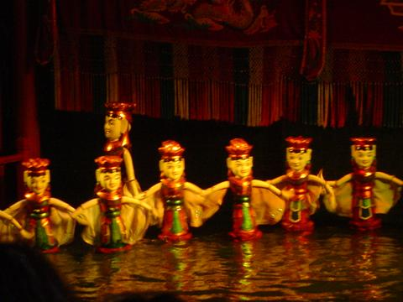
A puppet form almost exclusively done in Vietnam. The puppets are built out of wood and the shows are performed in a waist high pool. A large rod supports the puppet under the water and is used by the puppeteers to control them. The appearance is of various puppets moving over water. The origin of this form dates back seven hundred years when the rice field would flood and the villagers would entertain each other. Eventually villages would compete against each other with their puppet shows. This led puppet societies to be secretive and exclusive, including an initiation ceremony involving drinking rooster blood. Only recently were women allowed to join the puppet troops.
- Human-Arm Puppet
Also called a Two-Man Puppet, is similar to a hand puppet but is larger and requires two puppeteers; one puppeteer places a hand inside the puppet's head and operates its head and mouth; the other puppeteer wears gloves and special sleeves attached to the puppet in order to become the puppet's arms, so that the puppet can perform arbitrary hand gestures.
- BuDaiXi
Chinese puppet show originating in Taiwan, somewhat similar to the Japanese ones with people in the background (or underground) and controlling the puppets. Some very experienced puppeteers can perform them with various stunts (i.e. somersault in the air).
- Digital Puppet
Digitally animated figure that is performed by a puppeteer in real-time using a data input device and rendered by a computer using computer graphics software.
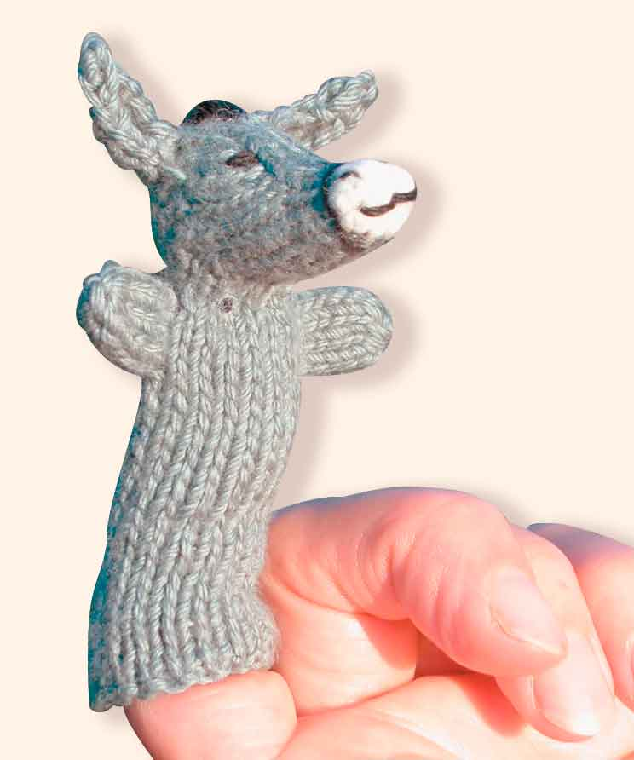
- Finger Puppet
An extremely simple puppet variant that fits onto a single finger. Finger puppets normally have no moving parts and consist primarily of a hollow cylinder shape to cover the finger.
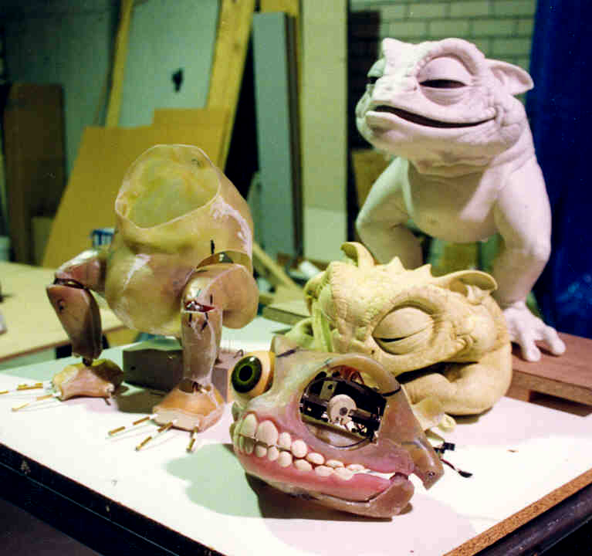
- Animatronic Puppet
A puppet that is controlled by a puppeteer using mechanics and robotics. The main types are servo-driven, pneumatic (air-driven) and hydraulic versions. These are sometimes directly controlled by levers, remotely controlled by cables or radio-controlled.

- Hand Puppet
This is a simple fabric puppet with fixed eyes and an open-and-shut hinged mouth. This sort of puppet is controlled by one hand that occupies the interior of the puppet. Hand puppets place the puppeteer's hand in the puppet's head, controlling the mouth and head, and the puppet's body then hangs over the entire arm. Other parts of the puppet such as the arms are operated by the puppeteer's free hand. The puppet may have strings or levers pulled from inside the head which move eyes, eyelids or similar body parts. A sock puppet is a particularly simple type of hand puppet made from a… you guessed it – sock!

APPENDIX B - 10 Commandments of Hand Puppets
- Control
Open the jaw of the puppet. Don't push forward while talking and don't close the mouth on words when you should be opening the mouth.
- Looking
Make sure the eyes of the puppet are looking at the whole audience and at any other characters they are relating to on stage.
- Talking
Open the mouth wider on long syllables and open it less on short syllables.
- Presence
Keep the puppet solid and upright, as if the puppet has weight and is standing on a stage. Avoid leaning your hand on the puppet theatre; it will make the puppet looked stooped and stunted in movement.
- Consistency
Keep the puppet at the same height. There is illusion involved with puppets that don’t actually have legs. Part of maintaining that illusion is being consistent in the height of the puppet.
- Animation
Give it a human twist. Slight thinking movements and even twisting the head a little while talking can give the puppet much more life.
- Practice
Keep all movements smooth and fluid. This involves practicing to the point where the movements of the puppet feel natural to the puppeteer. This relaxes an audience knowing that the puppet is being performed by someone who knows what they are doing.
- Performance
Know the puppet's personality. The puppet's personality is the aspect that will be most memorable to the audience. If it changes during the performance or next time they see the puppet, the impact of the puppet is weakened.
- Breath
Don't let the puppet die on stage. Whenever the puppet is visible on stage it is (figuratively) "alive". No matter what is happening behind the puppet theatre, keep the puppet ‘breathing’, looking around and performing.
- Unique
Let your puppets do what puppets do best. Puppets are not good for everything. Serious drama or expository preaching might best be left to humans. Being a monster, cute, furry and weird might best be left to puppets!

APPENDIX C - Puppet Temperaments

There are different ways to look at the type of people we are, how we react, make decisions, behave and respond to others - they are called personality tests.
Choleric - (ambitious and leader-like) - People with this temperament tend to be egocentric and extroverted. They may be excitable, impulsive, and restless, with reserves of aggression, energy, and/or passion, and try to instil that in others.
Bible Characters who may have been Choleric are Paul, James, Martha and Titus.
Sanguine (pleasure-seeking and sociable) - People with this temperament tend to be playful, lively, sociable, carefree, talkative, and pleasure-seeking. They may be warm-hearted and optimistic
Bible Characters who may have been Sanguine are King David and Peter
Phlegmatic (relaxed and thoughtful) - People with this temperament may be inward and private, thoughtful, reasonable, calm, patient, caring, and tolerant. They tend to have a rich inner life, seek a quiet, peaceful atmosphere, and be content with themselves. They tend to be steadfast, consistent in their habits, and thus steady and faithful friends
Bible Characters who may have been Phlegmatic are Job, Joseph Timothy Barnabas
Melancholy (analytical and literal) - People with this temperament may appear serious, introverted, cautious or even suspicious. They can become preoccupied with the tragedy and cruelty in the world and are susceptible to depression and moodiness. They may be focused and conscientious.
Bible Characters who may have been Melancholic are Moses, Abraham, Solomon and John.

