Chess Intermediate Pack
  - Disciple making – (Draft Version for Testing)
Each lesson has 4 basic parts:
- Chess experience – a physical activity related to the lesson and play chess on a board
- Life reflection – think about how chess connects to our lives.
- Bible engagement – read the bible, retell it and understand what it is saying to us
- Life application – bring all the lesson elements together and make a commitment

Intermediate Lesson Program
No | Title | Main Idea | Bible
1 | Never Take Any Game for Granted  Page 3 | Every game is an opportunity to improve and learn. God has given us this life, so do something with it to bring Him glory. Don’t waste it. | Hebrews 12: 1 - 3  Run the race, eyes on Jesus the perfector of our faith.
2 | Think Before You Act  Page 5 | Making wise decisions to choose the best moves can affect the outcome of your game of Chess. Likewise, in life, our decisions can affect our life for good or bad. | Proverbs 2:6 – 15  Wisdom comes from God
3 | Be a Problem Solver  Page 7 | Problems and challenges are a part of everyone’s life. How we deal with those problems and come up with solutions can affect our life for good or bad. | Luke 19: 1 – 10  Zacchaeus meets Jesus
4 | Assessing Opportunities  Page 9 | We must assess all the opportunities and work out which is the best move to gain long-term benefit. Learning to assess the best option is an important life skill. | Mark 2: 1 – 12  Jesus heals the paralytic
5 | Mistakes and Disaster  Page 11 | In Chess, there are miscalculations and mistakes some of which can lead to loss of material (pieces) and others to loss of the game. Learning to re-compose yourself after some of these blunders and play again is vital. Failure is not about falling down but STAYING down. | John 18:17-18, 25-27  Peter denies Jesus  Matthew 16:18  Peter is a rock to build the church on that will endure it all.
6 | Never Resign  Page 14 | In Chess, we learn not to give up even when the opposition seems to be winning. We must focus on the ultimate goal. | 2 Corinthians 5: 1 – 5  For now we groan, but we have an eternal home waiting for us.
7 | Sacrifice  Page 16 | In Chess, it is necessary to sacrifice a lower value piece to save a higher value piece. Short-term pain can give long-term gain. Jesus sacrificed His life to save us. His ‘play’ on the cross brought us eternal life. | Philippians 3: 8 – 9a  All is loss in comparison to knowing Christ.
8 | Counter Attacking  Page 18 | The best form of defence is attack but this takes perseverance and commitment to the goal. | Philippians 3: 13 – 14  Press on toward the goal

Intermediate lesson 1

Topic: Do not take the game for granted
Every game is an opportunity to improve and learn no matter whether we win or lose. God has given us this life, so do something with it to bring Him glory. Don’t waste it!

Activity 1: Tell the students to set the Chessboard in turns. Who can set the board correctly in the least amount of time?
- Has anyone ever been under time pressure where you are expected to accomplish something within a limited amount of time?
- Have you ever missed out on anything due to time or being late?
- Who is willing to share that life experience?
- What caused it?

Chess- Experience
Activity 2: Tell the students to stand in a big circle. Scatter chess pieces in the middle so that there are a few more than the number of students. On the command ‘go’, all the students have to run and collect as many pieces as they can. When all the pieces are picked up ask them to stand in a circle again. (Alternative: This could be done with sweets instead of chess pieces).
Ask the students:
- Who got the most pieces? Why?
- Did anyone not get a single piece? What happened? (Did those without any not take the game seriously? Or were you not fast or strong enough or…? What would you do differently next time?)
Play Chess: Play a short game of chess 2 or 3 minutes, with chess clocks available you can even set to play for 1 min in pairs. Most games might be lost on time. Award the winners with sweets.
Afterwards ask the students:
- Ask the winners – what did you learn from the game? (‘very little’ is the likely response)
- Ask the losers – What did you learn from the game? (many things)
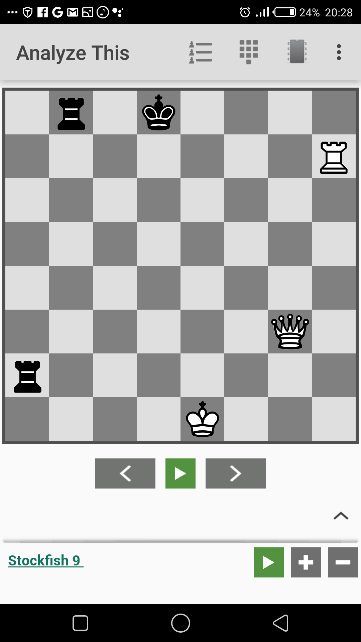
White played Qg7 instead of QxRb8 hence missing an opportunity to win the game.
Black plays Rb1 hence winning the game.
Say: We often learn more when we lose a game rather than win. Remind the students that every opportunity is a chance to learn and grow. That way you are always winning.

Life - Reflection
Ask the students to think about their lives:
- Who missed an opportunity to win or capture a piece?
- Think back to the earlier question: Have you ever missed out on anything due to time or being late? Would you do anything differently now?
- What opportunities have you got in your life right now? (school, business, friends)
- What kind of opportunities have you given up on? Why? (eg. school because it is too hard or too expensive).

Bible - Engagement
Read Hebrews 12:1-3 together. Go on a short run together. This could be a race.
Therefore, since we are surrounded by such a great cloud of witnesses, let us throw off everything that hinders and the sin that so easily entangles. And let us run with perseverance the race marked out for us, fixing our eyes on Jesus, the pioneer and perfecter of faith. For the joy set before him he endured the cross, scorning its shame, and sat down at the right hand of the throne of God. Consider him who endured such opposition from sinners, so that you will not grow weary and lose heart.

Ask the students after reading the passage again:
- What does this passage say that life is like? (a race)
- How is life like a race? (many answers)
- What does the Bible say we must we do to run the race well? (Throw off hindrances and sin, persevere, fix our eyes on Jesus, not grow weary and lose heart).

Life - Application
Say: Life is like a race. Don’t take it for granted, so do you best to run the race marked out for you by God.
Ask the students:
- What parts of your life have you taken for granted?
- Where do you need to throw off hindrances, persevere, fix your eyes on Jesus, not grow weary and lose heart?
Share and pray in pairs, then play chess.

Intermediate lesson 2

Topic: Think before you act

Making wise decisions to choose the best moves will affect the outcome of your chess game. Likewise, in life, our decisions can affect our life for good or bad.

Chess - Experience
Activity: Good and Bad decisions. Students answer a series of questions by running to either side of the playing space depending on their answer. Mark out one side to represent a ‘bad decision’ and the opposite side to represent a ‘good decision’. Start each question by saying ‘Is this is a good or bad decision?’ Sample questions:
1. Cheat in a test at school to get better grades (bad)
2. Be kind to someone who is mean to you (good)
3. Hang with friends rather than complete your homework (bad)
4. Take money from your family without asking (bad)
5. Tell a friend about Jesus and ask them to come along to the chess academy (good)
6. Share what you have to help someone more needy (good)
7. Ignore your friend when they’re sad because you have enough problems of your own (bad)

Option: ask a willing student to come up with their own set of good or bad decision suggestions that the others can answer by running to the ‘good’ or ‘bad’ decision side.

Play Chess:
Set up a game situation on the chessboard and let the students solve it by moving pieces. Ask the students why they have played in the given position.
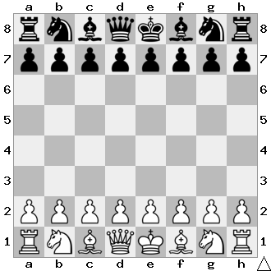
Say: Before the game starts, each player has about 20 different moves or ways he/she can play. The first move, however, begins a spiral into chaos. After both players move, 400 possible board setups exist. After the second pair of turns, there are 197,742 possible games, and after three moves, 121 million.

Life - Reflection
Making a good decision can affect and help you reach your goals and be successful. Making bad or unwise decisions can also affect the outcome of reaching your goals. The consequences of a bad decision may be felt for a long time.

Bible - Engagement
Read Proverbs 2:6-15.
For the Lord gives wisdom;
from his mouth come knowledge and understanding.
⁷ He holds success in store for the upright,
he is a shield to those whose walk is blameless,
⁸ for he guards the course of the just
and protects the way of his faithful ones.
⁹ Then you will understand what is right and just
and fair—every good path.
¹⁰ For wisdom will enter your heart,
and knowledge will be pleasant to your soul.
¹¹ Discretion will protect you,
and understanding will guard you.
¹² Wisdom will save you from the ways of wicked men,
from men whose words are perverse,
¹³ who have left the straight paths
to walk in dark ways,
¹⁴ who delight in doing wrong
and rejoice in the perverseness of evil,
¹⁵ whose paths are crooked
and who are devious in their ways.

Read it together again and together make up body and hand actions for each part to help remember it. Then ask students to work in pairs and to retell the scripture to each other.
Afterwards ask the students:
- What do you need to make good decisions? (Correct information and wisdom)
- What are the good consequences of wisdom in this scripture?
- What are the consequences when wisdom is ignored?

Life - Application

In pairs, if appropriate, share a time when you made a bad (or a good) decision. What happened? What were the consequences? Has it changed the way you act or think now? Pray in pairs for godly wisdom for each other, then play chess.

Intermediate lesson 3

Topic: Be a problem solver
Problems and challenges are a part of everyone’s life. How we deal with those problems and come up with solutions can affect our life for good or bad.

Chess – Experience
Moral dilemma: Create a number of possible moral dilemmas your students might encounter in life, write them down, and place each item folded up in a bowl or bag. Some of the items might include things like, “I saw a good friend shoplifting. What should I do?” or “The shop owner gave me more change than I was due after I bought some beans. What should I do?” Have each student draw an item from the bag one by one, read it aloud, then tell the others their answer on the spot as to how they would handle the situation.

Play Chess: Set up chess puzzles and let each student look for the range of options to find a solution for the best move. Ask them to suggest possible solutions.
Ask the students:
- Did you come up with the best solution straight away? (no)
- What process did you use to find the best solution? (assessed a few options and looked at long-term benefit)

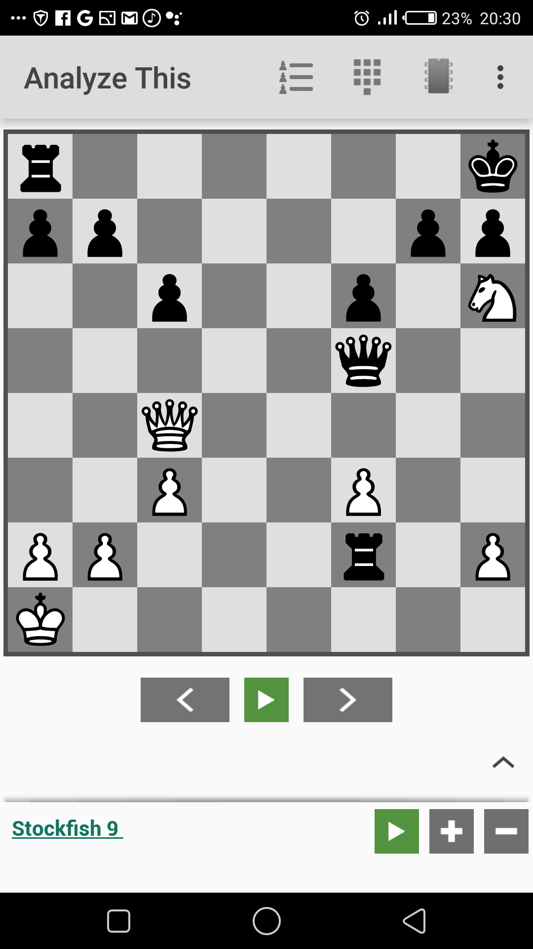

White plays Qg8+ and black plays RxQg8 then Nf7#. White could even capture the Queen on f5 using the Knight on h6 (Nxf5) which is not the best decision.

Life - Reflection
Ask the students:
- What problems have you had to face in life? (many answers)
- Tell us how you were able to solve them. (many answers)
- What would life be like without problems to overcome? (Some might say good – like heaven. Others might say boring – in that overcoming problems makes life interesting and worth living)

Bible - Engagement
Read Luke 19: 1-10 together. (Zacchaeus)
Jesus entered Jericho and was passing through. ² A man was there by the name of Zacchaeus; he was a chief tax collector and was wealthy. ³ He wanted to see who Jesus was, but because he was short he could not see over the crowd. ⁴ So he ran ahead and climbed a sycamore-fig tree to see him, since Jesus was coming that way.
⁵ When Jesus reached the spot, he looked up and said to him, “Zacchaeus, come down immediately. I must stay at your house today.” ⁶ So he came down at once and welcomed him gladly.
⁷ All the people saw this and began to mutter, “He has gone to be the guest of a sinner.”
⁸ But Zacchaeus stood up and said to the Lord, “Look, Lord! Here and now I give half of my possessions to the poor, and if I have cheated anybody out of anything, I will pay back four times the amount.”
⁹ Jesus said to him, “Today salvation has come to this house, because this man, too, is a son of Abraham. ¹⁰ For the Son of Man came to seek and to save the lost.”

Tell the story in your own words and give students different parts to act out as you tell the story again. One student acts as Jesus. The shortest student acts as Zacchaeus. The taller students as the other people.
Ask the students:
- What was Zacchaeus’ biggest problem? (He was hated in his own community and he was short)
- How were these problems solved? (He climbed a tree. He gave back money he had stolen.)
- How did Jesus treat Zacchaeus? What was the result? (He showed acceptance of him, wanting to spend time with Zacchaeus. The meeting with Zacchaeus changed his whole life –repentance and redemption.)
Life - Application
In all life’s situations faced there is always a potential good solution.
Discuss some of the challenges that the students are facing.
Ask the students:
- What challenges are you facing right now?
- What solutions have you considered?
- What makes one solution better than another?
If possible show the students how to make a chart listing the positives and negatives of a solution to a problem. Divide a piece of paper in half. Think about a solution to a problem you have. On one side of the paper write the positive consequences of that solution and on the other side the negative consequences. Then compare the two lists to help you decide whether the solution is the best one to solve the problem.

Students share in pairs any problem they may be dealing with and ask God for wisdom in finding the best solution. Then play chess.

Intermediate Lesson 4

Topic: Assessing Opportunities
We must assess all the opportunities and work out which is the best move to get long-term benefit.

Chess - Experience
Activity: The students stand in a circle shoulder to shoulder. One stands on the outside and must find a way to get to the middle of the circle. They will need to search for creative opportunities. (They could get the help of friends to help carry them over the top for example. Get them to think of as many ways as they can).
Ask the students:
- What ways can you see to get to the middle?
- What is the best option and why?

Play Chess: Set up the chess board so that one piece has a variety of opportunities to capture other pieces.
Ask the students:
- How many pieces can be captured from this position?
- Of all the captures available, which one is the best?
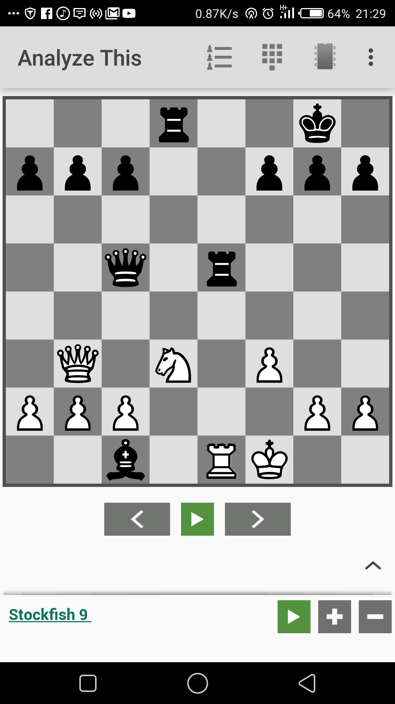

White’s knight has three options to capture Re5, Bc1 and Qc5 but the best option is to capture the queen.

Life - Reflection
Analyze with them on how to make the best use of the opportunities given to them.
- What sorts of opportunities do we get in life?
- Give them a variety of examples of opportunities in their lives (eg. going to school, stealing money to buy food, working for money, hanging out with lazy friends, playing sport).
- Which one is the best of all? Why? (It has the best long-term result)

Bible - Engagement
Read Mark 2: 1-12 - Jesus heals the paralytic
A few days later, when Jesus again entered Capernaum, the people heard that he had come home. ² They gathered in such large numbers that there was no room left, not even outside the door, and he preached the word to them. ³ Some men came, bringing to him a paralyzed man, carried by four of them. ⁴ Since they could not get him to Jesus because of the crowd, they made an opening in the roof above Jesus by digging through it and then lowered the mat the man was lying on. ⁵ When Jesus saw their faith, he said to the paralyzed man, “Son, your sins are forgiven.”
⁶ Now some teachers of the law were sitting there, thinking to themselves, ⁷ “Why does this fellow talk like that? He’s blaspheming! Who can forgive sins but God alone?”
⁸ Immediately Jesus knew in his spirit that this was what they were thinking in their hearts, and he said to them, “Why are you thinking these things? ⁹ Which is easier: to say to this paralyzed man, ‘Your sins are forgiven,’ or to say, ‘Get up, take your mat and walk’? ¹⁰ But I want you to know that the Son of Man has authority on earth to forgive sins.” So he said to the man, ¹¹ “I tell you, get up, take your mat and go home.” ¹² He got up, took his mat and walked out in full view of them all. This amazed everyone and they praised God, saying, “We have never seen anything like this!”

Tell the Bible story using the chess pieces as characters.
After telling the story, ask students to retell the story to each other using chess pieces.
Then ask the students:
- What did you like about this story?
- What was the goal of the friends? (to put their paralysed friend in front of Jesus)
- The friends looked at all the options and decided on a very creative solution. What did they do? (They lowered him on a mat through the roof)
- What did Jesus do for this man? (Forgave and healed him)

Life – Application
Life gives us many opportunities. We need wisdom to know which opportunities to follow. We need to think of the option with the best long-term benefit. Knowing Jesus personally is the best reward.
Ask the students:
- What have you learned today?
- What opportunities do you have to make a decision about today?
- Is there a friend you could help who is facing challenges?

Share and pray about what was discussed (above) in pairs, then play chess.

Intermediate Lesson 5

Topic: Mistakes and disasters
In Chess, there are miscalculations and mistakes some of which can lead to loss of material (pieces) and others to loss of the game. Learning to re-compose yourself after some of these blunders and play again is vital. Failure is not about falling down but STAYING down.

Chess - Experience
Activity: Demonstrate to the students, using either the chess board or mark out a board on the ground outside and use the students as the chess pieces - how you can checkmate a lone white king using only two black Bishops in opposite colors and a king.

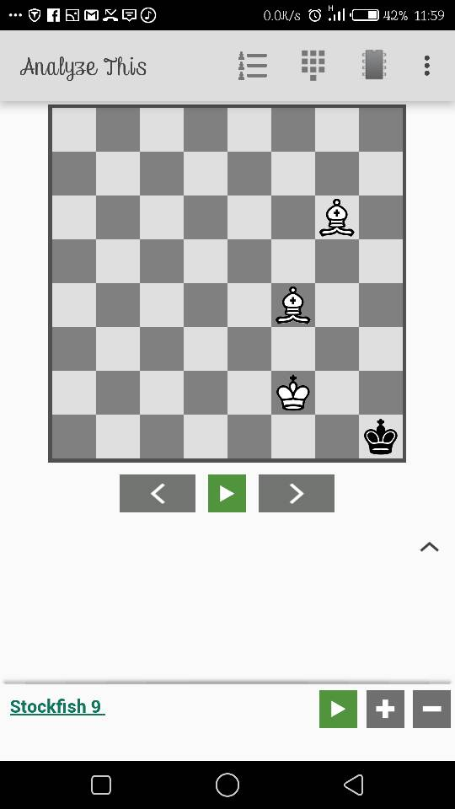

Be4 is the white’s move to deliver a checkmate.

Play Chess: Explain the chess input. A tactical play requires proper calculation and knowing the move order. Chess is regarded to be 99% tactics, but it takes time to master tactics.
Many times, you can try to execute a tactic and end up losing material or even the game itself. They therefore require diligence and precision. The ability to press on and stay focused eventually leads to the masterly level.

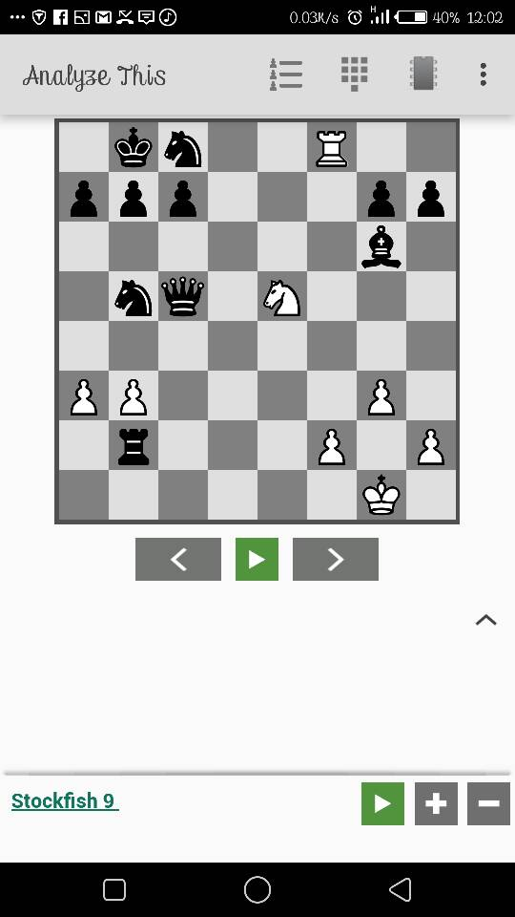

White played Nd7+ and black had one option Ka8, white played Nxc5, this makes white win a Queen but makes a mistake of missing a checkmate of Rxc8#

Life - Reflection
- Have you ever made a mistake that put you in an uncomfortable situation or made you lose an opportunity?
- Explain the situation if you are willing to share with us?
- What did you learn from that experience?

Bible – Engagement

Read Luke 15: 11 - 32 – The Two Sons
¹¹ Jesus also told them another story:
Once a man had two sons. ¹² The younger son said to his father, “Give me my share of the property.” So the father divided his property between his two sons.
¹³ Not long after that, the younger son packed up everything he owned and left for a foreign country, where he wasted all his money in wild living. ¹⁴ He had spent everything, when a bad famine spread through that whole land. Soon he had nothing to eat.
¹⁵ He went to work for a man in that country, and the man sent him out to take care of his pigs. ¹⁶ He would have been glad to eat what the pigs were eating, but no one gave him a thing.
¹⁷ Finally, he came to his senses and said, “My father’s workers have plenty to eat, and here I am, starving to death! ¹⁸ I will go to my father and say to him, ‘Father, I have sinned against God in heaven and against you. ¹⁹ I am no longer good enough to be called your son. Treat me like one of your workers.’”
²⁰ The younger son got up and started back to his father. But when he was still a long way off, his father saw him and felt sorry for him. He ran to his son and hugged and kissed him.
²¹ The son said, “Father, I have sinned against God in heaven and against you. I am no longer good enough to be called your son.”
²² But his father said to the servants, “Hurry and bring the best clothes and put them on him. Give him a ring for his finger and sandals for his feet. ²³ Get the best calf and prepare it, so we can eat and celebrate. ²⁴ This son of mine was dead, but has now come back to life. He was lost and has now been found.” And they began to celebrate.
²⁵ The older son had been out in the field. But when he came near the house, he heard the music and dancing. ²⁶ So he called one of the servants over and asked, “What’s going on here?”
²⁷ The servant answered, “Your brother has come home safe and sound, and your father ordered us to kill the best calf.” ²⁸ The older brother got so angry that he would not even go into the house.
His father came out and begged him to go in. ²⁹ But he said to his father, “For years I have worked for you like a slave and have always obeyed you. But you have never even given me a little goat, so that I could give a dinner for my friends. ³⁰ This other son of yours wasted your money on prostitutes. And now that he has come home, you ordered the best calf to be killed for a feast.”
³¹ His father replied, “My son, you are always with me, and everything I have is yours. ³² But we should be glad and celebrate! Your brother was dead, but he is now alive. He was lost and has now been found.”

Tell the Bible story using the chess pieces as characters.
After telling the story, ask students to retell the story to each other using chess pieces.
Then ask the students:

- What are the people in our story?
- What did the younger son do?
- What happened to the younger son later?
- What did the father do on his son’s return?
- What do you learn from the story?

Life – Application
There are many times we do wrong, perhaps to our friends, siblings, parents and other people. And at times wrong is done to us.
But in the story we have seen a son doing wrong to his father. What if you are the father (wronged person)? What we have seen is that the father forgave his son and even made a feast. This shows that when we are wronged, we should forgive others and come to peace with them. And when you have wronged someone else, you must realise your mess, and seek forgiveness just like the young son in our story.

- What do we do to those who do wrong to us and to those we wrong?
- What are you going to change from today onwards?

Pray for each other and play chess.

Intermediate Lesson 6

Topic: Never Resign
In Chess, we learn not to give up even when the opposition seems to be winning. We must focus on the ultimate goal.

Chess – Experience
Activity: Invite the students to share with you a little about their life at home.
Play Chess: Set up the chess board in a position where the king is in check (see diagram). The learner will naturally resign and think it is a checkmate. The teacher corrects the student.

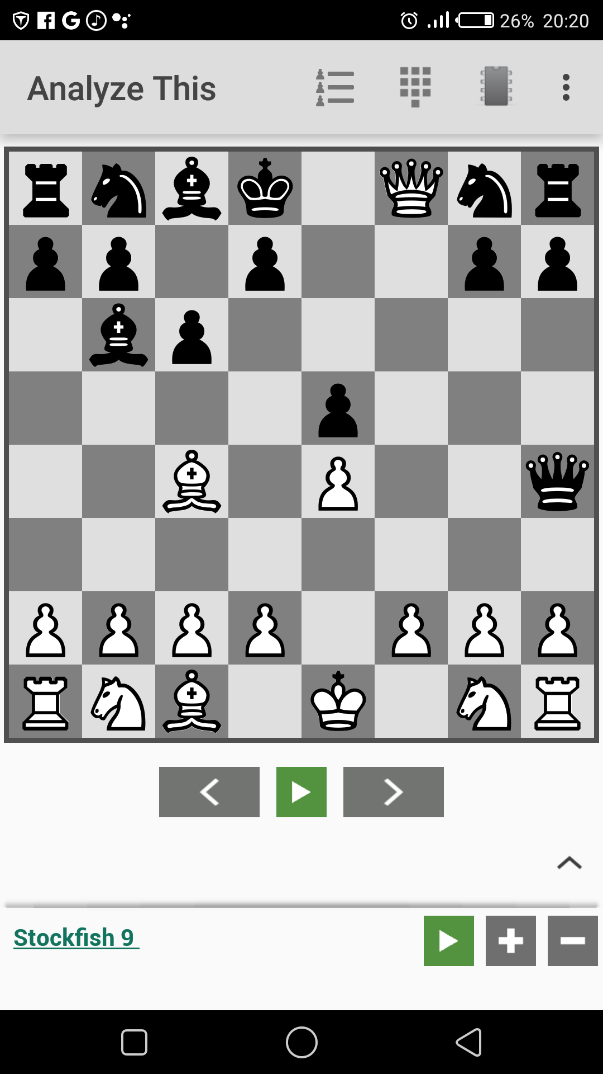

Black plays Kc7 instead of resigning that the king has no free or safe square to go to like e8 and e7 but he or she has a safe square on c7.

Ask the students:
- Why do you resign so easily? What else can you do?

Say: Look around and see, there might be better moves. Focus. Concentrate and find the move. (Allow them to make the next move).
You will be happy when you have found a good move. Show how you can be happy (smile, high five, laugh, thumbs up). Ask him/her to show different ways to show you they are happy. Stretch students to show you many ways. This will be fun.

Life - Reflection
- Have you ever found yourself in life where you thought you had lost? (lost money or failed a test).
- How did you feel? Show me with your face expressions.
- How did you overcome this?

Bible
Read 2 Corinthians 5:1 – 5 together. This was written in the Bible by Paul.
For we know that if the earthly tent we live in is destroyed, we have a building from God, an eternal house in heaven, not built by human hands. ² Meanwhile we groan, longing to be clothed instead with our heavenly dwelling, ³ because when we are clothed, we will not be found naked. ⁴ For while we are in this tent, we groan and are burdened, because we do not wish to be unclothed but to be clothed instead with our heavenly dwelling, so that what is mortal may be swallowed up by life. ⁵ Now the one who has fashioned us for this very purpose is God, who has given us the Spirit as a deposit, guaranteeing what is to come.

Ask the students:
- When Paul talks about an earthly tent, what is he talking about? (our bodies)
- What is life like in this body? (hard, difficult, burdensome)
- What do we long for?
- How do we trust this will happen? (the Holy spirit helps us now as a deposit for what will come)
We learn not to give up and to put situations in this life in the right perspective. Heaven is our ultimate goal.

Application
Discuss with the students:
- What are the challenges in your life right now?
- From this lesson, what are you going to do about them?
- How will you make sure you don’t give up?

Share and pray in pairs, then play chess.

Intermediate Lesson 7

Topic: Sacrifice
In chess, it is necessary to sacrifice a lower value piece to save a higher value piece. Short-term pain can give long-term gain. Jesus sacrificed His life to save us. His ‘play’ on the cross brought us eternal life.

Chess - Experience:
Activity – Give each person a sweet or coin. Now show them 3 small boxes. Explain that they can sacrifice their coin for what is in one of the boxes. Ask who wants to swap. (In one box put something much better than the coin. In the other two boxes put things that are worthless.
Afterwards ask:
- How did you feel when your sacrifice was worthwhile?
- How did you feel when you lost your coin for nothing?

Play Chess: Position the pieces so that a Rook is captured, which is a forced move for the opponent to capture whereby if it is not captured it is a check mate. When the rook gets taken it will be a checkmate in the next move. (Include a diagram of the board layout)

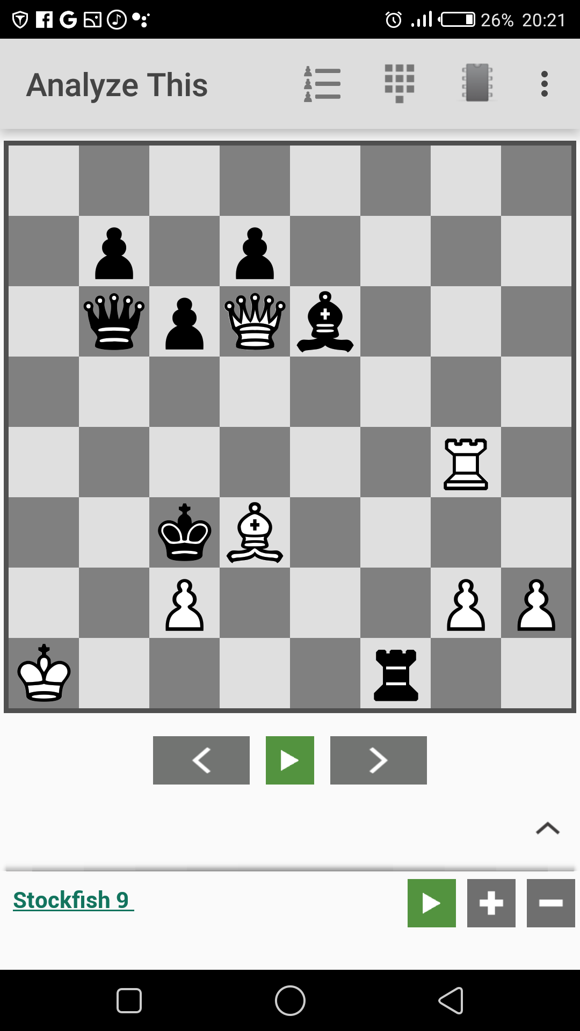

White plays BxRf1 and black checkmates on b2 by playing Qb2#.

Remember:
- Checkmate is the goal or dream in the game of chess.
- The Rook sacrifice is reasonable to attain the goal of attacking the King in checkmate. A player always has to look for pieces they are willing to sacrifice to gain the ultimate goal.
Ask the students:
- Why did you sacrifice your piece?
- How did you feel when you achieved a checkmate?

Life - Reflection
Ask the students:
- What kinds of sacrifice have you seen people make in your community?
- What was the cost?
- Why do you think they were willing to make this sacrifice?
- What sacrifices have you made in your life?

For example, think of a student who is committed to finishing school and university. The student decides not to go ‘clubbing’ or drinking with friends or waste time watching TV. They sacrifice small fun things to attain a better outcome in the long-term. Temporary happiness is the sacrifice.

Bible – Engagement
Read Philippians 3:8-9a together. In this passage, Paul talks about his life and what is the most important thing to focus on.

What is more, I consider everything a loss because of the surpassing worth of knowing Christ Jesus my Lord, for whose sake I have lost all things. I consider them garbage, that I may gain Christ ⁹ and be found in him…

After reading the verse ask a student to knock over all the pieces and wipe them to the side of the board to just leave the King and a pawn.

Ask the students:
- What does Paul consider to be the most important thing in life? (knowing Jesus)
- How does he think about the rest of life in comparison to knowing Jesus? (garbage)
- What is the most important thing in your life? (be honest)

Life - Application
Ask the students to draw or write all the things they love to do and the things they value.
Ask the students:
- What will you sacrifice in life to achieve your ultimate goal?
- Jesus sacrificed His life to save you. What is your response to his love and sacrifice to save you?

Share and pray in pairs, then play chess.

Intermediate Lesson 8

Topic: Counter Attacking
Counter Attacking literally means an attack made in response to an attack by the opponents. The best form of defence is attack but this takes perseverance and commitment to the goal. However, it can be difficult to counter attack when the game already seems lost.

Chess - Experience
Activity: Take the students outside and stand in pairs side on. Ask one to push against the other. The other can push back. Have fun trying to push each other off balance (keep it fun, not violent). Swap over who will push first.
Ask the students:
- Did you enjoy the activity? Why or why not?
- How did you respond when your partner first pushed you?
- What determined how hard you pushed back?

Play Chess: Set up the chess board as if it is part way through a game. Your pieces are in an attacking position. The opposition is in a weak position.

Ask the student to make the next move. What move do they respond with?

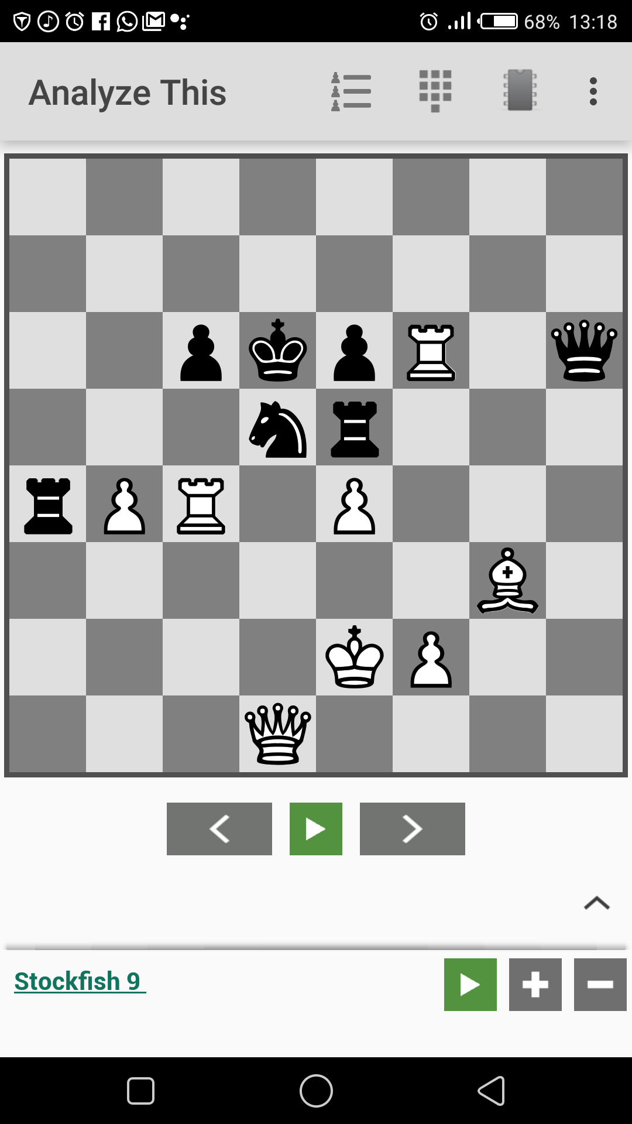

You can see that black’s knight is attacked by a pawn and the queen, the rook on e5 is pinned but with all those problems he or she can get a draw.
Black plays Ra2+, white plays Rc2-RxRc2, QxRc2-QxRf6 and black can merge out with a draw.

After the student responds, ask the reasons as to why they have made such a response. (Does the move show they are giving up and feel they are already beaten?)

Life - Reflection
Ask the students:
- What is the worst thing that you could imagine happening to you, besides dying?
- How would you react to this? (Give up or fight?) For example, how would you respond if you discovered you have HIV/Aids?
- Why is it often easier to give up than to fight?
When we are faced with a difficult situation in chess or in life it is easy to give up. This is natural for humans.
- What things are you tempted to give up on? Make a list.

Bible - Engagement
Read Philippians 3: 13-14 together
¹³ Brothers and sisters, I do not consider myself yet to have taken hold of it. But one thing I do: Forgetting what is behind and straining toward what is ahead, ¹⁴ I press on toward the goal to win the prize for which God has called me heavenward in Christ Jesus.

Ask the students:
- What does Paul say to do with disappointments and failures? (Forget them)
- What does Paul focus on? (the goal, the prize – life forever with Jesus)
- What does Paul finally do? (press on)
- In your life, what do you need to focus most on when things get difficult?

Life - Application
Ask the students:
- What are you thinking of giving up because it is too difficult?
- Make a plan to identify the ultimate goal in your life, and counter attack so that you will keep fighting and may succeed.

Share and pray in pairs, then play chess.

