Start Up Manual
V6.0

Steps to starting your own KidsHubTV
Shooting with Professional Cameras by professionals
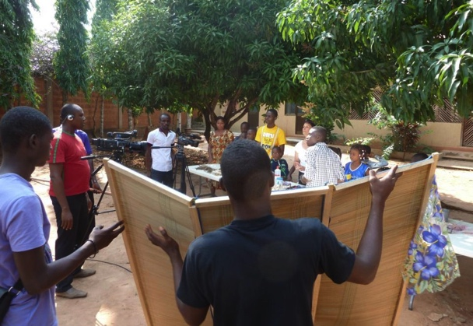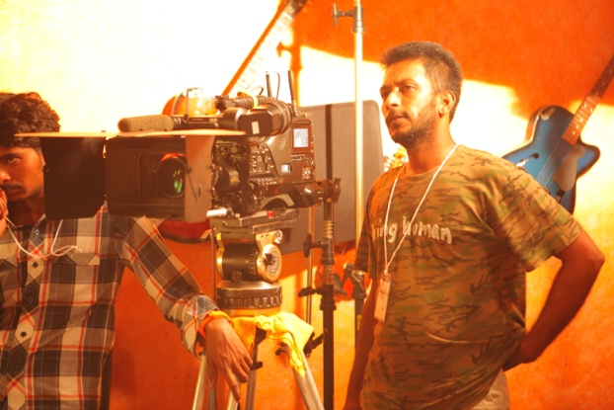
Togo India
Shooting with Semi- Professional Cameras by Semi - Professionals
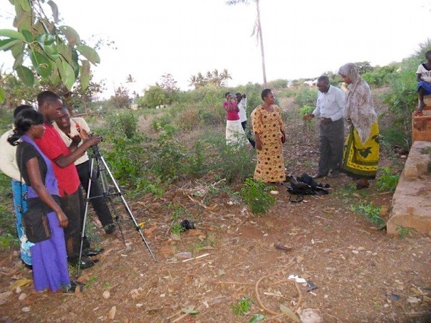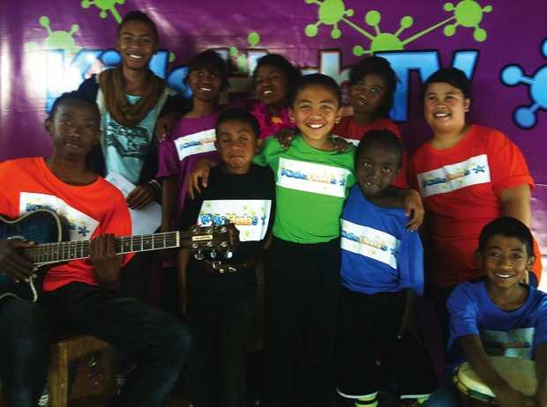
Tanzania Madagascar
Shooting with basic cameras by Children
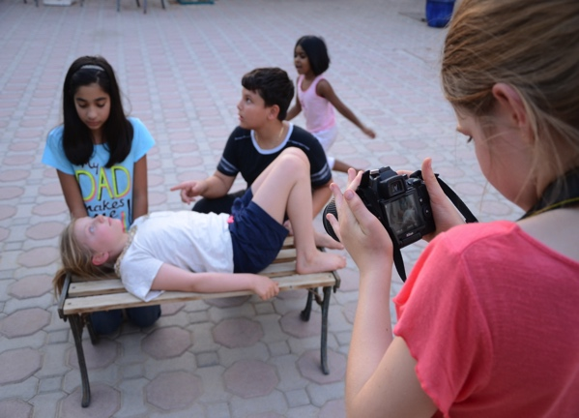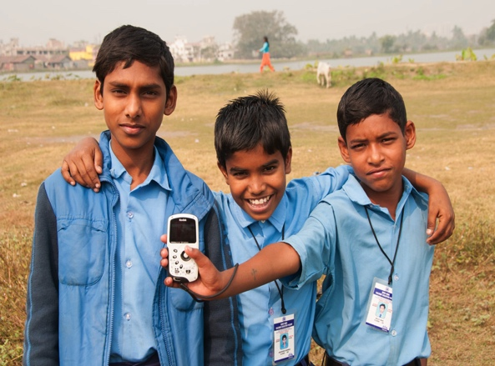
Middle East India

KidsHub TV is a collection of segments put together around a biblical theme and re-enforced with life skills, arts & crafts and sports for example and everyday events in a child’s life and in the community. It is not owned by anyone but is created by children in some countries and by professionals in others and shared freely globally with the intention to influence leaders and children and encourage them to reach out to their peers.

What You Will Need
Equipment to be purchased or hired:

- 1 x low end professional camera (xdcam, Sony HXR-MC50E, Canon 5D DSLR, etc.)
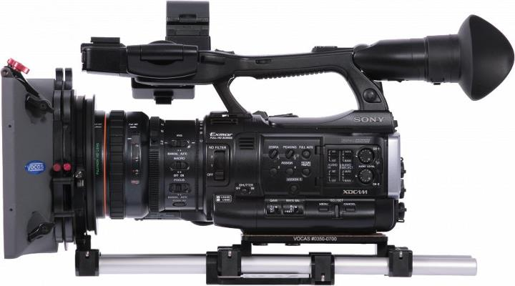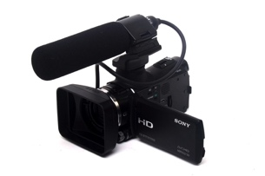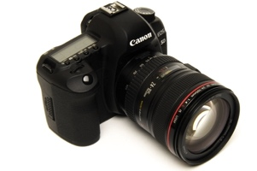
Low-end budget Camera (easy for children - Canon Vixia HF R400)
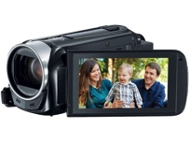
- Tripod
( Check for leg locks, three way heads, less leg sections, carbon- fibre material, height)
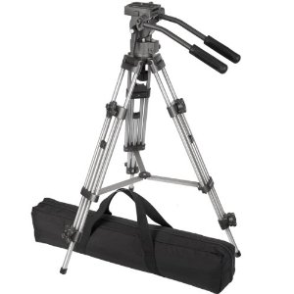

- 1 x boom microphone (or lapel mics, shot gun, portable recorder [for DSLR])
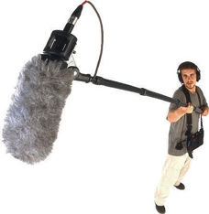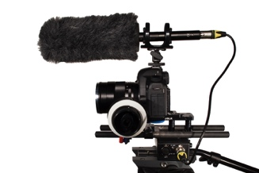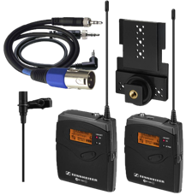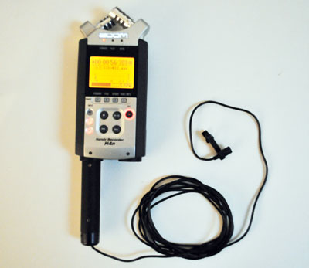

- 3 point light kit (or halogen, LED, sun gun, cool lights or shoot with natural sunlight) 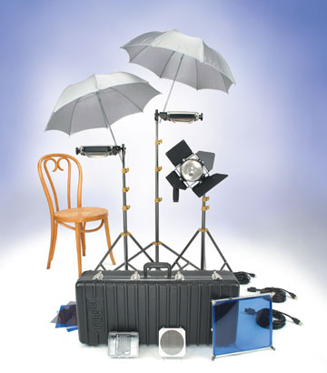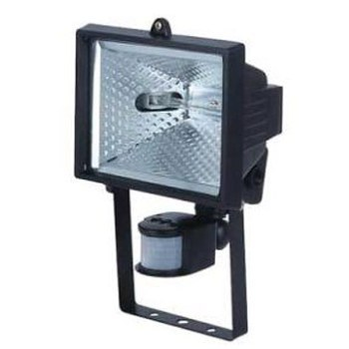 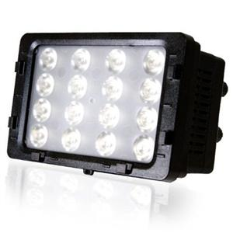
- Reflectors (or 1 x piece of foam board [or similar] to act as a light reflector)
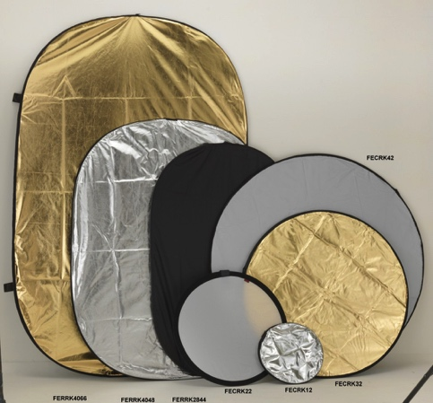
- 1 x computer for editing (with editing software)
Save project files so you can use to make corrections anytime. Label all your episodes and files properly so you can find them easily.
- Storage: Hard disk drives, tapes, DVD, Pen Drive, A-Frame (cloud).
Note: Save multiple formats of each episode.
Use Hard disk drives or tapes to save your library masters. Make a DVD master to replicate.
Remember to save mix and unmixed versions. Mix versions can be used to transfer into any format i.e. for website, DVD or broadcast. Unmix versions will help you to take the video and audio into the edit system and separate the dialogue tracks so you can insert any language dubs, i.e. different language voices.

Logistics:
- Location (studio with professional sets or any outdoor or big hall with set elements or real locations like factory, sports field, park, zoo, exhibitions, schools etc. relevant to your segment and theme or any quiet and spacious place.)
- Costume (either buy or ask the cast to bring their own clothes and accessories)
- Properties (tools and equipment needed for the theme of the episode and set properties to fill the background and foreground of your location.)
- Vehicles (public transport or car or any vehicle to pick up cast and crew)
- Permissions (acquire no objection letters from parents especially from non-professional cast and permissions for locations and for use of any copyright materials like songs, art work, statements, bible version etc.)
- Weather – check the weather especially if you are shooting outdoors or under roofs that would make noise.
- Holidays and Political or public events – be advised of holidays and political events or public events that can either help your shoot or cause problems to you.

*Personnel:
- Script Writer (could also be production assistant)
- Director (could also be script writer, production coordinator, producer)
- Camera operator
- Sound person (if using boom mic)
- Editor (could also be director, camera operator, editor)
- Production Coordinator (could also be the producer)
- Cast (age group of 9 to 19 with skills and good camera presence. Select children from churches, kids groups, theatre, film professionals)
*Children and youth should be involved as much as possible in all aspects of the production. Initially they could be trained alongside an adult with the view to handing over the role to them in the future. Children can be involved in both brainstorming and scripting episodes. Their ideas and suggestions are key to the show’s success. Initially children could be given the responsibility to interview and film other children for the KidSpeak and GodSpeak segments for example. Others could be given the responsibility to edit these segments. The uniqueness of KidsHubTV lies in the children’s involvement in all aspects of the production including but not limited to being members of the cast. The KidsHub Video Making 10 lesson curriculum (download at www.kidshubs.com) can be used to train children and youth in the basics.
Your crew could consist of several people fulfilling various roles of production or your crew could even be a minimum of 3 people i.e. director, camera operator, coordinator or assistant (translator if needed).

Finances:
- Approach Christian channels for a free broadcast. They may sometimes provide the equipment as well.
- Form partnerships for broadcast by approaching like-minded businesses to advertise during the TV show for example.
- Approach national and local broadcasters. They may be willing to air your show for free or at a reduced cost. If you are presenting a quality product that could attract advertising and gives local children ‘a voice’.
- Broadcast as video on demand on satellite dish TVs or VOD websites. This will generate income.
- Create 1 – 3 pilot episodes or segments to show to potential broadcasters.
These can also be uploaded to the website/Vimeo/Youtube for viewing.
- Show the pilot episode/s or segments to groups of children. Document their ages, gender and ask them to answer a simple survey (or interview and record their responses) about their thoughts on the show: what they liked best; their favourite segment and why; what they learnt; if they would like to be part of a KidsHub group etc. Use the results of the ‘test audience’ to help sell the potential of the show to broadcasters.
- If finances are a constraint try to shoot short segments first and later tie those segments with relevant content from the global pool of KidsHubTV video materials.

Current Resources Available
- KidsHubTV Segment and Opening titles with music.
- Bible Story Animations (see www.kidshubtv.com or www.max7.org)
- Transitions (video transitions that can be used to cut or transition between different segments in the show).
- 13 Scripts of the India TV show; 5 simplified scripts based on the Indian episodes (used in Nepal & Togo). More are being written.
- 13 Episode Synopsis (1 page summary of each of the 13 episodes of the Indian TV version).
- 13 KidsHub lessons for use in children’s ministry in conjunction with the 13 Episode KidsHubTV series.
- Transcripts (Hindi - 13 Episodes of the India TV show)
- Translations (Hindi to English, of the 13 India KHTV Hindi episodes)
- Translations of India KHTV English segments.

How can you use KidsHubTV?
- For broadcast on National & Local TV networks
- On a website
- As 2 minute or under 5 minute segments broadcast on cell phones via YouTube, Vimeo, NetFlix, Yahoo! Screen, Daily Motion, Hulu, Vube, LiveLeak, Twitch, MetaCafe, UStream, Break, viewster, TV.com, Crackle or social networks like Facebook, MixIt and Tumblr or similar
- As under 1 minute segment broadcast on cell phones via Klip, Viddy, Social Cam, Glmps, Vimessa and Captimo or similar
- As video on demand on various satellite dish networks and websites
- Create DVDs or USB thumb drives and circulate amongst churches, schools and children’s ministry groups
- Screenings in villages, schools, churches and any outreach
- Radio version

How many days does it take to shoot an episode?
It takes about 2 days to shoot one episode – depending on the show format.
If you shoot the segments all in one place or different locations in the one area it can be done in 1 -2 days. However if you want to travel to different villages or locations it will take longer: 2 -3 days per episode.

Note: The post production i.e. editing, music etc. will depend on you and your editor, typically 2 days to a week per episode.

What are the possible formats?
The 24 minute KHTV: (Regular Episode)
Drama Version: (India) each episode follows a dramatic story. There is usually a problem or issue the cast (children in the KidsHub group with their 2 leaders) have to solve. The leaders bring in the Bible story to help them resolve the issue and teach the children. This version is a simulation of a real KidsHub. For examples of English episodes see:
The Man Who Forgot God - https://vimeo.com/143247306
The Lost Sheep - https://vimeo.com/143247311

Anchor Version: (Togo, Madagascar and Nepal) anchor based version where 1 or 2 youth or a group present the Bible message for the episode and introduce the different segments hosted by children in the cast (and some also filmed by them). Each segment is linked to the Bible message for that episode. Each segment can be hosted by 1 or more children from the cast.

The 2- 5 minute KHTV: (Shorter Episode)
Segment version – This version showcases the unique aspects of for example your country or what your KidsHub group is doing or anything that is interesting in your community. It could be about animals, art & craft, sports, games, life skills, children’s views, children’s issues, achievements, Christian news, events, parables, testimonies, stories of your community, stories of individuals, food, nature, drama, painting, music, singing, Bible stories etc.

Segment version with anchors – This version is similar to the segment version except that there would be either one or two anchors who will start and end the episode and maybe even share a brief message related to the theme of the segment and tie it up with a biblical principle.

What’s the right version for my context?
Look at what resources you have, what unique activities you or your ministry is involved in and the issues or topics you would like to address and make segments.

Look at the India English segments to get some ideas of segments that are social, entertaining, skill based and biblical.

Read an episode script from both the Indian ‘drama version’ and the corresponding Togo/Nepal ‘anchor version’ to decide which will work for your context.

Budget too plays an important factor in choosing the format of your show. Drama versions may require more time and money than the anchor versions and segment versions.

Can anyone create their own version of KHTV?
KHTV is an expression of children and their KidsHub groups from different parts of the world. We believe that each kids group or KidsHub has the potential to create a video that is very unique to them. These segments can be shared locally but also globally via the KidsHubTV website. There is the potential for a KidsHub to include video segments made by other KidsHubs around the world in their own unique TV show. This will make each version of KidsHubTV both interesting locally and globally while engaging children from all over the world.

Several people from a region can create their own version of KHTV. Madagascar KHTV named their show as KidsHubs Kelimahefa (The name of their organisation), you too can have a unique add-on name to the existing KidsHubs or KidsHub TV title to differentiate yourself from the other KHTV in your region.

Steps for Drama Version (Regular Episode)
- Brainstorm and write the format for the show: number of cast and the skills you want each child to focus on; location of the drama; ‘Lifeskill’ segment (eg. relationships/health & hygiene/social/education) & ‘Let’s Do it’ segment (eg. sport/cooking/craft/art/music/dance/science/IT etc) ideas for your context.
- Identify cast - send out information to different churches & casting agencies and set a casting date, location & time. Audition children: set up a camera; start the audition filming each child holding sheet with their name then ask them to perform (a song/dance/drama/speech). Give them direction to change their performance slightly or act out a scenario to see if they can take direction. Ask them what their skills are. Take notes & contact details for each child.
- Start developing characters for the script once you have selected your cast based on their skills & personalities. Plan the Bible message and topics for each episode. See 13 episode scripts for ideas or create your own.
- Brainstorm segment ideas: using the current ones or write your own.
- Think about composing a song for each episode. Try to pre-record the song prior to the shoot and lip synch on camera or record it professionally and match the lip synch of the actor singing on camera in the audio studio during audio sweetening.
- Once the Bible message & topics are set, decide which character to focus on in each episode. (Focus on 1 character per episode). Then look at all 13 episodes in a series and how you will develop each character over the 13 episodes.
- Write /adapt scripts. (Start with the 13 episode scripts currently available).
- Shoot the episodes, edit, make library masters and broadcast.
- Transcribe all your edited final versions of the episodes so you have all the dialogue written up. This will be useful when/if you have to translate and dub into other languages.
- Write scene-wise synopsis of each episode and also a brief summary of each episode. Most broadcast channels will require this.
- Plan for follow-up: how will you get in touch with the children/audience if they want to talk to somebody? Partner with local children’s ministries or KidsHubs. Encourage children’s ministries to use the corresponding KidsHubTV lessons available (www.kidshubs.com or www.max7.org). Do you have access to follow up material you could hand out or send out as advertised on the show? Competitions to involve kids in the show?
- Should you choose to do multiple languages, you could shoot both the languages simultaneously with the same actors or schedule both the languages separately. You could also choose to do a longer KHTV version in one language and a shorter KHTV version in another language. For example in India the longer KHTV version is in Hindi and the shorter KHTV version is in English, both done by same actors.

Steps for Anchor Version
- Audition 2 – 4 people (2 young adults/youth, 2 children).
Children can anchor or host segments (and can also film their own after KidsHub media training).
Adults can anchor main show/Bible message but youth are preferred. The idea is for the children to reach out to their peers.
- Write scripts or adapt the existing simplified scripts available (character development not needed).
- Work out how to shoot the segments. Plan your locations, secure permissions to shoot in public areas, check the availability of guests on the show, buy the properties/items, organise the costumes etc. relevant to the theme or segment.
- Think about composing a song for each episode. Try to pre-record the song prior to the shoot and lip synch on camera or record it professionally and match the lip synch of the actor singing on camera in the audio studio during audio sweetening.
- And/or use skills of people around you to come up with segment ideas.

Steps for Shorter Version
- Audition 2 – 4 people (who are creative, lively and spontaneous on camera) for anchoring. Children can host or anchor segments (and can also film their own after KidsHub media training).
- Identify talented children who can be part of the crew to run camera, edit etc.; train and equip them to handle pre-production, production and post production.
- Identify topics based on the resources available and also those that are easily accessible. Research well, and/or use skills of people around you to come up with segment ideas.
- You can create segments about your traditions; festivals; a day in the life of a child (shoot a series of individual children from different backgrounds and talents); animals; insects; plants; how to recycle products; organic products; gardening; learning English; learning how to use computers; swimming; puppetry; memory verse drama of bible stories skits on various topics; painting; art & crafts; music; singing; travel; places; dresses; hair styles; food; family traditions; songs; archery or any sports; science projects; testimonies; success stories; quotes etc..
- Write your own scripts or adapt the existing global segment scripts (character development not needed).
- Work out how to shoot the segments. Plan your locations, secure permissions to shoot in public areas, check the availability of guests on the show, buy the properties/items, organise the costumes etc. relevant to the theme or segment.
- If your segments are songs-based then think about composing a song on the topic being covered. Try to pre-record the song prior to the shoot and lip synch on camera or record it professionally and match the lip synch of the actor singing on camera in the audio studio during audio sweetening. Try to do some fast songs with actions.
- You can use relevant graphics and titles of KHTV used in other versions if you want otherwise create your own graphics besides the main KHTV logo.

Steps for Shorter Version with anchor
The steps are similar to the shorter version, the difference is that the anchor or host would introduce the topic at the beginning and close reiterating significant elements from the episode and tying it with a Bible principle or value.

Steps to Create a Non- Fiction Video/Documentary

Know your audience
Who is your audience? What age group? What are their areas of interest? What are the difficulties they face that need to be answered?

Identify your topic
What is your topic? What is the main focus/idea of that topic? What do you want to convey to the audience? Do you have enough information on this topic? How do you want to convey it? Is there a thread or a consistent theme through out the segment?

Research
Research, read, make notes, watch videos, get hands-on experience and talk to people who know more about your topic.

Pre-Production
Planning before you shoot is very important and this preparation is called pre-production. Here are some questions you need to ask - What visual material do you need to tell your story? Can you obtain footage from someone who has already shot it? Do you need to shoot those visuals? Make a list of permissions you need to get. Schedule days of shoot. Check the appropriate time to shoot your video e.g. when is the best season to shoot an animal segment? Where is the best place to shoot it? What kind of tools do you need to shoot these segments? Is there any special effects or properties you need to tell your story? Who should your crew be? Do you need specialists to assist you in the relevant topic? Who will be on camera? Do you need to interview anybody? Did you talk to them and get their appointment for shoot? Plan what your actors/ subjects should wear on camera. Make your shot list or storyboard your script.

Scripting
Collect all your information and organize your thoughts. Create a simple outline of the story. Create a storyboard if you can or write down your thoughts to make an interesting story.
Sample Script
Segment Title |  | Lion |  | Programme | KHTV South Africa
Skill/ Element |  | Education/animals |  | Shot Date
Director/Producer |  |  |  | Edited Date
Artists |  |  |  | Language | English
Location |  | South Africa |  | Duration | 2 mins.
Description/ Synopsis of the segment |  | Exploring the characteristics of lions in South Africa and Biblical symbolism of lions.
Music | VIDEO |  | AUDIO |  | Remarks
Jungle Beats | Short clip from the film or picture drawn by a child.  General shots of lions in the wild |  | VO 1 (Voice Over)  ‘Simba’ from the film ‘Lion King’ is an immortalized character of a lion. This is a favorite story for the young and old. Indeed the lion is the called the King of Jungle. They are fierce, majestic, protective, strong, tactical, strategic and strong leaders. They are also social and can be contained.
 | Photos or videos of brown and white lions |  | VO 2  Europe, Asia, Middle East and Africa have the most number of lions in the world. They are protected species. It is common to find brown lions in these areas but white lions are native to South Africa.
 | Shots of Kruger National Park and lions. |  | VO 3  Kruger National Park is the biggest animal reserve in South Africa. It houses about 1600 lions.  Lions prefer living in open forests, it helps them to hunt and be close to their prey without being seen. They live in groups called a Pride. Either a male or a female take control over the Pride. The female does most of the hunting and raising the cubs. The male protect their territories.
 | Shots of lions hunting at night if possible or use shots of them sleeping or eating.  You can show all the animals or them just eating one species. |  | VO 4  Lions hunt at night and sleep during the day. They can sleep up to 18 hours a day. They hunt once in 4 days. They eat up to 7 kgs of meat a day.  They hunt animals like ostrich, quelea nestlings, tortoise, small crocodiles, buffalo, giraffe, zebra, wildebeest, porcupine and warthog.  The male lion weighs about 225kg and a female about 150 kg. They can live up to 15 years.
 | Shot of Bible maybe an illustrated one or a painting of Jesus - lion, Satan – lion  Use text Rev 5:5 |  | VO 5  Besides the story book Lion King, the lion is one of the favourite animals and symbols in the Bible. Jesus Christ is called the Lion of Judah and Satan is called the Roaring Lion.  Jesus symbolizes controlled, majestic power while Satan is depicted as a roaring lion looking to attack.
 | Use shots of children’s drawings of lions, Bible stories with lions, Jesus etc. and them drawing, looking at the Bible etc. |  | Interview/MOT  Elaborate more about the characteristics of Jesus and the lion and talk about being fearless and having victory.

Production
This is the stage where you will shoot and execute everything you have planned in your script and in your shot list.
Capture your shots, make sure your lighting is good, your audio is good and check if you shot everything you planned. Be ready for unexpected situations and go with your instincts.
This process can take 1-2 days depending on your project. If it is something that needs to be shot in various stages then your project will need to be shot at different times.

Post - Production
Post – production is where you finalise and complete your project. It can take about 2-3 days to many days depending on your project.
This is where you capture your footage i.e. all that you have filmed, all the photos, videos or images that you have collected via internet or people or different resources and then edit it. There are different editing software you can choose from depending on your computer and your budget to buy the program. Windows Movie Maker and iMovie come as part of your operating system. Final Cut Pro, AVID, Premier, Sony Vegas etc. are some of the other editing software you can purchase and use.
If your video requires voice over or narration, then this is the time to add it, so it will be easy to lay the footage over the recorded voiceover.
Add music
Make sure you have permission/copyrights for everything you use. Your video cannot be used globally if there are copyright issues.
Save your end product in various versions, always make two copies – one for library and one for duplication into DVDs etc.

Sharing your segments globally
You can upload your segments (when signed in as a ‘Producer’) to the KidsHubTV website. You can also email, FTP, courier or upload your segments in high resolution onto Vimeo or YouTube and share it with the global team.

KidsHubs Supporting Media

KidsHubsTV Website
The KidsHubTV website (www.kidshubtv.com) is aimed at children so they can watch Bible animations and related videos. Separate segments of interest (cricket tips, craft & art, science, IT & Media for example) can also be viewed and are linked to the Bible videos. Most of these segments are produced by KidsHubTV shows in different countries. In addition there is a sign up for Producer’s interested in creating their own KidsHubTV show and/or segments. Corresponding discipleship ideas and Bible curriciulum lessons are available for download to use in a local KidsHub group via a direct link to www.kidshubs.com. Information on how to start a KidsHub in a local church is also available for download from the site.

Your Agreement: Key Principles for KidsHubTV
If you decide to create your own KidsHubTV show (whether that be for distribution via broadcast, DVD or the web) you will need to agree that the resources specifically labelled “KidsHubTV” will not be used for any other program or to make a profit (other than what can be used to continue making and promoting the TV show). The following principles would also need to be agreed to:
- KidsHubTV is open source to encourage producers anywhere to create their own local version of the TV show.
- It is understood that in return producers would share content where applicable to be used in the KidsHub TV show produced in other countries.
- The TV show and it’s producers would always honour Christ and encourage the value & worth of children in God’s eyes and therefore in the world’s eyes.
- A producer would be free to use all the resources available to create the TV show with the understanding that they agree with the show’s theological basis. (See the statement of belief in the Lausanne Covenant http://www.lausanne.org/en/documents/lausanne-covenant.html)

Our Agreement with you:
- Initially we would like to be involved helping you in the pilot stage of your KidsHubTV show where possible (and if wanted). This will help us keep the global format relatively consistent and means that shows in different countries can more easily share video content/segments if they have a similar look and feel.
- We can then give creative input as needed (via email & skype).
- We would love to receive copies of segments or videos, interviews and testimonies of how children have been involved and/or been affected by KidsHubTV.
- After helping you initially we would then not be involved in the production but would value feedback on how you are going.

Kidshubtv.com
kidshubs.com

