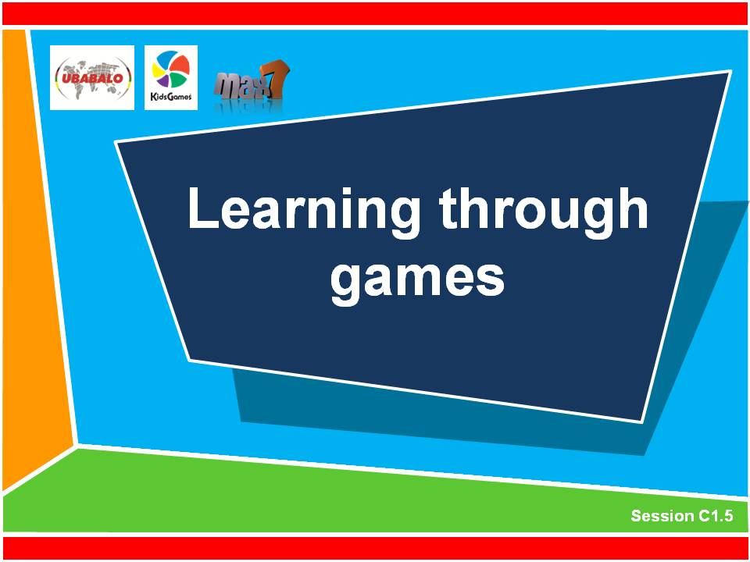
C1.5

Learning through games

90-120 minutes

Outcomes
At the end of this session participants will be able to:
Understand the elements of experiential learning
Prepare and modify a game to explore a Biblical message
Know practical skills in explaining, running and debriefing an experiential game

STEPS IN THE LESSON

This module will explore the things that we do to make our relationship with Jesus live and grow in our lives. It includes these elements:

Powerpoint slides (Slide 91 & following) for this session can be found by typing ‘cycas foundational training’ into the search bar at www.max7.org
Demonstrate experiential games 30 min
3 types of games 5 min
What is the experiential learning process 15 min
How to run an experiential game 15 min
Design an experiential game 25 min
Debrief 20 min

what you will need
Blindfolds
Short ropes for caterpillar game

Learning through games

session outline
- Demonstrate experiential learning games 30 min
Go outside or into a large area and play some experiential games with the group. The games you choose will be dependent on 3 things. The size of the group, the space and equipment you have, and the types of games you have already played in the training event. It is probably best not to repeat games you have already done.
Choose 2 or 3 games from the following list and demonstrate them to the group. Go through the entire experiential learning process so that you are modeling good practice to the group. They will learn so much more from seeing experiential games demonstrated well than by hearing you just explain how they should work. The games can be played in any order.
Experiential games to choose from:
    - Clumps
Experience it!
Ask the big group to gather in an area. Tell them you are going to call out a number between 2 and 9. They need to gather in groups of that number as quickly as they can. If they cannot join a group then they must stand at the side.
Reflection
After playing for a few minutes ask the big group to come together to talk. Ask the following questions to get them thinking about the game.
- Who enjoyed the game?
- Who didn’t enjoy the game? Why not?
- How did you feel when you were excluded from a group and the rest of the game?
- How do you feel when you belong? How do you feel when you don’t?
- How do you behave when you don’t feel you belong to a group?
Message
Read this scripture and discuss together. Ephesians 4:1-6, or John 15:12-17
Application
- What impresses you about this scripture?
- How can we help children and young people belong in our groups?
- Is there a way we can change the game to make it better for belonging? (If you have time play the game again with this change)
    - Caterpillar
Experience it!
Ask the participants to divide into groups of about 8 people. Each team stands in a line and each person puts his or her hands on the shoulder of the person in front. The person at the back of the line is given a ‘tail’, a short length of rope or material. It can be tucked into their belt so it hangs down like a tail. On ‘GO’ the teams have to move around. The front person has to try and grab the tail of the back person on another team. Each team must work together so that they do not break the link and protect the tail. If they break their link or lose their tail they lose the game. The last team with their tail wins. Play two or three rounds of the game.
Reflection
After playing for a few minutes ask the big group to come together to talk. Ask the following questions to get them thinking about the game.
- Who enjoyed the game?
- Who was the most important person in the team? (Front, back or middle)
Most groups will realize that everyone is as important to the team as anyone else.
Message
Read this scripture and discuss together. 1 Corinthians 12:12-20
- How is this game like the Bible message we just read?
Application
- What different roles are there in the leadership of your group?
- How do we honor everyone in his or her roles?
    - The noisy obstacle course
Experience it!
Ask the participants to spread out around the room. They need to make themselves into a human obstacle course with their bodies. Ask for 2 volunteers. One is blindfolded and is given only spoken instructions by the other to get through the obstacle course to get to an object at the other side (eg a ball). Everyone in the room must remain silent as the blindfolded person is guided through the room.
Reflection
After playing for a few minutes or when the object has been found, ask these questions:
- Who enjoyed the game?
- How is this like leading and making young disciples?
- How could we change the game so it is more like real life?
Play the game again with the same volunteers. This time the group is allowed to make a noise, call out and even give incorrect directions. The person giving directions has to stand in one spot and cannot move. At the end ask the two volunteers these questions:
- What was most difficult for each of you?
- How did you cope in the game?
- How is this like youth work?
Message
Read this scripture and discuss together. John 10:14-16
Application
- How can we help children and young people listen to God’s voice?
- How can you listen more closely to God’s voice?
- What is your responsibility as a leader of children and youth?
    - 4. Pass on a drawing
Experience it!
Ask the participants to get into groups of 10 and form a line. A simple drawing is shown to the back person of each group. (example: triangle, star, cloud) On ‘GO’, the back person in each line has to draw the correct shape on the back of the person in front with their finger. They may draw it twice only. Then that person draws it on the back of the person in front of them, and so on. The first group to pass on the correct shape to the front of the line is the winner.
Reflection
After playing it for the first time ask the group these questions:
- Where did the message stop and change in the line? Why?
- Do you think the message was very complicated?
- How could you do it better?
Play the game again and pass on a different shape.
Message
Read this Scripture passage and discuss together. Proverbs 3:1-4
Application
- What has this Scripture got to do with the experiential game?
- How can we faithfully write God’s message on the hearts of our children and young people?
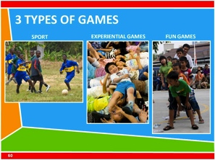
- Three types of Sports and Games 5 min
    - Explain the types of Games in CYCAS
In CYCAS (and particularly in GCG) there are three types of games:
Fun Games | Played purely for fun
Experiential Games  and activities | Games with a learning point
Regular Sport | Games like Football, Basketball, Athletics, Rugby, etc.
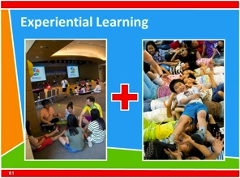
There are games just for fun. There are experiential games that help children and young people learn an important lesson, and then there are sports such as football and basketball. They are all games. However we play them and use them quite differently with children and young people.
In this session we have played the 2nd type of game – the Experiential Games or games that can teach a message.

- What is the experiential learning process? 15 min
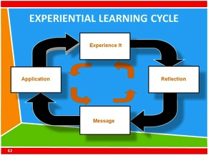
    - Explain the experiential learning process
Look at the PPT slide of the experiential learning process. Explain each step to the group.
Experience it! | Children and young people have fun and are challenged by participating in the game.
Reflection | With questions children and young people are invited to think about the game and what happened to different people in the game.
Message | Open the Bible together and read a relevant truth from God’s word.
Application | Discuss how this Bible truth applies to our lives. Use reflections from the experience of the game to add to the discussion.
- How to run an experiential game 15 min
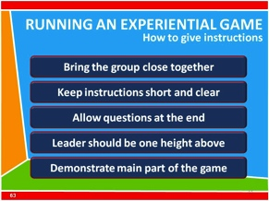
    - Explain how to give instructions
- Bring the group close together and ask them to sit down before you give instructions.
- Keep the instructions short and clear.
- Do not let children or teenagers or leaders speak while you are explaining the game.
- Allow children to ask questions at the end.
- The leader giving the instructions should be one height above the eye level of the children or young people. If they are sitting on the ground you can sit on a seat or stand. If they have to stand up for any reason then the leader should stand on a chair or on a step.
- Demonstrate the main part of the game so everyone will understand. Practice the game for a minute or two and then stop the game to clarify any instructions. Then keep playing.
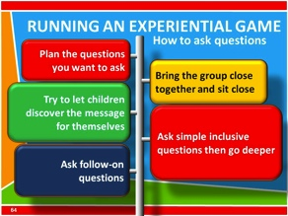
    - How to use questions in the reflection and application times
- Bring the group together and sit close. Leaders can be at the same height as the children or young people. This will invite sharing and discussion.
- Plan the questions you want to ask. Think of the direction you want the questions to follow to bring out the message you want to highlight from the game.
- Ask simple inclusive questions first and then go deeper. For example, first ask whether they enjoyed the game.
- Try to let children or young people discover the message for themselves.
- Ask follow-on questions. For example, when a child answers a question, ask another question to get them to think deeper about the topic.

- Design an experiential game (Option 1)
Divide the group into groups of 4 people. Each small group is given one of the following Bible verses. Each group is given 5 minutes to read the bible passage and then to discuss what is really the important theme or teaching point from the verses.
Verse suggestions
Romans 5: 6-8 (Salvation)
Luke 15: 8-10 (Parable of the lost coin)
Luke 6: 46-49 (The wise and foolish builders)
Luke 6: 27-31 (Love your enemies)
Galatians 2:20 (Living for God)

The groups are then given 15 minutes to design a game that will help teach this main idea. The group can use a game they already know, or modify a game to get the point across better. They can even make up an entirely new game. Follow the process of the experiential learning model to prepare to lead the game with the whole group. Plan how to explain the game, some reflection questions and application ideas.
After 15 minutes, ask each group to come back together and lead the games for the whole group. All the steps of the Experiential Learning Cycle should be done; experience it, reflection, message and application.

- Design an experiential game (Option 2) 20 min
Divide the participants into two equal groups. Each group is given a basic game to use and develop. The group must turn the game into an experiential game by modifying the game and by creating discussion questions to help bring about understanding of the message and application of the lesson.
After 15 minutes, ask the group to come back together and lead the games for another group. All the steps of the Experiential Learning Cycle should be done; experience it, reflection, message and application.
    - GAME 1 - ‘Stuck in the mud’
One person is chosen as ‘Chaser’. The Chaser’s role is to chase and tag as many children as possible. When a child is tagged they are ‘stuck in the mud.’ They have to stop, stand with their feet apart and wait to be freed.
Any untagged person can release another. They need to crawl through the legs of the person who is to release them. While a person is freeing someone else they cannot be tagged.
    - GAME 2 - ‘Rob the nest’
4 volunteers are chosen from the group. They are the runners. A square with sides of about 5 meters is created and at each corner a small circle with a diameter of 50cm is drawn. Each of the runners is allocated a corner circle as their base. 10 shoes (or any other similar objects) are put into the centre of the square. On ‘GO’, the runners have to run to the centre and pick up one shoe at a time and place it into their own corner circle. They keep running to the centre to collect the shoes until all of them have gone. Then they are allowed to ‘rob the nest of the other runners. They can only carry one shoe at a time and they must place it in their corner. They cannot stop anyone from robbing from their nest. The game is won when one of the runners has got 4 shoes in their corner.
    - Other game options
- Relay
- Pizza plate relay
- The puzzle-collaborative game
- Crows and cranes
- Pairs link arms
- Debrief 25 min
Allow each group to run the game for the others. Make sure the whole process of experiential learning is followed; Experience it, reflection, message and application. At the end of the whole session ask the participants to think about what they have learned. Discuss the usefulness of experiential games and how you would use them in a group.

END SESSION

