video media sessions 1-10
Video Manual
Book 1 - Version 3

KidsHubs is a free global program that helps reach out to and disciple children and young people. It can be used as part of an existing program or group, in a church, a school, a camp or to start a new group in your community. KidsHubs is about helping children learn how to follow Jesus from the Bible at the same time as learning a new skill for life. It is a great way to get adults and teenagers interacting with children and helping disciple them. KidsHubs can be based around just about anything – sport, media, photography, drama, cooking, farming, chess, music and so much more. KidsHubs is not an organization, but a free idea and a movement. Whatever you develop, share it back with KidsHubs by uploading to www.kidshubs.com and through the Max7 open source ministry website www.max7.org. Doing a KidsHub requires that all Hub leaders have absolute integrity and be able to serve and protect children at all times. Keep it fun, active and safe learning environment for all. Children will learn that Jesus and the Bible are about every part of their life.
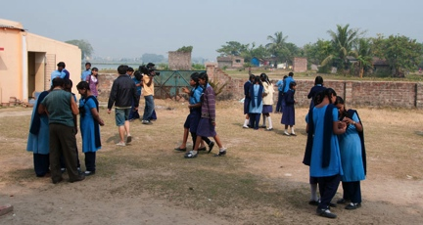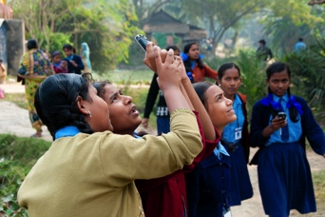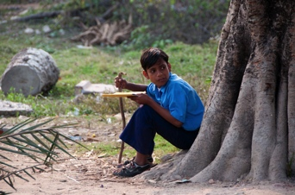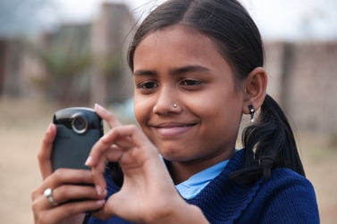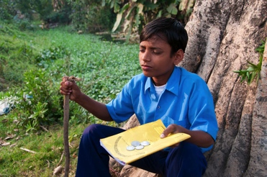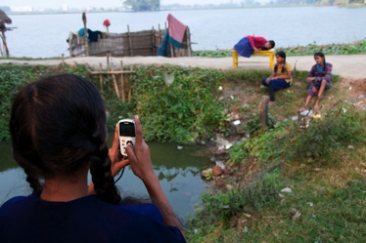

WHERE DID THIS KIDSHUB VIDEO MEDIA MANUAL COME FROM?
This manual has come from the Kolkata, India KidsHub where it was first done with 44 children from a poor part of the city. The video media training was a week-long camp with the group continuing to learn after the camp was finished in a KidsHub in their school. This manual contains the program used with these children and can be adapted to your situation. In Kolkata, not one child had even held a camera before the KidsHub started. By the 4th day they were filming complete short Bible stories by themselves. The results are astounding and can be seen by searching ‘Kolkata’ or viewing the ‘KidsHubs around the world’ channel on www.kidshubtv.com.
In the Kolkata model the children were split into 14 groups of 3-4 children, each with a camera. They used small Kodak “Playsports” cameras, although Flip, Sony Bloggie or even a smart-phone video camera can work.
It is important to label the cameras so that each group knows which camera belongs to their group - to avoid confusion.
For the week-long version of this video training program, there was not enough time to teach the children to edit the videos. The KidsHub leaders edited these each evening. If your KidsHub is spread over many weeks, the children themselves can do this using simple editing software such as iMovie or Windows Movie Maker or other software designed for video editing.
Be enthusiastic. The lessons are designed to be simple to teach regardless of how much knowledge of the media the leaders possess.

Overview of the Video Sessions
No | SESSION TITLE | PAGE
1 | Framing and Timing | 5
2 | How to use a Camera | 10
3 | Composition and The Rule of Thirds | 17
4 | Lighting | 22
5 | Project #1 (The Parable of the Lost Coin) | 25
6 | Project #2a (Storyboarding) | 29
7 | What is Editing? | 33
8 | Sound | 36
9 | Project #2b (Filming and Acting) | 39
10 | Showcase | 41
Each of these lessons are set out for you to be able to lead, even if you don’t know much about video production. Read through each lesson before you teach the children. Try filming the different activity/exercises yourself. You can download the video examples mentioned at www.kidshubtv.com or www.max7.org

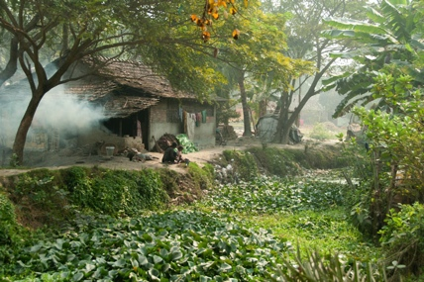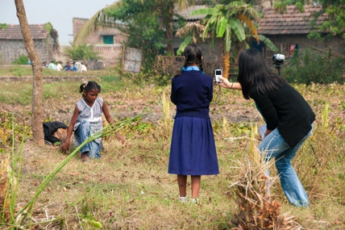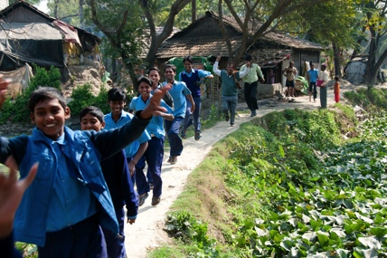

the lesson outline
Each KidsHubs lesson uses these elements, not necessarily in the same order each lesson:
Activate Imagination | A fun and engaging activity to set up the lesson, build excitement for what will be taught and impart some simple skills that may be used later in the lesson.
Communicate the Bible | A time to explore how what is being taught in video skills relates to what we discover in the Bible.
Explore the media | A time to teach the video skills for this lesson.
Apply skills | A time to give the children practical “hands on” experience of the lesson being taught.
Review | The final part of the lesson to go over what has been taught to help the children remember it for next time.

Glossary of terms used in this manual
Camera Operator | The person that operates a film or video camera for the purpose of recording a production to film.
Character | 1. A person represented in a drama, story, etc.  2. A part or role, as in a play or film.
Composition | The visual arrangement of objects, actors and space within the frame.
Director | The person in charge of deciding the overall camera coverage and the camera movements, and who guides the actors’ performance in the making of a production.
Frame | 1. The frame is what the camera records. Like a picture frame, the video camera records a rectangular image. Anything outside the frame is not recorded.  2. “To Frame” means to use the camera to set up a shot with a particular composition of visual elements
Footage | Is an old film word to describe the amount of film material shot and exposed when it was measured in feet. In video it is often used to describe the video filmed – as in “let’s look at the footage together on the screen.”
Headroom | The space on the screen between the top of the subject’s head and the top of the frame.
Leadroom | The space in front of a subject, for them to lead (walk) into. Example; a person is on a bike left of screen, the right of screen is the leadroom for them to ride into.
Shot | A unit of action filmed without interruption from a single camera. Shots are the building blocks of a story. Each shot is filmed and then edited together one after another to create a story.
Storyboard | A series of drawings that shows on paper what the camera needs to film to build up the story. It is like a blue print for the whole story.
Subject | The main person, animal or object that you are filming in any shot.
Timing | The length of time it takes to capture a shot. Most shots are quite short.

Lesson 1

Framing, shots and timing
Running time: 60-90 minutes
Bible Passage AND MESSAGE
Matthew 18:10-14 - When God looks he sees even a small lost sheep that needs rescuing. And Luke 15: 3-7
Main Ideas
- FRAME - By the end of this lesson the children will understand about considering what is in the camera frame.
- SHOTS – They will understand that a video is made up of ‘shots’ or short pieces of video put together to form a larger story.
- TIMING - The children will understand that shots are short amounts of time.
Preparation
- Familiarize yourself with the lesson content before the children arrive.
- Download “The Lost Sheep” from www.max7.org
Equipment needed:
Camera, Diagram, Projector or TV Monitor (to view footage), Computer, Workbook and Pencil (one for each child) Chalkboard (to draw diagrams), download appropriate videos for this lesson, stopwatch, cardboard frames (optional).

Lesson 1 outline

Activate Imagination 15 mins

Welcome children – FUN ACTIVITIES 5 mins
ACTIVITY 1  Choose a warm-up/fun activity from the Appendix (at the back of this manual) to welcome children. This will help the children get to know each other. You could play a fun game/ energizer. E.g. People to people game. | ACTIVITY 2 – COUNT THE FOOD  Tell the children you brought in a bag of sweets or candies or fruit and that there should be about enough for everyone. Beforehand make sure there is one sweet less than there are children. Ask one child to count all the children while another child counts all the sweets. Now ask them to give their answers. Ask the group these questions:  - Is there a problem? (Yes but only one is missing.)  - What can we do?  Tell the group that we will have to solve it later.

ACTION WORDS – “ACTION” and “CUT” 1 min
In many lessons we will teach an ‘Action Word’. These are fun activities that can teach a concept as well as helping you get everyone quiet and make it fun. Teach the children the words and the actions that go with them:
When you yell ‘ACTION’ the children can run around, jump, talk, dance or whatever they want. When you yell ‘CUT’ they must stop and be quiet. Make it fun and try it 2-3 times until the children get the idea.

THE FramE GAME (FRAMES, SHOTS AND TIMING) 6 mins
This activity is to help them understand framing and learning to see what the camera ‘sees’. Ask the children to stand in two lines opposite one another about 2 meters (7 feet) apart. Ask them to hold up their hands (thumb to 1st finger of both hands to create a frame) in front of them to make the shape of a rectangle. Explain that this is their ‘frame’. It is like a picture frame on the wall and it is also like what a camera can “see” when you use a camera. Ask them to look through the ‘frame’ to the person opposite.
PART 1: The children in each line take it in turns – one line to be the ‘actors’ and the other are ‘camera operator’. The camera operator makes their ‘frame’ with their hands while the actor opposite to them makes a fun pose. (E.g. smile, laugh, sad face or pull a silly face) Keep swapping roles every minute or less.
EXPLAIN: That what you see through your fingers is like what the camera “sees” when you video. You need to practice with your fingers to see what is INSIDE and what is OUTSIDE the frame. Check that the children understand that the part the camera sees is called THE FRAME.
PART 2: Encourage the children to move their frame (fingers) further or closer to their eyes to change the framing of the picture. Ask them what they notice about what appears in the frame when the fingers are close to the eyes (see more things) or further way (see less things).

Kids Speak 4 mins
Sit the children in a group close to you. Ask the children these questions to begin a discussion. Also tell them about the first time you used a camera and what that has meant for you.
- Who has ever held a camera before? (OR When did you last use a camera?)
- What did you enjoy about using a camera?
- What do people use cameras for?

Communicate the Bible 20 mins

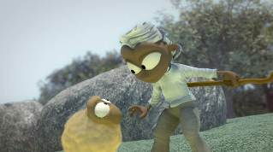
WATCH a video 3 mins
Show a short video that has a series of scenes, plus
includes wide, medium and close up shots. A good
video to use is The Parable of The Lost Sheep pictured here.
(Download from www.kidshubtv.com or www.max7.org)

ACTIVITY – ACT IT OUT (optional - 5 mins)
If you have a long session, you could involve the children in acting out the various parts of the story in a few minutes to help them understand what happens in the story and play the roles of the Shepherd, the 99 sheep and lost sheep.

Discussion (Luke 15:3-7) 7 mins
Sit with the children and discuss these questions about the Bible Story from Luke 15:3-7. Have the Bible open so that the children see that the video story came from the Bible. If you have Bibles for the children ask them to have them open.
READ Luke 15:3-7 together.
- What did you like about this Bible story?
- What was surprising about the story?
- What would you have done if you were the shepherd?
- Would you be satisfied with 99 sheep and not worry about losing one?
Explain that Jesus told this story because some leaders (called Pharisees and Religious Teachers) thought Jesus was mixing with normal people and street people. They thought someone like Jesus should only mix with good and important people! Jesus told this story to show that God is interested in everyone, no matter how small or unimportant they might look. To God they are very important.
- If the Shepherd is like God, as Jesus explains, what does this story tell us about God?
- Do you think you are most like the 99 sheep safe in the pen or like the sheep out in the forest and lost?
Jesus wants to find all the lost sheep. A few pages along in the Bible after this story, Jesus said in Luke 19:10, that he came “to seek and save the lost”. Jesus loves and cares about you.
- Give the children an option to talk to someone further about this if they would like to.

Explore the media 25-30 mins

Activity: PUT IT TOGETHER 12 mins
This activity will teach the children about the very basics of how a video story is put together.
Explain to the children that we will use this video story to help explain how to put a video together. This is important because they will be filming their own Bible stories in later sessions.
PART 1 Ask the following questions (keep this section quite short):
- If you were making this same video story, with real people and sheep, what would you need? | Answers: actors, sheep, camera, camera operator, a story, rocks, trees, music, etc.
- If you were any actor in this story, show me how you would act? Do it all at the same time. | All the children should start acting out the roles at the same time – some as sheep, some as shepherd.
- If you were the camera operator in this story, what would you do? All do it at the same time. | The children should put up their fingers into a camera frame shape and video the action.
PART 2 How to be a Camera Operator:
Keep the children standing up, and move them into two lines facing each other.
Explain that next we are going to think about what the Camera Operator will need to do to make this video story. To know this, you need to understand three words – ‘Frame’, ‘Shot’ and ‘Timing’.
Do these simple activities to explain the three concepts. The first time in each activity one line of children are the CAMERA OPERATORS and the other line are the ACTORS. Do it for 30-60 seconds then swap over:
1. FRAME | First, ask them to hold their fingers into a camera frame shape (see The Frame Game at the start of the lesson). Ask the CAMERA OPERATORS to use their fingers to video the ACTORS in the other line. Swap over between the two lines of children and repeat the activity.
2. SHOT | Second, explain that to demonstrate what a ‘shot’ is in video, you are going to use the words we learnt at the beginning ― “action” and “cut”:  - When the leader says “action” ― the ACTORS start acting (as sheep or shepherd) and the CAMERA OPERATORS start filming what the actors are doing.  - When the leader says “cut” ― everyone stops.  Do this a few times and swap the lines over.  EXPLAIN that everything that happens between the words ACTION and CUT is called the ‘shot’. Videos are made up of lots of shots. Each shot contains a small part of the story.
3. TIMING | Third, make both lines CAMERA OPERATORS for this activity. Have one of your other leaders to be the actor, preferably someone who doesn’t mind doing funny actions.  Ask the CAMERA OPERATORS (all the children) to video the leader and everything they do with their finger frame. Do the following three activities and keep close to the time suggested. Your acting leader needs to know that timing is important. Use the same words ‘action’ (when you want them to start) and ‘cut’ (when you want them to stop):  1. ACTION – Leader walks, drops something accidentally and after a few steps, realizes what they’ve done and turns around and goes back to pick it up and shakes it - CUT (10-15 seconds)  2. ACTION - Jump up, turn around and say ‘yeah’! - CUT (3-4 seconds)  3. ACTION – Look straight at the children with great surprise and laughs – CUT (1 second)

WATCH THE VIDEO AGAIN 10 mins
Ask the children to come and sit back down to watch the same video again. This time we are going to watch for the three concepts we have just learnt – FRAME, SHOT AND TIMING.
1. SHOT - Ask the children to watch the video and count how many different shots were used to create this story. Start playing the video and count out loud together. Each time the video moves to a new shot, count it. Go for about 30-45 seconds or until the children understand what the different shots are and then pause the video. For example, these are the first 4 shots of the video of the Lost Sheep:
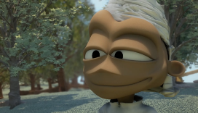
2. FRAME – Next, before you watch the next part of the video, ask the children to notice what is in the frame in each shot. Play and pause the video asking what they can see. Some shots have lots of sheep in them, some have only one sheep. Some have the camera up close to the actors and some have the camera far away. Play the video for another 30 seconds this way so that the children can see how each shot is different, then pause the video.
3. TIMING – Ask the children to see how long each shot goes for. Play the video and notice that some shots are very short and some go a bit longer. The following activity reinforces this with an active game.

ActIVITY: A few seconds 4 mins
This activity is helps children understand the concept of time.
You could do one or both activities depending on how long you have:
Ask the children to see what they can do in 5 seconds. Ask for a volunteer to do each activity:
- How many hands can you shake?
- How many words can be read aloud from a book?
- How many star jumps can you do?
Ask the group to do the following activities together with the leader using a watch:
- Run on the spot for 3 seconds
- Jump up and down for 5 seconds
- Hold their breath for 2 seconds
- Breathe deep then hold breath for 10 seconds
Explain that stories made on video are made up of quite short shots. Some shots will be 2 seconds, 3 seconds or 5 seconds. Very few are 10 seconds or more. The eye doesn’t need very long to understand what it is seeing.

Activity: Cut a frame from cardboard (optional)
If you have time allow children to make a frame from cardboard. The inside of the frame should be 10cm X 6 cm. Allow the child some time to practice using their frames to find interesting pictures. They can take these frames with them to play with.

Apply skills 10 mins

Activity: Telling Stories 10 mins
Ask the children to find a partner. Ask each person to tell his or her partner a story. (Example: an embarrassing moment, what they did on the weekend or what happened on the way to school.) After 2 minutes swap roles.
Explain that we love hearing stories, we tell stories and we learn from stories. In these KidsHubs video sessions we are going to learn how to tell stories on video.

Review 8 mins

Kids Prayer 3 mins
Ask children to sit in a circle. Ask them to pray with their fingers held in the camera frame from the earlier activities. Ask them to thank God for the things they can see around them through their frames. They can pray in short sentences.

Review questions 2 mins
Sit the children close together discuss these concepts from today.
- What is a frame? What do you capture within a frame?
- What is a shot?
- How long do video shots go for? (a mix of lengths, but mostly quite short)

Kids Challenge 2 mins
Ask the children to notice what is around them. God sees everyone just like the shepherd saw the one lost sheep, even though he had 99 safe in the sheep pen. Everyone is in God’s frame. His ‘frame’ is bigger than the whole universe and no one and nothing is hidden from him.
Challenge for the week:
- Who do you think Jesus notices in your school, street or community that no one else even cares about? What could you do to show love to that person?

Dismiss 1 min
Thank the children for being involved in the activities.
Play a fun game to finish the lesson if there is time.

Lesson 2

How to use a camera
Running time: 90-120 minutes*
*If you have more time available or can spread this lesson over two sessions, it will give the children
more time to use the cameras and give each child more time to experiment.
Bible Passage and message
Psalm 8
Main Ideas
By the end of this lesson the children should:
- Be able to use a video camera
- Understand the basic camera shots while filming a subject
Keywords:
- Subject
- Wide shot / Medium shot / Head and shoulder shot /
Close up shot
Preparation:
- Familiarize yourself with the lesson content before the children arrive.
- Download “The Wise and Foolish Builders” from www.kidshubtv.com or www.max7.org (or replay “The Lost Sheep” video from Lesson 1)
Equipment needed:
Camera, Diagrams, Projector or TV Monitor, Computer, Workbook and Pencil (one for each child) Chalkboard (to draw diagrams), download appropriate videos for lesson, Bible.

Lesson plan

activate imagination 10 mins

Welcome
Choose a warm-up/fun activity from the Appendix (at the back of this manual) to welcome children. This will help the children get to know each other. You could play a fun game or energizer.

ACTION WORD – WIDE AND CLOSE UP
This week teach the action words “WIDE” and “CLOSE UP”.
When you call out WIDE, the children run a long way from you to edges of the room. When you call CLOSE UP, they run up very close to you. Try this a few times. End with a CLOSE UP and then ask them to sit down quietly for the next section.

Kids Speak
Sit the children close. Ask them to tell you what they learned from the last lesson about framing and video shots.
- What did they like most about the lesson?
- Who has made a frame with their hands to look at things?
- Did anyone notice someone that no one seems to care about?
- Were you able to do something to help them?
- What does Jesus do for people who are lost?

Warm-Up Game: Catch the action
Ask the children to jump up and stand in a circle.
In this game the children have to pass an action around the circle via a light bump into the next person. The leader starts with clapping and then bumps into the child next to them. That child starts clapping too and then passes it to the next until it has gone right around the circle. Try other actions or let the children make some up (for example: silly noise, laughing, head wobble, etc.)

Explore media 30 mins

DRAWING ACTIVITY - Shots and subjects
Explain that we are soon going to use the cameras, but before we do we have a few more things to learn.
Draw the following simple picture on a chalkboard/ whiteboard or flipchart. Ask children to copy this diagram in their workbooks as you are drawing it up the front. Add the words as you explain or revise each concept:
- Explain that the border around the outside is the Frame (learnt last session).
- Explain that any video is made up of many shots (learnt last session).
- Underneath the frame write “the video is made up of many shots”. Explain that every time the camera operator starts a new frame or subject then this is a new shot.
Frame
Subject
The shot – a video is made up of many shots
THE SUBJECT (or Character)
- Every video is about someone or something. That someone (or something) is called the Subject. This is the main part of the video and what the camera is mostly filming.
When the children have drawn the diagram, ask them to leave their books on their seats.

DEMONSTRATION GAME – ‘FOUR SHOTS’
Ask the children to stand up and play this simple game of actions to learn the four types of shots that will be needed to start making a video. Teach each of these four actions to help them remember:
1. WIDE SHOT | stretch their arms out as wide as they can with their palms facing forward.
2. MEDIUM SHOT | slightly bend arms and face palms inwards like you are holding a very big box.
3. HEAD AND SHOULDER SHOT | bring palms in so they are just outside the line of your shoulders.
4. CLOSE UP SHOT | bring palms in to just either side of your face.
Once you’ve taught the actions, repeat them in order to help them remember.
Play a game by saying the shots a bit like the game “SIMON SAYS”. Say the word “WIDE SHOT” and do the wide shot action then another and another. At some stage you say one of the shots and yet demonstrate the wrong one. You can play this as an elimination game or just play it for fun and don’t eliminate anyone. The point of the game is to remember the 4 shot names.

DRAW THE FOUR SHOTS
Now demonstrate what these shots look like on a video. To do this we will draw the four shots on a chalkboard/ whiteboard or flipchart and then play a video to see if the children understand how to spot the different shots.
Draw the 4 shots on a flipchart or chalkboard/ whiteboard:
Wide shot Medium shot
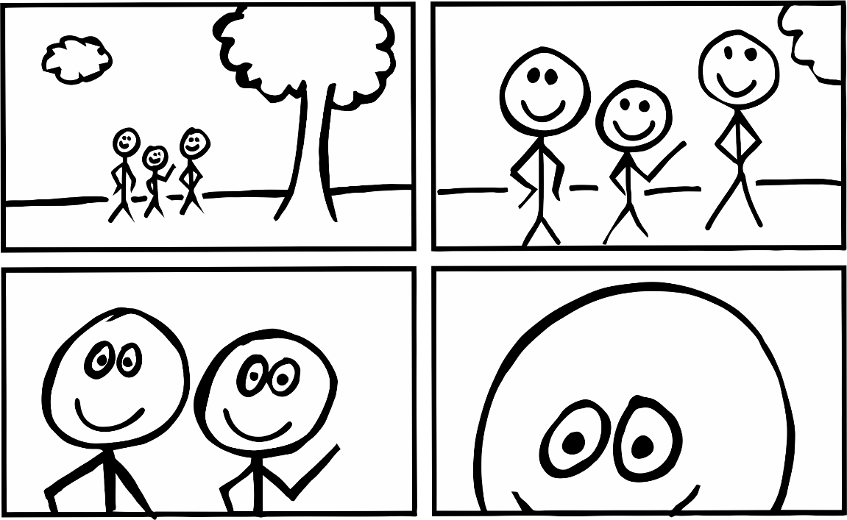
Head and shoulder shot Close Up shot

WATCH THE FOUR SHOTS
Watch a video with the children and see if they can pick which shots have been used. It will be helpful to be able to pause the video to point out the different shots. Once the children are used to it, they could call out the shots as the video is playing.
Choose your video: You could use The Lost Sheep from the last lesson or search for The Wise and Foolish Builders at www.kidshubtv.com or www.max7.org or another video that demonstrates the four shots.
Example of The Wise and Foolish Builders:
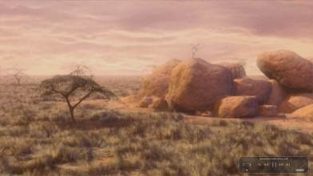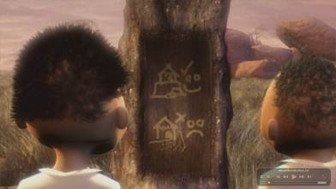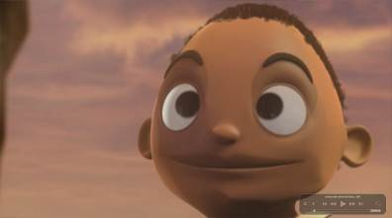
Wide shot Head and Shoulders shot Close Up shot
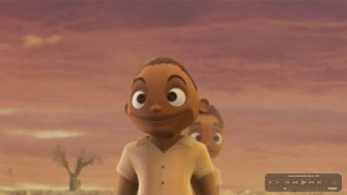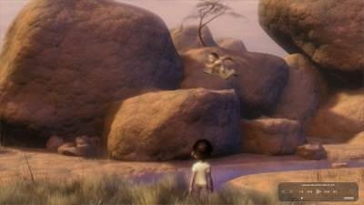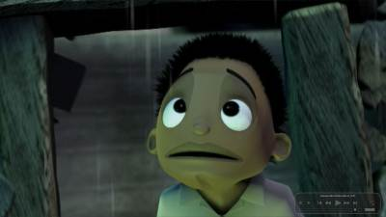
Medium shot Wide shot Head and Shoulders shot
Ask why a video maker might use the different shots. Once the children have given a response, you could add in the following explanations:
THE SHOT | WHY WOULD YOU USE IT? | FROM KIDSHUB KOLKATA
Wide shot | A wide shot shows you where the story is taking place. It is often one of the first shots used so that the audience watching the video knows whether the story is happening in a city or in a house or out on an African plain. | 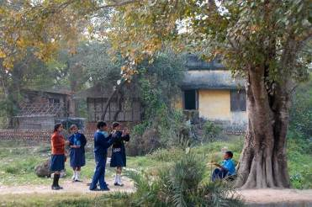
Medium shot | The medium shot is useful when the characters are doing an action (walking, jumping, riding, etc.). | 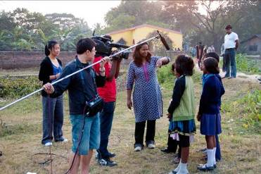
Head and Shoulders shot | A Head and Shoulder shot shows the faces of the characters, and is used when they are talking together or looking at each other. | 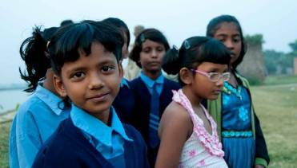
Close Up shot | Close Ups show a lot of detail as the camera is very close to the character or object you are filming. This is used to show how a character is feeling, as the eyes can be easily seen. It is also useful to show an object close up if that is important to the story. | 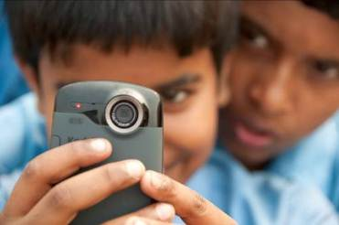

Experience activity – QUICK 4 shots GAME (optional)
This is a quick game to reinforce the 4 shots. Stand in front of the children. Explain to them that you are the subject and they are the camera.
When you call out WIDE, MEDIUM, HEAD and SHOULDER or CLOSE UP, the children need to move to the spot in the room that they think is the correct location and hold up their finger frame to capture the shot. For example, if you say WIDE they would move as far back as they can to take in the whole room. If you called CLOSE UP, they would all move very close to you. To make it more fun, give the instructions more quickly as the game goes along so that children are moving from spot to spot quickly.

SPLIT THE CHILDREN INTO KIDSHUB PROJECT GROUPS
Split the children into groups with 4 or 5 children in each group. These are called ‘KidsHubs Project Groups’. These will be the groups that the children will be in for many activities, so create groups of children who can work together well.
It is best to have one camera for each group. For example, for 20 children you will need 4 or 5 cameras.

Explain THE KIDSHUBs RULES IN USING AND LOOKING AFTER THE CAMERAS
From this point on the children will use the cameras and begin to video as they learn. Take some time to make clear rules about the cameras. We suggest you create your KidsHub rules about the following:
1. One person holds the camera at a time. No grabbing of the camera as these are fragile and can break if they are dropped. The person holding the camera is the Camera Operator.
2. The Camera Operator should put the camera strap around their wrist to avoid dropping it.
3. Explain what will happen with the cameras at the end of each KidsHub session.
4. We suggest that you NUMBER EACH GROUP and NUMBER EACH CAMERA so that the groups use the same camera each time.
5. Add any other instructions relevant to your group.

Explain how to use a camera (running time 5-10 mins)
Use the following time to explain how to use the cameras. As each camera model is different, we cannot give detailed instructions here. Learn how to use your cameras and explain the following parts of the camera:
CAMERA FEATURE | ASPECTS TO POINT OUT
Power button | How to turn on and how to turn off.
The Lens of the Camera | The lens is like the ‘eye’ of the camera. Be careful not to put your fingers on the lens as it leaves marks and could spoil your video shots.
Record Button | Show how and where to begin recording video. On most cameras a red light will come on when recording. Show how to stop recording.
Video Playback | If your cameras will playback video, show how to play back what has been recorded.
Delete | Show the delete button. Explain that this button will erase what has been recorded. This is helpful if you want to get rid of a shot that you will never use. Be careful not to press this button unless you really need to as video cannot be recovered if it has been deleted.
Battery Power | Show how the camera operates by a battery. Explain that the battery will go flat, so to remember to turn off the camera to save power when you are not recording.
Microphone | Show where the camera records sound and voices.
Other features | Some cameras have other useful features. Show these now if they are important to using the camera.

Activity: FILM Five funny faces (running time 5-10mins)
Once the children know how to use the cameras, give them an activity that allows every child to have a turn at filming. The timing of this activity will depend on how many children and how many cameras. Ideally give the children enough time for each child to video 3 short shots.
Ask the children to do the following simple and fun activity:
In their KidsHubs Project Groups, ask them to go outside (or inside if you have to). In their groups, each child needs to have a turn filming the others in the Project Group using the WIDE, MEDIUM, HEAD AND SHOULDERS AND CLOSE UP shots they have learnt. Ask them to take turns filming people in their group making funny faces or showing different feelings (happy, sad, surprised, tired, angry, curious, etc.).
To do this, the children should set up the shot by having the CAMERA OPERATOR stand facing the SUBJECTS/CHARACTERS with the camera. The first WIDE shot; they should be standing a long way from the subjects. They should start recording and film for 4-5 seconds and then stop recording. (HINT: They should count to 5 quietly in their mind.) Then they move to the next shot, or closer to the subjects, to create the MEDIUM shot. Again film for 5 seconds and stop. Move closer to do a HEAD AND SHOULDERS shot, film 5 seconds, then stop. Move even closer to a CLOSE UP on one subject, film and stop.
Each child should have a turn doing this activity.
If you have time, let the children playback their shots within their Project Groups.

Evaluate the video clips (running time 5 mins)
If you are able, choose the video from one group and watch it on a big screen so everyone can see using a data projector. Ask for feedback on what the shots are like. If you are able, make some comments on what makes a good shot.

Communicate the Bible 15 mins

Activity: (running time 10-20 mins)
Read Psalm 8 to the children.
You can give children a sheet of paper to draw on as they listen to the psalm. (Optional)
Afterwards discuss these questions together.
- What things does Psalm 8 say that God created? Make a list of them? (Stars, birds, animals, plants etc.)
- What things do you see around you that are not on this list?
- What is your favourite thing that God has made? Why do you like it so much?
- What do we learn about God from this Psalm?

Apply skills 25 mins

Project: Make a video of Psalm 8
In groups, get the children to film different things that are mentioned in psalm 8. This is to help them put into practice the 4 types of shots they have learned about. Each child is to have a go with filming the 4 different shots.
Encourage them to make their video as interesting as possible. Don’t just film them straight on. Try filming a close up of their eye, ear, nose or mouth. Make it interesting for a viewer.

evaluate the video clips (running time 5-10 mins)
Review the clips on the screen and discuss what a good shot is like and what makes a bad shot. Try to evaluate different groups, so you can give them feedback and help them improve their camera work.
Remember to turn the cameras off and stop recording.
Explain how to charge the battery in the camera. Go through the steps on how to charge.

Review 15 mins

Review - What shot?
Sit the children close together and show them different photos or pictures (that show c/up, m/s and w/s). Play a game where children need to call out which shot the photo is. (wide, medium, head and shoulders or close up.)

Kids Prayer
Ask children to stand in a big circle. Pray for the people and events that are far away overseas and in our nation. Then take a few steps closer. Now pray for those people and events in our community. Now take some more steps forward and stand very close together. Pray for our group and ask God for our needs. Lastly sit down and quietly talk to God alone.

Kids Challenge
During the week pray for the things and people far away as well as those very close. Pray for the needs of others and yourself.

Dismiss
Thank the children for being so involved in the activities. Play a fun game to finish the lesson if there is time.

Lesson 3

Composition – how to frame a good shot
Running time: 60-90 minutes
Bible Passage and Message
John 14:1-7 – Everyone is so important to God that Jesus is preparing a place in his Father’s home for everyone who follows him.
Main Ideas
- By the end of this lesson the children will understand the “Rule of Thirds”.
- Be able to capture different shots using the rule of thirds.
Keywords
Thirds
Composition
Preparation
Familiarize yourself with the lesson content before the children arrive.
Equipment needed
Camera, Diagrams, Projector or Monitor, Computer, Workbook or paper and Pencil (one for each child), Chalkboard (to draw diagrams), Bibles (for children if possible), download appropriate videos for lesson. Object for warm-up game.

Lesson Plan

Activate imagination 10 MINS

Welcome
Choose a warm-up/fun activity from the Appendix (at the back of this manual) to welcome children. This will help the children get to know each other. You could play a fun game/ energizer.

Kids Speak
Sit the children close. Ask them to tell you what they learned from the last lesson. (Different types of shots).
What kinds of things do they do where objects have to be put in the ‘right place’? (help in the kitchen, tidy the house).
What reasons are there to put things in the proper place?

Warm-Up Game: What was moved?
Ask the children to sit in a circle. Put 10 or so objects in the middle of the circle. Ask all the children to look at the items carefully. Especially look to see how each one is placed in relation to the others. Ask the children to close their eyes. Now move one object while their eyes are closed. When they have opened their eyes they have to work out which object or objects has been moved. The person who guesses correctly can be the next person to move the object/s. Make the game more challenging with each turn.

Explore media 20 mins

Explain the Rule of thirds (running time 10-20 mins)
Explain: The basic idea behind the rule of thirds is to imagine breaking an image or picture into thirds (both horizontally and vertically) so that you have 9 parts. As you video you need to imagine the image has invisible lines across it to help you frame your shot. With this grid in mind the ‘rule of thirds’ now identifies four important parts inside the frame where you should have points of interest. Points of interest should be where the lines cross. The lines can also act as guides to help position subjects in the frame.
For thousands of years, visual art has been using the rule of thirds to structure composition. It is a very harmonious way of presenting images visually. It can also help new filmmakers plan shots effectively. Use the 9 box grid, or only the vertical or horizontal lines to compose your shots. As you become more experienced you can ‘break’ the rule of thirds to make the viewer more uncomfortable, or to laugh. This all depends on the affect you want to have on the viewer. The rule of thirds is to help the viewer understand what is happening in the shot, by helping newer filmmakers think through and compose their shots well.
Draw up this diagram and explain it to the group.
1st 2nd 3rd
1st
4 main points of interest
2nd

3rd

Draw some frames
Ask the children to draw 3 frames on a piece of paper like the one above. In each frame they will draw a different image.
HEAD AND SHOULDER SHOT
Draw a face in your frame. Leave a space above the head, the eyes should be on the first third down and shoulders should take up most of the bottom third.
This way the eyes take up two points of interest and the mouth (depending on head movement) will touch the 2 lower points of interest during speaking. This rule needs to be flexible with the amount that your subject has to move.

MEDIUM SHOT
Draw 3 people in the frame like this. For a medium shot, have the heads, on the first third down. Leaving space for headroom; which is the distance from the top of the head to the top of the frame. Two heads are at points of interest.

In this medium shot, the actions of the two outside figures are on the 4 key points of interest. You may even change the angle of the shot depending on where the focus activity is occurring during the shot.
WIDE SHOT
Draw a person on a bicycle in a wide shot. Explain that you want the person to have moving space or what we call leadroom; to have space in front of the subject depending on which direction they are facing or even where their eyes are. For example; if your subject is on the right of screen you want space for them to move towards the left of screen.

In this wide shot the cyclist may move from the lower key point of interest up to the top key point on the left, or stay along the bottom third of the shot and travel to the lower left key point of interest.

Examine video
Choose your video: You could use The Parable of The Lost Sheep or The Wise and Foolish Builders from www.kidshubtv.com or www.max7.org or another video that demonstrates the composition of shots. Reinforce the concept of thirds for composition.

Apply skills 30 mins

Experiment: composing shots (running time 15-30 mins)
Ask children to get into their KidsHubs Project Groups of 4 or 5 people. They will take turns being the camera operator and the subject. Ask each group to give each member a turn at filming the same subject 3 times but composing it differently each time. They can choose from the wide, medium, head and shoulders and close up shots. Each child needs to try filming 3 different shots for 5 seconds each. Encourage them to look at framing their subject using thirds and looking to see where the 4 points of interest are in their frame. Practice getting the right shot or good composition.

Evaluate Footage (running time 15 mins)
Look at the video clips on the screen and discuss what a good shot is, and what a bad shot is. Try to evaluate different groups, so you can give them feedback and help them improve their camera work.
There are many ways to improve the composition. It could be that the camera only needs to be moved slightly to make it a better shot. Changing the framing of a shot even in small ways can make a big difference visually. Remind them of the rule of thirds again if you think the children are finding it hard to understand or the framing of their shots has not improved.

Communicate the Bible 10 mins

ACTIVITY – read and draw 5 mins
If you have Bibles for the children ask them to have them open. READ John 14:1-7 together. Give each child a piece of paper. Ask them to fold or mark it into thirds horizontally and vertically to create 9 frames (see previous activity). Divide the children into 3 groups. Ask each child in group 1 to draw a wide shot (W/S);
- of God’s house with many rooms with themselves and a few friends in it;
- and of the upset woman (perhaps showing empty hands).
Ask group 2 to each draw a medium shot (M/S) of Thomas looking confused and questioning Jesus.
Ask group 3 to each draw a close up (C/Up) of Jesus smiling face as he’s saying “I am the way, the truth and the life!” Remind them about the 4 points of interest and the ‘rule of thirds’ when drawing their subjects.
Read the Bible passage again as they draw giving them only a few minutes to do a quick sketch. When the groups are ready, re-read the Bible passage a third time asking each group to hold up their drawings when they hear their part of the reading.

Discussion (John 14:1-7) 5 mins
- What would your dream home /place look like?
- Who would be there with you?
- What was surprising about what Jesus said?
- Where was Jesus going? (heaven - to be with God his Father)
- What does Jesus say about himself in verse 6? (“I am the way, the truth and the life! Without me, no one can go to the Father.”)
- How does that make you feel?

Review 10 mins

Games: Thirds (running time 5 mins) 5 mins
As a group, say out loud together “third, third, third”. With elbows bent have your hands up in front of you, palms facing each other, imagining you are framing a third. Each time you say “third” you move your hands across in front of your face from left to right marking out 3 thirds. Now place your parallel hands in a horizontal position in front of you. Doing the same thing move your hands up and down in front of you splitting your frame into 3 imaginary thirds. Repeat it in different ways; low voice, high voice, quiet voice etc.

Kids Prayer 5 mins
Ask children to divide a piece of paper into 9 sections to make a prayer grid. Ask children to write or draw things that they can pray for in the squares. Children can ask for prayer needs of others in the group. Then spend some quiet time praying for these things.

Kids Challenge
During the week pray for the things and people that are on your prayer grid.

Dismiss
Thank the children for being so involved in the activities. Play a fun game to finish the lesson if there is time.

Lesson 4

How to light a subject
Running Time: 60-90 minutes
Bible passage and message
John 9:1-7 – Jesus is the light of the world.
Main Ideas
- By the end of this lesson the children should be able to light a subject correctly.
- Explain where the light should be when lighting the subject.
Keywords
Subject
Lighting
Preparation
Familiarize yourself with the lesson content before the children arrive.
Equipment needed
Camera, Projector or TV Monitor or Computer to view footage, blindfolds, wrapped sweets (or objects to pick up), Bibles (enough for children to share), candle.

Lesson plan

Activate Imagination 10 mins

Welcome children
Choose a warm-up/fun activity from the Appendix (at the back of this manual) to welcome children. This will help the children get to know each other. You could play a fun game/ energizer.

Game: Treasure hunt
Ask the children to stand in a big circle. Ask 3 volunteers to be blindfolded. As they are being blindfolded scatter about 20 wrapped sweets (or objects to pick up) on the floor. Now ask the 3 blindfold children to find the sweets. (They will find it difficult)
Play the game again, but this time, the blindfolded children will have a helper to give them instructions.
At the end of the game ask the blindfolded children how they felt? Why?

Kids Speak
Sit the children in a group close to you. Ask the children these questions to begin a discussion.
- What kinds of lights do you love? (Fireworks, sun, moon, candles etc.)
- Why might light be important while we are filming?
- What can light do in our video? (Stop shadows, create shadows, helps us see things etc.)

explore media 10 mins

Activity: what not to do (running time 10mins)
Ask a child to stand in front of a light, window or a torch, facing the camera (note: the light should be behind them). Record them telling you something about themselves (e.g. recent experience). Stop after about 15 seconds. Connect the camera to the TV monitor or projector and show the group the footage. Ask them:
- What is wrong with this shot?
- Why is their face dark?
- Why is it important to see the person’s face that is speaking?
Explain that when filming a person speaking to the camera it is important to make sure their face is well lit, with minimum shadow falling across it. If the sun or light is behind their head, their face will be totally dark. This is called backlighting, and should be avoided where possible as it creates unusable footage. To avoid backlighting, the camera operator should have their back to the sun or source of light, and their subject should be positioned so that the light is hitting their face. Avoid having the person look directly into the sun or light, as they may squint.
When you are outside, where do you want the light to be?
(You want the sunlight to be on a 45-degree angle to the subject, so the light is not directly in the subject’s eyes and also so light covers most of their face.)

learn a word: Subject
Subject: Is the person, animal or object that you are filming. In art terms it is called a subject.

Communicate the Bible 30 mins
Read John 9:1-7 to the children. 10 MINS
As they listen ask them to close their eyes and imagine what is happening in the story. Once the story has been read ask them to read it themselves and then close their Bible and retell the story to a partner. See if the partner can fill in any missing facts.
As a big group discuss these questions:
- What do you think would be the worst thing about being blind?
- What did you find surprising about this story?
- What was the man’s biggest problem?
- How did Jesus heal him?
- What does this story tell us about God?
Why did Jesus say he is ‘Light of the world?’ (Jesus shows us what God is like. He came to be a light in the darkness of our sinful world. To guide and show us how God wants us to live His way. Jesus can see right into us. He can see everything about us good and bad. Jesus shines the light of truth into our dark world and because of him we can get to know God).

Act it out 10 MINS
Ask the children to get into groups of 4 or 5. They have 10 minutes to organize themselves so that they can act out this Bible story in front of the group. (John 9:1-7) give each group a different but interesting piece of clothing or prop to use in their play.
Allow each group to present their play of the Bible story to the whole group.

apply skills 30 mins

Game: Where should the sun be (running Time 5mins)
Help children understand that they cannot move the sun when they are filming, but they can move the subject (person) to get the best light.
Tell the children that they are going to play a game where they are the sun. Set up a subject to film, and you (the leader/teacher) are the camera operator. Choose a place to stand to film the subject and ask the children to be the sun for you. Ask the children (as the sun) to stand around the subject where they think the sun should be when you are filming the subject’s face.
Move to different points in the room and ‘freeze’. (The children practice moving around the subject to find the best place to light it).

activity: Filming an interview in the light (running time 15-20 mins)
Ask the children to get into their KidsHubs Project Group. Their task is to film interviews of each person in their group. Each interview needs to be about 30 seconds long and needs to be filmed in a different location. Film the subject with the light in the correct spot. Get them to work out where the sun is. The interview could be about their family, home or school. If children are ready for an acting challenge, ask them to be a reporter interviewing the Blind Man whom Jesus healed. Swap roles in directing and camera operation.
EXPLAIN: You learned earlier about using the sunlight to light your subject. Now we need to put this into practice. As you film your interview, you will need to decide either to move the subject or camera to get the light just right. Remember to hold the camera steady, and be about 1 meter from the camera when speaking.
After each interview check the footage to see if the light is OK. If it’s not good, ask the groups to try filming it again.

Evaluate the footage
Allow each group to swap their camera with another group. Each group should look through the interviews of the other group and pick one interview with excellent lighting. After each group has found an example, gather together as a big group and look at all the chosen interviews.

Review 5 min

review
Ask the children what they have learned today. Why is light so important?

Kids Prayer
Gather the children into a circle. Light a candle and put it into the middle. Ask children to pray with their eyes open looking at the candle. Ask children to pray for the things and people who are in darkness and need God’s light. After each person prays, the whole group says this verse together. ‘We are all children of the light and children of the day. We do not belong to the night or to the darkness.’ 1 Thess 5:5

Kids Challenge
Ask the children to notice during the week, how the light affects how they see things. Whenever they see a light, encourage them to thank Jesus for being the light. Ask Him to lead people out of darkness and into the light.

Dismiss
Thank the children for being so involved in the activities. Play a fun game to finish the lesson if there is time.

Lesson 5

Understanding the Story
Running time: 60-90 minutes
Bible Passage and Message
Luke 15: 8-10 - Everyone is important to God. He wants everyone to come into in His Kingdom.
Main Ideas
- By the end of this lesson the children should be able to explain the 4 elements in a story.
- Be able to explain a short story in video.
keywords
Editing
Storyboard
Preparation
- Familiarize yourself with the lesson content before the children arrive.
- Edit a short clip using the children’s footage taken from other lessons or download ‘The Lost Son’ from www.kidshubtv.com or www.max7.org.
Equipment needed
Camera, Diagram, Projector or TV Monitor, Computer, Workbook and Pencil (one for each child) Chalkboard (to draw diagrams), Bibles.

Lesson plan

Activate imagination 15 mins

Welcome 3 mins
Choose a warm-up/fun activity from The Appendix (or a game you know) to welcome children. This will help the children get to know each other.

Kids Speak 5 mins
Sit the children close. Ask them to tell you what they learned from the last lesson. (Lighting and interviewing).
Now show them a small object that is precious to you. Tell them a true story about a time you lost something precious to you. Discuss this question with the children:
- What have you lost that is probably not worth much to anyone else, but is valuable to you?

warm up game : hot and cold 7 mins
Ask two children to be volunteers. One is going to be the ‘seeker’ who will be blindfolded and the other will instruct them where to go. An object will be hidden in the room so that everyone except the blindfolded person can see it. The only words that can be used are HOT or COLD. Hot means they are getting closer to the item, and cold means they are heading away from the item.
Alternate rules: everyone else can shout out hot or cold.

Explore the media 25 mins

a Story is made up of many Shots (running time 10-15mins) 15 mins
Explain to the children how a story is made up of many different shots. Show a short clip or segment (if you can cut together footage taken from other lessons or download ‘The Lost Son’ from wwwkidshubtv.com or www.max7.org).
Ask the group to watch the video and count the clips again and check how many shots are in the story. (there are many).
Draw on a board the different shots they saw in the clip. Go through part of the story and explain the story using 7 pictures.
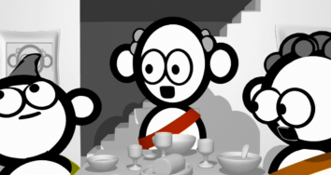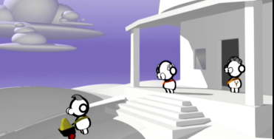
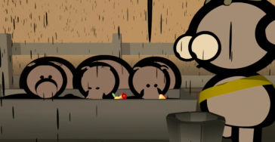

Editing (a quick explanation) 2 MINS
Explain how different shots are filmed and then are edited to put them in the right order. Different shots can be chosen and cut down in length so that the story flows.

1 2

>>>time 10 second shot>>>>>>>>>>>

Use or redraw this diagram (above) to explain that an original shot needs to be longer than the shot you finally use. Points 1 and 2 show the cuts or edit points that trim a 10 second shot down into what is most useful for the final edit.
It is important to always think about what and where you are going to film and film a little bit more than is needed for each shot so that it is easier for editing the clip. You can always cut the length of a shot in editing but you cannot add to it once it has been filmed.

Kids speak 3 MINS
Ask the children these questions to begin a discussion.
- What is your favorite story?
- Why do stories exist in the world? OR Why do we tell stories?
- What types of stories are there? (true/ fiction, humorous/ serious, sci-fi, historical, parables, fables)
- Do some parts of a story go so slowly that you want to cut them shorter? Which part/s – think of an example?

Explanation (running time 5-10mins) 5 mins
What is a story? A story is a series of events that happen to a main character. Stories usually have three parts. These are the beginning (orientation), a problem or obstacles and a resolution at the end.
Beginning - orientation. We meet the main character and find out where they live and what they are doing. We find their motivation and needs.
Middle - A problem or obstacle affects the character. This creates interest in the story as something has to happen to solve the problem or overcome the obstacle. The character may try different ways of solving the problem. The solution may take some time.
End - The problem is solved and there is a resolution. Many of the loose ends of the story are tied together so the viewer or reader feels satisfied.
All stories follow a similar pattern.

Communicate the Bible 20 mins
Read the story of ‘The lost coin’ to the children. Luke 15:8-9

Discussion 5 mins
Sit with the children and discuss these questions.
- What do we know about the woman from this story?
- What does this story tell us about God?
- Why did Jesus tell parables?
- What are the 3 parts to this story?

Practice: Storyboarding (running time 15-20mins) 15 mins
Read Luke 15:8-9 again and explain that you are going to create a storyboard of the story. A storyboard is a plan of how you are going to film a story with different shots. (It will be explained in more detail in Lesson 7).
Ask children to get into their KidsHubs Project Group. Get each group to draw a storyboard (maximum 8 shots) for this story. The children will need to adapt the lost coin story to fit into the 8 shots. Each group needs to talk about it and draw up their own storyboard. The drawings do not need to be detailed; stick figures are fine.
You can demonstrate to help get them started.
Shot 1: The establishing shot is the location of where the person is.
Shot 2: The close up of the 10 items being counted.
Shot 3: The emotion of the lady in discovering something is lost.
Shots 4-7: A number of different shots of the lady looking in different/ interesting places.
Shot 8: The lady has found her coin and is happy.
*Explain that the first 2 shots are the orientation. Shots 3-7 are the problem or conflict. The last shot is the resolution.

Apply skills 20 mins

FILMING: Lost Coin (running time 20-30mins) 20 mins
Ask the groups to go out and film the lost coin story in their KidsHubs Project Groups. Use the storyboard that each group has drawn up to plan the filming. Give each person in the group a job. These are the jobs: director, camera operator, props person, character (lady).

Review 10 mins

review
Ask the children:
- What they have learned today.
- What roles were easy and what were difficult in the filming?
Re-read Luke 15:8-10 emphasizing verse 10. Ask the children:
- Why did Jesus tell the story of the woman who lost her coin?
(verse 10: everyone is important to God. He wants everyone to come to Him and be a part of His kingdom / family. Even just one person turning to follow Jesus is cause for great celebration in heaven).

Kids Prayer
Ask the children to think of all the people who are most valuable to them. Pair and share with a partner and discuss who those people are. Now together pray for those people. Pray that Jesus would find them and that they would follow Him.

Kids Challenge
Gather the children into a small group. Show the children two notes of currency of the same value. One is crisp and new and the other is old and worn. Ask the children which one is more valuable. (Both are the same). Remind them that we are all valuable in God’s eyes but that sometimes we treat people like they are less valuable. The challenge this week is to treat people the way that God values them.

Dismiss
Thank the children for being so involved in the activities. Play a fun game to finish the lesson if there is time.

Lesson 6

Understanding Sound
Running time: 60- 90 minutes
Bible Passage and message
1 Samuel 3: 1-10 – The calling of Samuel as a boy by God.
Main Ideas
- By the end of this lesson children will understand that they need clear loud voices when speaking to the camera.
- They will understand how background noise can affect their video footage and to be quiet ‘on set’ when filming.
Keywords
Microphone
Background noise
Preparation
Familiarize yourself with the lesson content before the children arrive.
Equipment needed
Camera, Projector or Monitor, Computer, Workbook and Pencil (one for each child) Chalkboard (to draw diagrams), Bible.

Lesson plan

Activate Imagination 15 mins

Welcome children 3 mins
Choose a warm-up/fun activity from the Appendix (or one you know) to welcome children. You could play a fun game/ energizer. E.g. People to People game.

activity: Echo Noise 2 mins
Ask the children to find what interesting sounds they can make with their bodies. Invite them one at a time to show the group and have the group try and copy it.
Next create short rhythms for the children to copy using some of these sound effects as wells as hand claps and feet stomps.

What can you hear? 3 mins
Ask the children to stop and listen to the noise around them. What are some of the noises they can hear? Spend one minute listing all the noises they can hear, writing them in their workbooks or on a piece of paper. Now join with a partner and compare lists.
- How many sounds did you have all together?
- What sounds did you miss compared to your partner?
- What sounds are missing?
- Could you hear any quiet sounds?

Listening Experiment 2 mins
Tell the group that you are going to do an experiment in listening to find which situation makes it easier to hear. Ask them to work in pairs. Each pair will try to have a conversation for 15 seconds in different situations. One can ask questions while the other answers them.
Situations:
- Sitting back to back
- One person standing while the other is sitting on the floor
- Standing facing each other 1 meter apart
- Standing 10 meters apart across the room

Kids Speak 5 mins
Sit the children in a group close to you. Ask the children these questions to begin a discussion. (Option: End by telling them of a time you missed an important instruction).
- Which situation made it the most difficult to hear? Why?
- Which situation did you find the easiest hear?
- Have you ever found it really difficult to hear something important? What happened?
- How do you know when someone is really listening to you?

Explore the media 25 min

Explanation 1 min
What is a microphone: This is the area where the camera records the sound. It is important to be close to the person speaking so that the sound is clear.
Locate where the microphone is on the camera, caution the children not to put their finger over the microphone, or the sound will be muffled.

Speaking to camera 4 mins
Ask the children these questions to begin a discussion.
- If you were to speak softly would people be able to hear you on video? Why not?
- If you were to scream, would they understand you? Why?
- What do you think is the best way to speak on video? (E.g. Clear and loud)
(Optional: find examples of YouTube videos that depict muffled sound and clear/well spoken sound e.g. a news presenter).

activity - How close to the camera is best? 10 mins
Ask children to work with a partner. Spread out so that other groups cannot be heard easily. (If there is not a lot of room, have two volunteers perform the task in front of the rest of the group.)
Ask them to see how far away they can be from the camera to record their voices. One is the speaker and the other is the camera operator. The speaker will be speaking to the camera about “A day in my life” OR “a day in Samuel’s life in the temple”. Where do they go? What do they eat? Who do they see?
Start with a close-up shot so that you can only see the speaker’s mouth in the frame. Record for 10 seconds. Then move back 2 paces and record again. Keep moving back and taking 10 second videos until the final one is an image of a full length person standing far away and talking. The person talking to the camera must try to speak at the same volume all the time.

Evaluation 10 mins
Gather the children together and choose a few examples to look at on a TV screen or projector. Evaluate the best distance for recording voices and discuss the effectiveness of the examples you have seen.

Apply Skills 20 mins

Activity: Noisy Location 10 mins
Divide the children into their KidsHubs Project Groups. Each group will divide their members into different roles. One person will need to be camera operator and one person the speaker. The others will be noisy extras. Each group will film one member of their group speaking to camera while the others in the group make noises around where it is being filmed. Spread out around the room, the whole group will work in the same room so that there will be a lot of confusion with loud background noise.
The person who has to talk in front of the camera can again speak about “a day in my life” or “a day in Samuel’s life in the temple”, explaining what they do each day. For example: it could be the jobs around the home or things they do at school, what sport they may play and when, who their friends are etc.

Explanation 3 mins
Background noise can be a distraction on your video. When filming, try and film in quiet areas. It is OK if you cannot find a quiet area, as sometimes this cannot be helped. Depending on what you’re filming, background noise can be helpful if you want to create a busy, lively atmosphere instead of a quiet one. Just remember the person/s you are filming will have to speak louder than the surrounding noise so they can be heard.
If you want the person speaking to the camera to be clear and easy to understand, then record in a quiet area.
On a professional video shoot, the Director or Assistant will call ‘Quiet on the set’ in a loud voice before filming starts so that everyone in the crew knows to be quiet.

Group discussion 7 mins
In small groups discuss the difficulties the children had when interviewing their partner from a long distance away.
- Could you hear your partner?
- Could you hear other interviews?
- Where do you think would be a better place to interview your partner and why?

Communicate the Bible 10mins

Bible reading 3 mins
Read this Bible story to the children. 1 Samuel 3:1-10 the calling of Samuel as a boy.
Ask the children to sit close together in a circle. Each person puts their left hand palm facing up on their knee and their right hand pointing with one finger over the hand of the person on their right. Tell them you are going to read the story again but this time they must grab the finger of the person next to them every time they hear the word ‘Samuel’.

Discussion 7 mins
Sit with the children and discuss these questions.
- What is interesting about this story?
- What do we learn about God from this story?
- When is a good time to hear God’s voice? (All the time, wherever we are).
- Why should we find a quiet place so that we can focus on hearing Him? Where is a quiet place for you?

Review 15 mins

Kids Prayer
Remind children that God listens to everyone. He listens to people from different places, with different languages, different ages and all at the same time. Say, ‘I wonder how many people are praying right now’…
Ask the children to sit alone in the room and talk/pray to God quietly by themselves.

Review questions
Sit the children close together to discuss these concepts from today.
- Why is sound so important?
- What do you need to think about when choosing a location to video? (How much background noise is there. Can a quiet place be found etc.).
- What distance between the camera and the person being filmed gave the clearest sound recording?

Kids Challenge
Ask the children to listen to what is around them (particularly people speaking to them or things they hear on TV, computer or radio etc.). Who do they need to listen to more? What do they need to listen to less?

Dismiss
Thank the children for being so involved in the activities. Play a fun game to finish the lesson if there is time.

Lesson 7

storyboarding
Running time: 60-90 minutes
Bible Passage and message
1 Corinthians 12:12-20 – We are all part of the God’s family. We are all part of the ‘body of Christ’ and we all have a part to play in it.
Main Ideas
- By the end of this lesson the children will be able to breakdown a story and create a storyboard.
- At the end of this lesson the children will choose one Bible story to film for their KidsHubs Group project.
keywords
Crew
Preparation
Familiarize yourself with the lesson content before the children arrive.
Equipment needed
Camera, Diagram, Projector or TV Monitor, Computer, Workbook and Pencil (one for each child) Chalkboard (to draw diagrams), short piece of rope or material (for Caterpillar game), Bibles (one for each KidsHubs Project group if possible).

Lesson plan

Activate Imagination 15 mins

Welcome children 3 mins
Choose a warm-up/fun activity from the Appendix to welcome children.

Warm Up Game: Caterpillar 7 mins
This activity is to help the children understand that everyone is important in a video crew.
Ask the children to divide into groups of about 6-8 people. Each team stands in a line and each person puts his or her hands on the shoulder of the person in front. The person at the back or end of the line is given a ‘tail’, a short length of rope or material. It can be tucked into their belt so it hangs down like a tail. On ‘GO’ the teams have to move around. The person at the front of each line has to try and grab the tail of another team. Each team must work to stay connected together and protect the tail. If they break their link or lose their tail they lose the game. The last team with their tail wins. Play two or three rounds of the game.
After playing for a few minutes ask children to come together again in one group. Ask the following questions to debrief the game.
- Who enjoyed the game?
- Who was the most important person in the team? (Front, back or middle)
Most groups will realize that everyone is important to the team, not just one person.

Learn A Word: Crew
While still in a group explain to the children what the word ‘crew’ means.
Crew: is the group of people who work on a video or film project together. A typical video crew is made up of many people doing different roles (e.g. Director, Camera operator, Lighting, Sound, Props, Make up etc.).

Kids Speak 5 mins
Ask the children these questions to begin a discussion. Also tell them about a time you worked in a team.
- What is good about working in a team?
- What different roles are there in a video film crew?

Communicate the Bible 10 mins

BIBLE READING 5 mins
1 Corinthians 12:12-20: Read this scripture and discuss together. You could do it a number of ways.
- Pass the Bible around the circle asking each child to take it in turns to read one verse each till you have read 1 Corinthians 12:12-20 together. Read it again to see how smoothly it can be read one verse at a time by each person.
- Or divide the children into 3 groups. Each group represents a body part: “the foot” (vs15); “an ear” (vs16 and 17b) and “an eye” (vs17a). Gather the children in a tight group around you and read verses 12-13. As you read verse 14 ask the children to move outwards into their 3 groups. Continue reading asking ‘the foot’ group to repeat what is said in verse 15. Then ask ‘the ear’ group to repeat what is said in verse 16. Continue reading till the end of verse 17 asking ‘the eye’ and ‘ear’ groups to do actions as you read. Then ask the group to gather around you altogether again as you read verse 18 – 20.

Discussion 5 MINS
Sit with the children and discuss these questions.
- What did you like about this Bible passage?
- How is the Caterpillar game they played earlier (or how is the way they just read the Bible passage) like the Bible message they just heard?
- What does the passage tell us about ourselves?
- What does this passage tell us about God?

Explore the media 20 mins

Explain a storyboard 5 MINS
A storyboard helps you plan the video you are going to make. It is a set of shot-by-shot drawings and brief written explanations indicating the major points of a scene or program. The script of what the characters say will also be a part of the storyboard. A storyboard looks like a cartoon strip, but is much longer. It will have a frame for every shot you need to film.
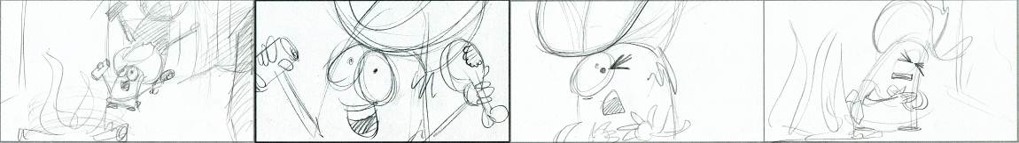
[Diagram of a storyboard]

Explain the Project 5 MINS
Children will work in their KidsHubs Project Group. Explain that today they are going to start planning a short video (2-4 minutes) to show to others at the ‘Showcase’ (see Lesson 10). In this session we will be planning the storyboard. Later we will film the project, and then edit it before we show it to our friends and parents at the Showcase.
In lesson 5 we had a brief look at drawing storyboards for the “lost coin” video. Today will be creating a storyboard for a short film. In your groups you will be completing a storyboard of all the shots you will want to capture in your short film.
As a group you will read through the story that you have chosen for your project. Make sure you look at these things:
- How will it be scripted (what will people say)?
- What types of shots will you use?
- Where are you going to film?
Decide who will be the camera operator, director, actors.
As a crew you will want to read over the story many times to become familiar with it. Each crew member should look at the storyboard/ script from their own perspective. Camera operator, actors, director, (props, lighting, sound).

Choosing a short story 10 mins
Ask each KidsHubs Project group to choose a Bible story from this list. And/or allocate one to each group. If possible give each group a Bible to look up the passage or a copy of the Bible story they have chosen to video.
- Zacchaeus- Luke 19:1-10
- Lost Son- Luke 15:11-31
- Blind Bartimaeus – Mark 10:46-52
- Pool of Siloam – John 9:1-11
- Good Samaritan- Luke 10: 25-37
- Jesus calming the storm- Matthew 8:23-27
As a leader, if you can think of other short stories in the Bible that the children could video, list them also.

Apply Skills 25 mins

KidsHub project group time
Ask children to work in their groups to plan and create their storyboard of the story that was allocated to them and then answer the questions and decide on crew roles (mentioned above).
Encourage all the children to contribute to the process.

Review 10 mins

Kids Prayer
Ask children to pray in their groups. Ask God to give them wisdom about their project, that they will be able to show the true meaning of the story; that their viewers will understand the meaning.

Review questions
Sit the children close together to discuss these concepts from today.
- Why is the crew/team so important?
Ask each group to present their storyboard and briefly explain how they will video their Bible story.

Kids Challenge
Ask the children to think about the teams they belong to. The challenge this week is to work out how they can be a better member of the team.

Dismiss
Thank the children for being so involved in the activities. Play a fun game to finish the lesson if there is time.

Lesson 8

Basic Editing
Running time: 60 – 90 minutes
Bible passage and message
Luke 15:8-10 – God sent His own perfect Son to find us and rescue us.
(Children will explore the passage further following on from Lesson 5).
Main Ideas
- By the end of this lesson the children will know how to cut between basic shots and simple editing.
- Understand timing when editing different shots.
Keywords
Real time
Edit
Preparation
- Familiarize yourself with the lesson content before the children arrive.
- Edit at least one ‘Lost Coin’ KidsHubs Project group video creating 2 versions, each with different music.
Equipment needed
Projector or TV Monitor, Computer, Workbook and Pencil (one for each child) Chalkboard (to draw diagrams), Bible, Computer and/or editing program to demonstrate editing a video, KidsHubs Project Group videos of ‘The Lost Coin’ from Lesson 5 (edited).

Lesson plan

Activate Imagination 15mins

Welcome children
Choose a warm-up/fun activity from the Appendix to welcome children.

Warm up game: Drawing on the back (running time 5 mins) 6 mins
Ask the participants to get into groups of 10 and form a line. A simple drawing is shown to the person at the end of the line of each group (e.g. triangle, star, cloud). On ‘GO’, the back person in each line has to draw the correct shape on the back of the person in front of them with their finger. They may draw it twice only. Then that person draws it on the back of the person in front of them, and so on. The first group to pass on the correct shape to the front of the line is the winner.
After playing it the first time ask the group these questions:
- Where did the message stop and change in the line? Why?
- Do you think this message is very complicated?
- How could you do it better?
Play the game again and pass on a different shape.

Kids Speak 6 mins
Sit the children in a group close to you. Tell them about something really exciting that has happened to you. Invite children to share the 3 highlights of their life. Begin a discussion with the children.
- Are there parts of your life that you would like to fast forward through?
- What would you edit (remove) from your life?

Learn a word: Real time and Edit 3 mins
Real Time: Time as we experience it. Most editing in films and TV programs show actions which have been reduced from real time to a shorter length.
Edit: The process of putting video material into a scripted order to form a final program. Digital editing is done with a computer, using digital editing software.

Communicate the Bible 10 mins

bible reading 5 mins
Luke 15:8-10: Ask for a volunteer to read ‘The Lost Coin’ story that you looked at in Lesson 5.
Watch one of the KidsHubs Project Group videos of the Lost Coin story from lesson 5.

Discussion 5 mins
Ask children to sit with a partner and talk about these questions.
- How do you think God came to earth?
- Why did he come searching for people?
- What did God do to find people?
Gather the children together again in a large group and ask them to share their answers.
Talk about Jesus and how we are all valuable to God. It doesn’t matter how small we are, God comes to find us and rescue us. Explain Jesus death on the cross as punishment for our sins. God sent His son to do this for us so we could be made right with God and become his children forever. This is how God came to find us.

Explore the media 25 mins

Discussion (running time 5-10 mins) 5 mins
Ask the children these questions to begin a discussion.
- Why would a film need to be edited after shooting?
- What is editing? (to prepare a video by deleting, arranging, and splicing (cutting), by synchronizing (matching) the sound record with the film, etc.)
- Who has watched a movie? Do you notice it’s not in real time? (explain real time: in other words a story which takes a year in real life could take just 15 minutes in a movie)

watch: kidshub project group ‘lost coin’ Videos (running time 20-30mins) 20 mins
This is a time for the children to learn to critique the videos they have made. Ask the children to watch through one of the ‘Lost Coin’ videos once and then tell them that they are film critics and need to make decisions on whether or not shots were effective or not.
- Were any of the shots too long?
- Were any shots cut too short?
- Could the story be understood clearly?
Talk about how music is used in videos. Think about how different styles of music can change the mood of the video. Show the same ‘Lost Coin’ video with 2 types of music. Discuss with how the music can change the feel of a video.

Apply skills 20 mins

observe the editing process 20 mins
Show the children how footage of their ‘Lost Coin’ video was edited together.
Set up a computer with a simple editing program for the group to see. Have all the unedited video footage of a ‘Lost Coin’ story loaded into the program. You could connect the computer to a data projector so everyone could see the computer screen as you are editing. Show the group how to edit. Begin by cutting up all the footage into shots. Then decide on the length of each shot and put each one on the timeline. The group can decide where edits should be made in the original video footage.
Keep going back to the beginning, watching the video as you edit and order the shots.

Review 10 mins

Kids Prayer
Ask children to pray in their groups. Ask God to give them wisdom about their project.

Review questions
Still in their groups ask the children to discuss:
- Why is the process of editing so important?

Kids Challenge
Ask the children to think about the bad habits they would like to edit from their lives. What can they do about this?

Dismiss
Thank the children for being so involved in the activities. Play a fun game to finish the lesson if there is time.

Lesson 9

Kidshub Project
Running time: 3 hours
Bible passages and messages
Zacchaeus- Luke 19:1-10
Lost Son- Luke 15:11-31
Blind Bartimaeus – Mark 10:46-52
Pool of Siloam – John 9:1-11
Good Samaritan- Luke 10: 25-37
Jesus calming the storm- Matthew 8:23-27
Main Ideas
- By the end of this lesson children will put their ideas together and film what they storyboarded in Lesson 7.
- They will also experience working together as a crew and learn a few different roles.
Preparation
Familiarize yourself with the lesson content before the children arrive.
Equipment needed
Camera, Diagram, Projector or TV Monitor, Computer, Workbook and Pencil (one for each child) Chalkboard (to draw diagrams), Bibles.

Lesson plan

Activate Imagination 15 mins

Welcome children 5 mins
Choose a warm-up/fun activity from the Appendix to welcome children. You could ask the children what game they would like to replay from the previous lessons or get them to teach the group a favorite game they play.

Kids Speak 10 mins
Sit the children in a group close to you. Tell them about something really exciting that has happened to you. Invite children to share the 3 highlights of their life. Begin a discussion with the children.
- Are there parts of your life that you would like to fast forward through?
- What would you edit from your life?

COMMUNICATE THE BIBLE 10 mins

kids prayer 5 mins
Ask the children to get into their KidsHubs Project groups. Encourage them to pray together about the filming of their chosen Bible story today. They could ask God to help them accurately present the truths that are in His Word – the Bible. Pray for the audience that will see their videos – that they may be open to seeing, hearing and responding to the message.
Once they have done this explain the importance of what they are doing – creating a video version of God’s Words. Encourage them to re-read their group’s chosen Bible story together carefully to make sure their storyboard and script match what the Bible says.

bible reading 5 mins
- Zacchaeus- Luke 19:1-10
- Lost Son- Luke 15:11-31
- Blind Bartimaeus – Mark 10:46-52
- Pool of Siloam – John 9:1-11
- Good Samaritan- Luke 10: 25-37
- Jesus calming the storm- Matthew 8:23-27

Explore the Media 2 mins

Explain the process of Filming 2 mins
Remind the children that today they will be filming their short Bible story in their KidsHubs Project Groups for the Showcase.
They should have completed their storyboard in Lesson 7.
They should also know the roles each person has in the filming process. (Director, camera operator, actor)
Explain there will be time to do all the filming today and maybe some of the editing.

Apply Skills 120 mins

ACTIOn: Filming short Stories
Send each group out to film their short Bible story. Remind the groups to video establishing (wide) shots, medium, head and shoulder shots and close ups. Also explain that they might want to get extra shots (called cutaways - you may decide not to tell them about this and just see if they do it themselves. However, having extra shots can make it easier to cut the story together when it comes to editing.
As the leader you will need to collect up the cameras at the end of the day and edit the footage together of each of the stories so they can be shown at the Showcase. This can take some time so be prepared and/or ask others to help you.

Review 10 mins

Kids Prayer
Ask children to sit together as one big group. Allow children to thank God for what has happened during the KidsHubs Media training.

Review questions
Discuss with them the following issues:
- Were they happy with the process of filming?
- Were they happy with what they have produced?
- What did they find difficult?
- What are they excited about in showing their short film at the Showcase?

Dismiss
Thank the children for being so involved in the activities. Play a fun game to finish the lesson if there is time.

Lesson 10

Showcase
Running time: 60-90 min*
*Timing to rehearse with the children, set up for the Showcase, edit videos and then run the Showcase event will need to be determined by you.
Main Ideas
- The Showcase is a special event to invite family and friends of the children involved in the KidsHubs Media training to view the exercises and short films that the children produced.
- The children should be encouraged to run the whole event and tell family and friends what they have learnt
- They could also give a brief description (synopses) of each of the short films to be screened.

Preparation
- Edit all the KidsHubs Project Groups’ Bible story videos ready to be screened.
- Ensure family and friends have been invited.
- Prepare the space where you will hold the Showcase (consider decoration, places to sit, a Speaker (to present Christian message if appropriate), food (if appropriate) etc.
Equipment needed
Camera, Projector or TV Monitor, Computer, download appropriate video’s for talk/sermon, ensure all films are edited for showing, decorations and light snack/food (if appropriate).

Lesson plan

Pre-Showcase: Decorating room/event and organise program

preparing for the showcase
Work with the children to decorate the room or area in which the Showcase event will take place.
Ask some children to speak at the Showcase event. These children should be confident to speak in front of a large audience. Below are suggestions of roles for the children and topics they could talk about.
- Master of Ceremonies (announce and introduce what is happening during the Showcase)
- What we learned
- What were some of the challenges
- What next? (for example: ideas for future video projects to do as a group)
- Pray
- Bible reading
You may need to help them with this if they cannot think of what to say.

set up
While the room or space is being decorated ensure all equipment is set up to screen the videos. Ensure all videos have been edited and saved to be able to show them. If you are good with PowerPoint you may want to create a page to have to all the Bible story videos presented.

the Showcase

ShowCase Sample program
- Opening prayer - (you may like to ask a Minister, Pastor or Leader who has oversight of the children you are training).
- Song
- Photo video (short video of photos taken of the children during the training).
- Introduction of the Lost Coin (child)
- Lost Coin Video (1 video taken from Lesson 5 and 7 if possible)
- KidsHubs Project Videos (children from each group could introduce and explain their video)
- 2 children share what they have learnt
- Message/ Christian talk
- Distribution of Certificates (to children for completion of the KidsHubs Media training if appropriate)
- Final Video (this could be a Bible animation from www.kidshubtv.com or www.max7.org or a KidsHubs Project Group video)
- Closing Prayer

appendix

Energizers and Games for a Group
Mirror | In pairs, one acts as mirror. E.g. waking up this morning, clown putting on make-up.
Write your name | With finger, elbow, foot.
Hot potato | Mime around circle, object changes form according to imagination.
Hello – hi | ‘Hello’ (wave) and response ‘Hi’ (hold phone to ear).  Alternate pitch and speed.
Tie shoelaces | In pairs, tie the shoelaces of one, using only one hand of each.
Banana song | Lyrics (with actions). Sing/chant the song and change the action word each time through:  Bananas of the world unite!  Then you peel banana, peel peel banana, then you peel banana, peel peel banana...  Then you slice banana, slice slice banana, then you slice banana, slice slice banana...  Peel (right arm arcs down then left arm)  Slice (jazz hands, knees cross)  Mash (beat fists)  Fry (Indonesia – mimic stir fry with hands)  Shake (Ukraine – mimic shaking a milkshake or cocktail)  Eat (hands up high motion into mouth – alternate sides)  Go bananas (crazy-ness)!!
Hang about! | Hang about, thumbs out, wrists together, elbows together, knees, toes, bottom out,  head back, tongue out.
Dum dum dee-dum | Dum, dum dee dum (one hand squeeze nose, other hand cross over hold alternate ear) ...  dum, dum dee da dum (get faster and harder – Indonesia).  From Ukraine, in circle slapping knees of self and person next to you.
This and that | Leader does series of actions saying ‘this, this, this, this, that...’  (children copy when leader says ‘this’, but not when says ‘that’ (like the game “Simon says”).
Molecules  in motion | Move around but not allowed to bump into anyone: swim, hop, move sideways,  be a crab, run [leader can gradually bring the boundaries in]
Mexican karate | In pairs, 1-2-3 ‘go!’ – each person puts out a number of fingers -  first person to correctly add up fingers on their hand plus the other person’s hand wins.
Paper Scissors Rock | Either in pairs or as team.  Paper (hand flat), Rock (hand shaped as a fist), Scissors (index and middle finger out like blades of a pair of scissors). At the count of 3 a pair of dueling children hold out their choice.  Rock beats Scissors (blunt); Scissors beats Paper (cut); Paper beats Rock (cover).  Team Game is where one pair plays Paper, Scissors Rock.  Their outcome triggers one team to run, chase and tip the other.  Winners chase losers.  Game ends when there is no one left on one team, or when the leader calls a stop to the game.
Slow motion –  really fast | Or shake high – shake low – freeze!
Human machine | One person invents a motion and a noise to go with it, they start the noise and associated action and another person imagines how they can add an action and noise to what is being done, other people gradually add themselves to the human machine until it everyone is a part of it.
Pull each other up | In pairs, 3, 4, 5, 6?!! Hold hands, feet touch in middle.
Pass it on | Pass a message down to the front of the line by writing on the next person’s back.  They imagine what has been drawn and attempt to correctly pass it to the next person  (by drawing on their back) and so on.  The person at the front puts up their hand and guesses what has been drawn on their back  e.g. triangle, smiley face, banana, clock...
Coin date | Give each participant a coin. Each person is to meet someone they don’t know and share a memory or what happened in their life in the year that is on the coin of the other person.  Once they have done this they can move around and find a new person to talk with and share a personal story with. Allow 5 minutes for this.
Action names | Stand in a large circle. Each person thinks of an action that can be done when their name is said.  The first person in the circle says their name and does the action.  Everyone in the circle repeats the name and the action.  The next person on the left says their name and does their action and then everyone repeats it  and then does the name and the action of the first person again.  Continue like this around the circle until the whole group is saying the names and doing  the actions of everyone. The game will become very fast and active.
Laughing is  the only language | Imagine that laughter is the only language people can speak.  Each person in the room has to greet others in the room by shaking hands and laughing in their own way.  No talking is allowed. Allow everyone to move around the room and do this for about 1 minute.
Pass it on laughter | In this extension, you may only greet someone once you have been greeted. One person begins with a fun handshake and a laugh. Everyone who has had this greeting by the original person or someone else who has been greeted this way can then pass it on. How long does it take for everyone in the group to be reached?
Find the candies | Spread some wrapped candies on the floor.  Have some people blindfolded and ask them to look for the candies without help.  After 60 seconds, ask volunteers to help each of the blindfolded people by giving directions but not touching them.  After 60 seconds more, ask the volunteers to take the blindfolded person by the hand and guide them  to where the candy is.
What was my favorite? | Each time a statement is made by the trainer each participant has to move to the side of the room that shows which he or she prefers.  For example: “Go to the left if you liked ice cream or the right if you preferred fruit as a child.”  Use the chart below to play the game, add your own ideas.  Go to the left if you … Go to the right if you …  would have preferred to go to the zoo would have liked to be given a toy  made your own toys had mostly bought ones  remember your childhood well if you remember very little  liked going to church didn’t enjoy church or never went to church  liked to be alone liked to be with others
Contagious | Pick one person to be ‘in’ and spread everyone else standing around the room.  Instruct everyone to pretend to be dead (but they stay standing).  There should be no movement or sound.  Explain that the person who is ‘in’ has a contagious condition that will infect everyone in the room.  But they can only transmit the condition by touch.  When they touch or bump anyone in the room, that person who is touched immediately comes to life  with the condition.  Everyone should copy exactly what the ‘in’ person is doing in action and sound.  For example, the person who is ‘in’ might be contagious with Clapping.  As they move and bump into people, all they touch come alive and start clapping.  Try the game 2 or 3 times.  You could do it with Laughter, A Crazy Walk, Singing a Song, Sneezing, Doing a Dance Move or let the person who is in come up with their own ‘condition’.

